Fortune Procurement System

Date Prepared:
June 6, 2026

Prepared by:

Date:
June 6, 2026

Table of Contents
Table of Contents 1
Revision History 2
Introduction 3
Purpose 3
System Scope 3
Getting Started 5
How to Access 5
User Roles & Access Levels 6
Access Control Principles 8
The system applies the following access control rules: 8
● Users can only access modules assigned to their role. 8
● Approval actions are only available when assigned within an active workflow step. 8
● Procurement records are visible only to authorized participants within the procurement process. 8
● Supplier users can only access their own organization’s records and submissions. 8
● Administrative users have access to audit logs and system configuration functions. 8
● All user actions are recorded in the system audit trail for accountability and compliance. 8
Workflow-Based Permissions 8
Certain permissions are dynamically granted based on workflow assignments. 8
Workflow Stage 8
Authorized Roles 8
PR1 Creation 8
Employee / Requestor 8
Warehouse Validation 8
Warehouse Personnel 8
PR1 Approval 8
Assigned Approvers 8
RFQ Management 8
Procurement Officer 8
Supplier Quotation Submission 9
Supplier 9
Alternative Item Review 9
Employee / Requestor 9
PR2 Creation 9
Procurement Officer 9
PR2 Approval Phase 1 9
Assigned Approvers 9
PR2 Approval Phase 2 9
Assigned Approvers 9
Purchase Order Creation 9
Procurement Officer 9
Purchase Order Approval 9
Assigned Approvers 9
Supplier Acknowledgement 9
Supplier 9
Goods Receipt Note (GRN) Processing 9
Warehouse Personnel 9
RSE / TSQA Review 9
TSQA Reviewer 9
Administrative Note: Roles, workflow assignments, module visibility, approval hierarchies, and position-based permissions can be configured by system administrators through the User Management and Workflow Configuration modules. 10
User Interface Overview 10
Core Interface Components 10
Navigation Overview 11
Administrator Dashboard 11
KPI Cards 11
Recent Activity 12
Sidebar Navigation 13
Top Navigation Bar 13
Dashboard Actions 14
Accessible Modules 15
Notes 16
Employee / Requestor Dashboard 16
KPI Cards 16
Recent Activity 16
Sidebar Navigation 17
Top Navigation Bar 18
Dashboard Actions 18
Accessible Modules 19
Notes 19
Warehouse Dashboard 19
KPI Cards 20
Recent Activity 20
Pending Validation Queue 20
Open Goods Receipts 21
Sidebar Navigation 21
Top Navigation Bar 21
Dashboard Actions 22
Accessible Modules 22
Workflow Information Displayed 23
Notes 23
Procurement Dashboard 23
KPI Cards 23
Recent Activity 24
Canvassing Queue 24
Open RFQs 24
Sidebar Navigation 24
Top Navigation Bar 25
Dashboard Actions 25
Accessible Modules 26
Workflow Information Displayed 26
Notes 27
Approver Dashboard 27
KPI Cards 27
Recent Activity 28
Pending Approvals 28
Sidebar Navigation 28
Top Navigation Bar 29
Dashboard Actions 29
Accessible Modules 30
Workflow Information Displayed 30
Notes 30
Supplier Dashboard 31
KPI Cards 31
Recent Activity 31
RFQ Inbox 32
Sidebar Navigation 32
Top Navigation Bar 33
Dashboard Actions 33
Accessible Modules 33
Workflow Information Displayed 34
Notes 34
TSQA Dashboard 35
KPI CardskasAll visible KPI cards display count-based metrics. Clickability is not verified from the visible interface. 35
Recent Activity 35
Active RSE Records 35
Sidebar Navigation 36
Top Navigation Bar 36
Dashboard Actions 36
Accessible Modules 37
Workflow Information Displayed 38
Notes 38
Database Management & Data Table Operations 39
Empty Database 39
DataTable Options 40
Functional Instructions 41
Users List 41
User Roles and Access 42
Users Last Login 45
Employee Lists 47
General Section 48
Profile Section 53
Set Salary Section 54
Leave Section 59
Core HR Section 60
Project & Task Section 60
Payslips Section 61
Import Employees 62
General Settings 64
Mail Setting 65
Language Settings 66
Variable Type 67
Variable Method 78
IP Settings 81
Location 82
Company 83
Department 84
Designation 85
Announcements 86
Company Policy 87
Promotion 88
Award 89
Travel 90
Transfer 91
Resignations 92
Complaints 93
Warnings 94
Terminations 95
Add/Update Attendances 96
Import Attendances 97
Office Shift 98
Manage Holiday 99
Manage Leaves 101
New Payment 102
Payment History 104
Goal Type 105
Goal Tracking 106
Indicator 107
Appraisal 108
HR Calendar 109
Daily Attendances 110
Date Wise Attendances 111
Monthly Attendances 112
Training Report 113
Project Report 114
Task Report 115
Employees Report 116
Account Report 117
Expense Report 118
Deposit Report 119
Transaction Report 120
Pension Report 121
Job Post 122
Job Candidates 123
Job Interview 124
CMS 126
Training List 127
Training Type 128
Trainers 129
Events 130
Meetings 131
Projects 132
Tasks 137
Client 141
Invoice 142
Tax Type 144
Support Tickets 146
Accounts List 147
Account Balances 149
Payee 150
Payer 151
Deposit 152
Expense 153
Transaction 154
Transfer 155
Category 156
Assets 157
File Manager 158
Official Documents 159
File Configuration 160
Client Projects 161
Client Tasks 162
Client Invoice 163
Client Invoice Payment 164
Troubleshooting & FAQs 166
Common Issues and Solutions 166
Frequently Asked Questions 166
Appendices 167
Appendix A – Data Backup Guidelines 167
Appendix B – Notification Triggers 167
Appendix C – File Upload Specifications 168
Appendix F – Role Permission Examples 168
Glossary 168

Revision History

Ver. | Date | Part of the Document | Document Changes | Author
1.0 | 08/04/25 | User Manual Documentation | Initial outline of user manual documentation | Patricia Nicole P. Mendoza
1.1 | 08/05/25 | Introduction, Getting Started, Navigation Overview, Functional Instructions (By User Role) | Initial entry of content | Patricia Nicole P. Mendoza
1.1 | 08/06/25 | Navigation Overview, Functional Instructions (By User Role), Appendices, Glossary | Initial entry of content | Patricia Nicole P. Mendoza
1.2 | 08/06/25 | Getting Started, Navigation Overview | Insert supporting UI images | Patricia Nicole P. Mendoza
1.3 | 08/11/25 | User Manual Documentation | Finalize document content | Patricia Nicole P. Mendoza
1.3 | 08/12/25 | Database Management & Data Table Operations, Functional Instructions | Refine supporting UI images | Patricia Nicole P. Mendoza

Introduction

Purpose

This user manual is a comprehensive reference for individuals and organizations using the Fortune Procurement System. Its primary goal is to ensure users at all levels—administrators, employees, warehouse staff, procurement officers, approvers, suppliers, and TSQA reviewers—can effectively navigate, operate, and optimize the system's implemented functionalities.
- Purchase Request (PR1) creation and lifecycle management
- Warehouse stock validation
- Multi-step approval workflows (PR1, PR2, PO)
- Canvassing and Request for Quotation (RFQ)
- Purchase Order (PO) generation and supplier acknowledgment
- Delivery tracking and Goods Receipt Note (GRN)
- Supplier accreditation and product catalog management
- Raw Material Scientific Evaluation (RSE) and TSQA review
- Internal messaging, notifications, and audit logging
The document outlines step-by-step procedures, role-based access capabilities, system workflows, and navigation guidance based solely on verified application code and database schema. It does not describe features that are not implemented in the current system.

System Scope
The Fortune Procurement System is a centralized digital workspace for managing organizational procurement processes. It is modular and role-specific. The following modules are implemented and verified in the codebase:
Module / Feature | Description
PR1 — Purchase Request | Employees create purchase requisitions with line items, purpose, required date, and priority. PR1s progress through warehouse validation and approval before canvassing.
Warehouse Validation | Warehouse staff validate stock-on-hand per line item, record availability decisions (sufficient/insufficient), and route items for internal fulfillment or procurement.
Approval Workflows | Configurable multi-step approval chains for PR1 (2 steps), PR2 Phase 1 (4 steps), PR2 Phase 2 (3 steps), and PO (4 steps). Each step requires a specific role and position.
Canvassing / RFQ | Procurement issues RFQs to invited suppliers. Suppliers submit item-level quotes including alternatives. Procurement selects winning quotes per item.
Substitute Review | Employees review and accept or reject alternative items quoted by suppliers during canvassing.
PR2 — Purchase Request v2 | Procurement-generated purchase request derived from approved PR1 and completed RFQ. Requires dual-phase approval before PO generation.
Purchase Orders | Formal orders issued to selected suppliers. Include line items, pricing, delivery address, payment terms. Require multi-step approval ending with supplier acknowledgment.
Delivery Tracking | Tracks shipment status from pending through delivered. Supports delivery receipt document upload.
Goods Receipt (GRN) | Warehouse records received quantities per PO line item. GRN status: open or closed.
Supplier Accreditation | Suppliers submit accreditation applications with supporting documents. Procurement reviews and approves or rejects.
Product Catalog | Suppliers maintain product records linked to accreditation. Products pass procurement review and TSQA verification for raw materials.
RSE / TSQA Review | Raw Material Scientific Evaluation records are created for qualifying products. TSQA staff conduct scientific reviews with pass/fail results.
User & Access Management | Administrators manage users, roles, positions, departments, workflow steps, and per-position module visibility.
Notifications | In-app notification bell with read/unread tracking for workflow events.
Messaging | One-to-one internal messaging with optional file attachments.
BugTrack | Internal bug reporting with severity levels and email notifications to configured address.
Audit Logging | Immutable system action trail viewable by administrators.
Reporting / Dashboards | Role-specific dashboards with KPI counts and work queues. No standalone exportable report module exists.

Getting Started

How to Access
The Fortune Procurement System is accessed through a secure web-based login portal. Users must be provided with a valid email account before accessing any procurement functions.
To log in:
- Open your web browser.
- Navigate to the Fortune Procurement System URL provided by your administrator.
- Enter your registered email address in the Email Address field.
- Enter your account password in the Password field.
- (Optional) Enable Remember this device for 30 days if using a trusted company device.
- Click Sign In.

Note: Access to system modules is determined by the user's assigned role and position. Users will only see procurement functions that have been authorized for their account.
Security Reminder: Do not share login credentials with other users. Always log out when using a shared or public computer.
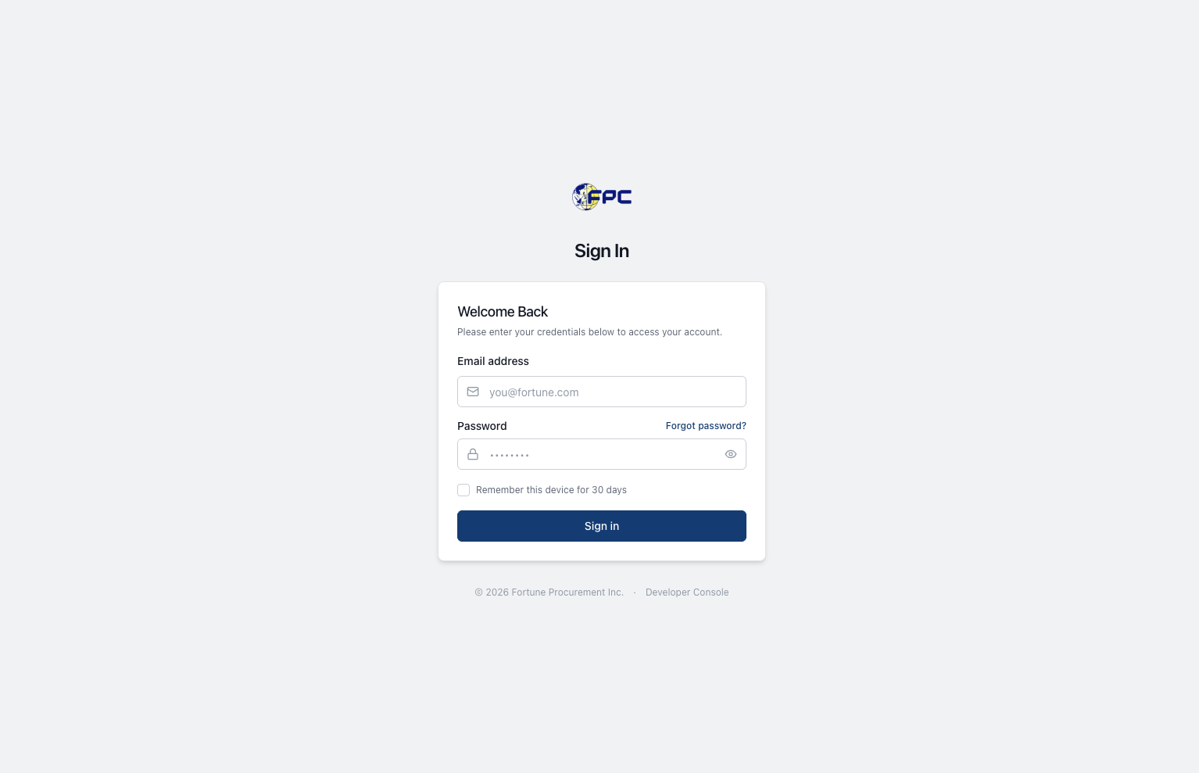

User Roles & Access Levels
The Fortune Procurement System uses role-based access control (RBAC) to ensure that users only have access to the functions and information required for their responsibilities. Access permissions are assigned by administrators and may be further restricted based on workflow position, department, or approval authority.
User Role | Access Privileges
Administrator | Full system access. Manage users, roles, departments, workflow configurations, approval matrices, supplier records, notifications, audit logs, and system settings.
Employee/Requestor | Create and submit Purchase Requests (PR1), monitor request status, review supplier alternative items, receive notifications, and view procurement history related to submitted requests.
Warehouse Personnel | Review submitted PR1 requests, validate stock availability, mark items as sufficient or insufficient, record inventory validation results, and route requests for further processing.
Approver | Review and approve or reject procurement documents based on assigned approval workflows. Access may include PR1 approvals, PR2 Phase 1 approvals, PR2 Phase 2 approvals, and Purchase Order approvals.
Procurement Staff | Manage RFQs, invite suppliers, review quotations, compare bids, create PR2 records, generate Purchase Orders, track deliveries, manage supplier communications, and monitor procurement activities.
Supplier | Maintain company profile, submit accreditation applications, manage product catalogs, respond to RFQs, submit quotations, acknowledge Purchase Orders, and track procurement transactions.
TSQA Reviewer | Review Raw Material Scientific Evaluation (RSE) submissions, evaluate supplier products, approve or reject scientific assessments, and provide quality assurance recommendations.

Access Control Principles

The system applies the following access control rules:

Users can only access modules assigned to their role.

Approval actions are only available when assigned within an active workflow step.

Procurement records are visible only to authorized participants within the procurement process.

Supplier users can only access their own organization’s records and submissions.

Administrative users have access to audit logs and system configuration functions.

All user actions are recorded in the system audit trail for accountability and compliance.

Workflow-Based Permissions

Certain permissions are dynamically granted based on workflow assignments.
Workflow Stage | Authorized Roles
PR1 Creation | Employee / Requestor
Warehouse Validation | Warehouse Personnel
PR1 Approval | Assigned Approvers
RFQ Management | Procurement
Supplier Quotation Submission | Supplier
Alternative Item Review | Employee / Requestor
PR2 Creation | Procurement
PR2 Approval Phase 1 | Assigned Approvers
PR2 Approval Phase 2 | Assigned Approvers
Purchase Order Creation | Procurement
Purchase Order Approval | Assigned Approvers
Supplier Acknowledgement | Supplier
Goods Receipt Note (GRN) Processing | Warehouse Personnel
RSE / TSQA Review | TSQA Reviewer

Administrative Note: Roles, workflow assignments, module visibility, approval hierarchies, and position-based permissions can be configured by system administrators through the User Management and Workflow Configuration modules.

User Interface Overview
The Fortune Procurement System provides a centralized procurement workspace designed to manage the complete procurement lifecycle, from Purchase Request (PR1) creation through supplier quotation management, Purchase Order processing, supplier acknowledgment, delivery tracking, and Goods Receipt Note (GRN) completion. The interface dynamically adapts based on the user's assigned role and permissions.
https://fortune-procurement.vercel.app/login

Core Interface Components

Component | Description
Top Navigation Bar | Displays notifications, messages, user profile, and quick actions.
Sidebar Menu | Provides access to modules based on user permissions and assigned role.
Dashboard Area | Displays role-specific metrics, pending actions, and workflow summaries.
Data Tables | Used for managing procurement records, requests, suppliers, and approvals.
Search & Filters | Allows users to quickly locate procurement documents and records.
Notification Center | Displays workflow updates, approvals, and system alerts.
Action Buttons | Create, approve, reject, edit, view, and manage records.

Navigation Overview
Upon successful login, users are redirected to their designated dashboard. Dashboard widgets, menus, notifications, and available actions vary according to assigned role permissions and workflow responsibilities.
Dashboard Layout
- Administrator Dashboard
- Employee / Requestor Dashboard
- Warehouse Dashboard
- Procurement Dashboard
- Approver Dashboard
- Supplier Dashboard
- TSQA Dashboard

Administrator Dashboard
The Administrator Dashboard is the primary landing page for users assigned the System Administrator role. It provides a centralized view of user management statistics, organizational structure records, audit activity, and administrative modules.
Dashboard Title: Dashboard
Dashboard Description: Monitor users, master data, and system activity from one place.

KPI Cards
The dashboard displays the following summary cards:
Card Name | Displayed Information | Click Action
Total Users | Total number of user accounts in the system | Opens User Management
Roles | Total number of configured system roles | Opens Roles
Positions | Total number of configured positions | Opens Positions
Departments | Total number of configured departments | Opens Departments
Audit Logs | Total number of audit records | Opens Audit Logs

Recent Activity
The Recent Activity panel displays the most recent administrative actions performed within the system.
Visible fields include:
Field | Description
Timestamp | Time the activity occurred
Activity | Recorded system action
Document Type | Related document classification
Reference Number | Related record identifier
The panel displays the five most recent records and includes a View All option for accessing the complete audit history.
Examples of recorded activities include:
- USER_REACTIVATED
- USER_DEACTIVATED

Sidebar Navigation
The Administrator Dashboard provides direct access to the following modules:
- Dashboard
- User Management
- Roles
- Positions
- Departments
- Workflows
- Module Visibility
- Audit Logs
No expandable child menus are currently present within the Administrator sidebar.

Top Navigation Bar
The top navigation area contains:
Component | Function
Dashboard Breadcrumb | Indicates current page location
Executive Office Indicator | Displays active organizational context
System Administrator Indicator | Displays active user role
Notifications | Opens notification center
Messages | Opens internal messaging
Bug Track | Opens Bug Tracking module
User Profile | Opens user profile page

Dashboard Actions
The following actions are available directly from the dashboard:
Action | Function
Collapse Sidebar | Hides or expands the sidebar navigation panel
Notifications | Opens unread system notifications
Sign Out | Ends the current user session

Accessible Modules
Administrators can access the following modules directly from dashboard links and KPI cards:
Module | Purpose
User Management | Manage user accounts and user information
Roles | Manage role definitions
Positions | Manage organizational positions
Departments | Manage department records
Audit Logs | Review system activity and audit history

Notes
- All KPI cards are clickable.
- Recent Activity records are linked to the audit trail.
- Audit Logs can be accessed from both the KPI card and the Recent Activity section.
- Module availability is determined by the System Administrator role.
- The dashboard currently focuses on user administration, organizational structure management, and audit monitoring.

Employee / Requestor Dashboard
The Employee / Requestor Dashboard is the primary landing page for users assigned the Employee role. It provides a centralized view of purchase requests, approval status, delivery tracking, and substitute item reviews.
Dashboard Title: Dashboard
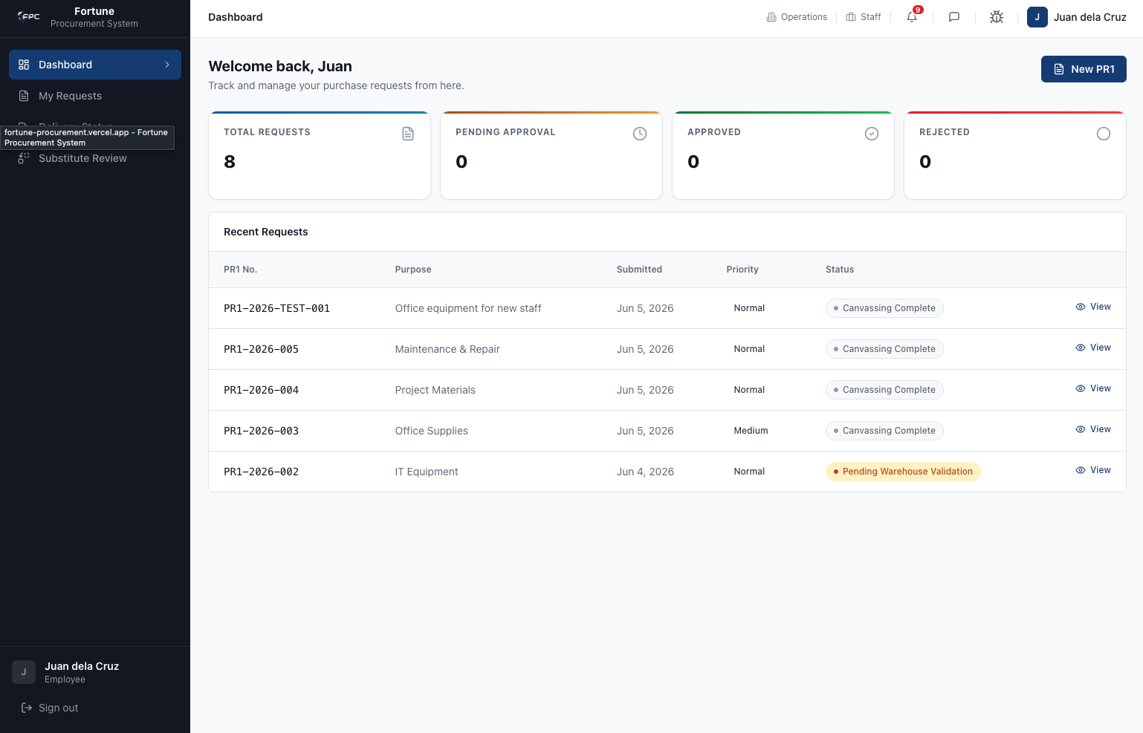
Dashboard Description: Track and manage your purchase requests from here.

KPI Cards
The dashboard displays the following summary cards:
Card Name | Displayed Information
Total Requests | Total number of PR1 requests submitted by the employee
Pending Approval | Total number of requests awaiting approval
Approved | Total number of approved requests
Rejected | Total number of rejected requests

Recent Activity
The dashboard contains a Recent Requests panel displaying the employee's most recently submitted purchase requests.
Visible fields include:
Field | Description
PR1 No. | Purchase Request reference number
Purpose | Purpose or justification of the request
Submitted | Date the request was submitted
Priority | Request priority level
Status | Current workflow status
Action | View request details
The panel displays the five most recent records.
Examples of displayed statuses include:
- Pending Warehouse Validation
- Canvassing Complete
- Approved
- Rejected
Users may open individual request records through the View action.

Sidebar Navigation
The Employee Dashboard provides direct access to the following modules:
- Dashboard
- My Requests
- Delivery Status
- Substitute Review

Top Navigation Bar
The top navigation area contains:
Component | Function
Dashboard Breadcrumb | Indicates current page location
Operations Breadcrumb | Displays organizational context
Staff Breadcrumb | Displays active user group
Notifications | Opens notification center
Messages | Opens internal messaging
Bug Track | Opens Bug Tracking module
User Profile | Opens employee profile page

Dashboard Actions
The following actions are available directly from the dashboard:
Action | Function
Collapse Sidebar | Hides or expands the sidebar navigation panel
New PR1 | Creates a new Purchase Request (PR1)
Notifications | Opens unread system notifications
Sign Out | Ends the current user session

Accessible Modules
Employees can access the following modules directly from dashboard links and navigation menus:
Module | Purpose
New PR1 | Create a new purchase request
My Requests | View and manage submitted PR1 requests
Delivery Status | Track delivery progress of approved purchases
Substitute Review | Review supplier-proposed substitute items
PR1 Details | View complete request information and workflow status

Notes
- KPI cards are informational only and are not clickable.
- Employees can only view requests that they created.
- The Recent Requests section displays the latest submitted PR1 records.
- Delivery Status provides visibility into purchase order fulfillment and delivery progress.
- Substitute Review allows employees to accept or reject supplier-proposed alternative items during the canvassing process.
- Module visibility is controlled by assigned role permissions and workflow assignments.

Warehouse Dashboard
The Warehouse Dashboard is the primary landing page for users assigned the Warehouse Personnel role. It provides a centralized view of purchase requests awaiting warehouse validation, goods receipt processing activities, and warehouse-related workflow queues.

Dashboard Title: Dashboard
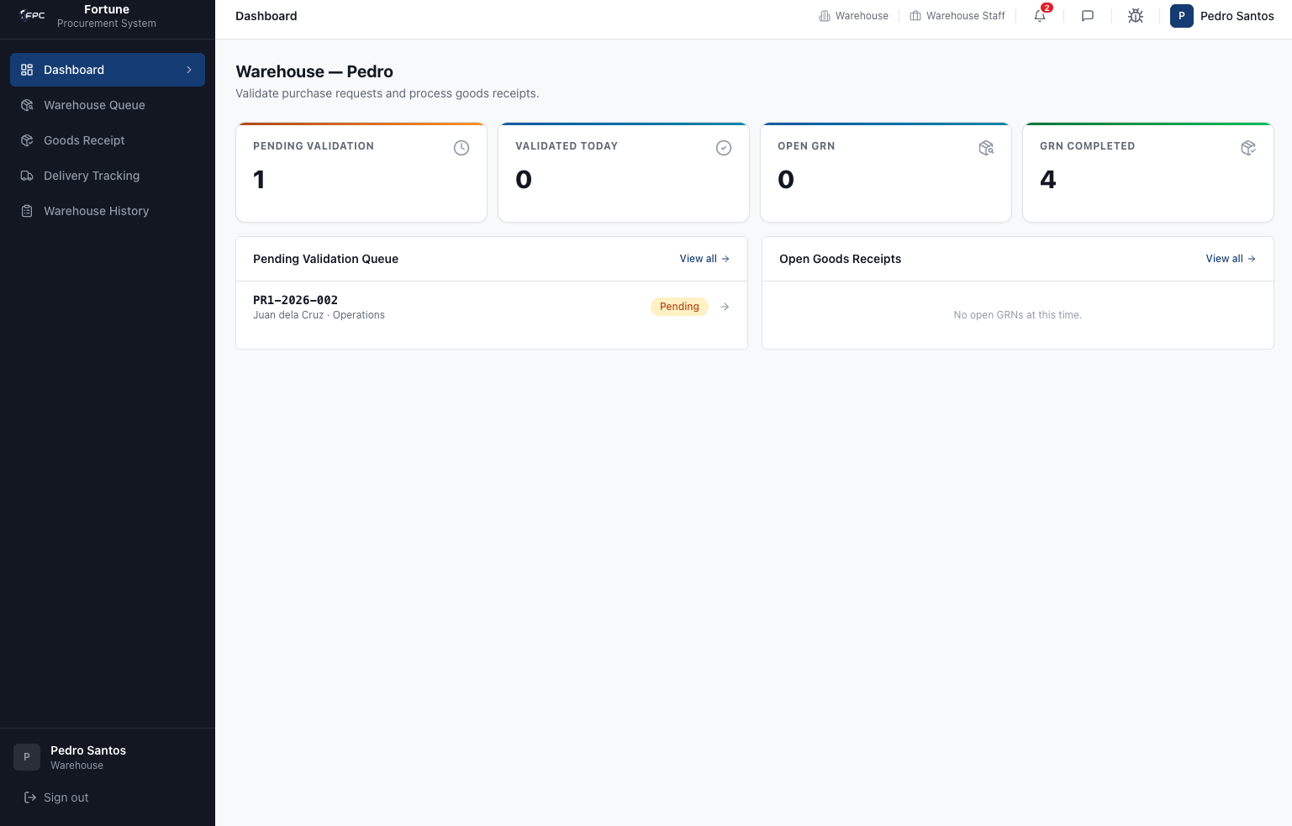
Dashboard Description: Warehouse — Validate purchase requests and process goods receipts.

KPI Cards
The dashboard displays the following summary cards:
Card Name | Displayed Information
Pending Validation | Total number of purchase requests awaiting warehouse validation
Validated Today | Total number of requests validated during the current day
Open GRN | Total number of open Goods Receipt Notes
GRN Completed | Total number of completed Goods Receipt Notes

Recent Activity
The dashboard contains two work queue sections.

Pending Validation Queue
Displays purchase requests awaiting warehouse review and stock validation.
Visible information includes:
Field | Description
Reference Number | Purchase Request reference number
Requestor | Employee who submitted the request
Department | Requesting department
Status | Current validation status
The section includes a View All option that opens the Warehouse Queue.

Open Goods Receipts
Displays Goods Receipt Notes (GRNs) that are currently open and pending completion.
The section includes a View All option that opens the Goods Receipt module.

Sidebar Navigation
The Warehouse Dashboard provides direct access to the following modules:
- Dashboard
- Warehouse Queue
- Goods Receipt
- Delivery Tracking
- Warehouse History
No expandable child menus are currently present within the Warehouse sidebar.

Top Navigation Bar
The top navigation area contains:
Component | Function
Dashboard Breadcrumb | Indicates current page location
Warehouse Breadcrumb | Displays organizational context
Warehouse Staff Breadcrumb | Displays active user role
Notifications | Opens notification center
Messages | Opens internal messaging
Bug Track | Opens Bug Tracking module
User Profile | Opens user profile page

Dashboard Actions
The following actions are available directly from the dashboard:
Action | Function
Collapse Sidebar | Hides or expands the sidebar navigation panel
View All (Pending Validation Queue) | Opens the Warehouse Queue
View All (Open Goods Receipts) | Opens the Goods Receipt module
Notifications | Opens unread system notifications
Sign Out | Ends the current user session

Accessible Modules
Warehouse personnel can access the following modules directly from dashboard links and navigation menus:
Module | Purpose
Warehouse Queue | Review purchase requests awaiting warehouse validation
Warehouse Validation | Open and process individual validation records
Goods Receipt | Create, update, and manage Goods Receipt Notes (GRNs)
Delivery Tracking | Monitor delivery progress
Warehouse History | Review historical warehouse transactions and validations

Workflow Information Displayed
The dashboard displays the following warehouse workflow indicators:
- Pending Validation
- Validated Today
- Open GRN
- GRN Completed
- Pending Status

Notes
- KPI cards are informational only and are not clickable.
- Warehouse validation requests are displayed in the Pending Validation Queue.
- Individual validation records can be opened directly from the queue.
- Goods Receipt processing is accessed through the Goods Receipt module.
- Dashboard visibility is controlled by Warehouse Personnel role permissions.
- The dashboard focuses on stock validation activities and Goods Receipt processing.

Procurement Dashboard
The Procurement Dashboard is the primary landing page for users assigned the Procurement Staff role. It provides a centralized view of supplier accreditation activities, product review queues, Request for Quotation (RFQ) management, canvassing activities, Purchase Orders, and procurement workflow monitoring.
Dashboard Title: Dashboard
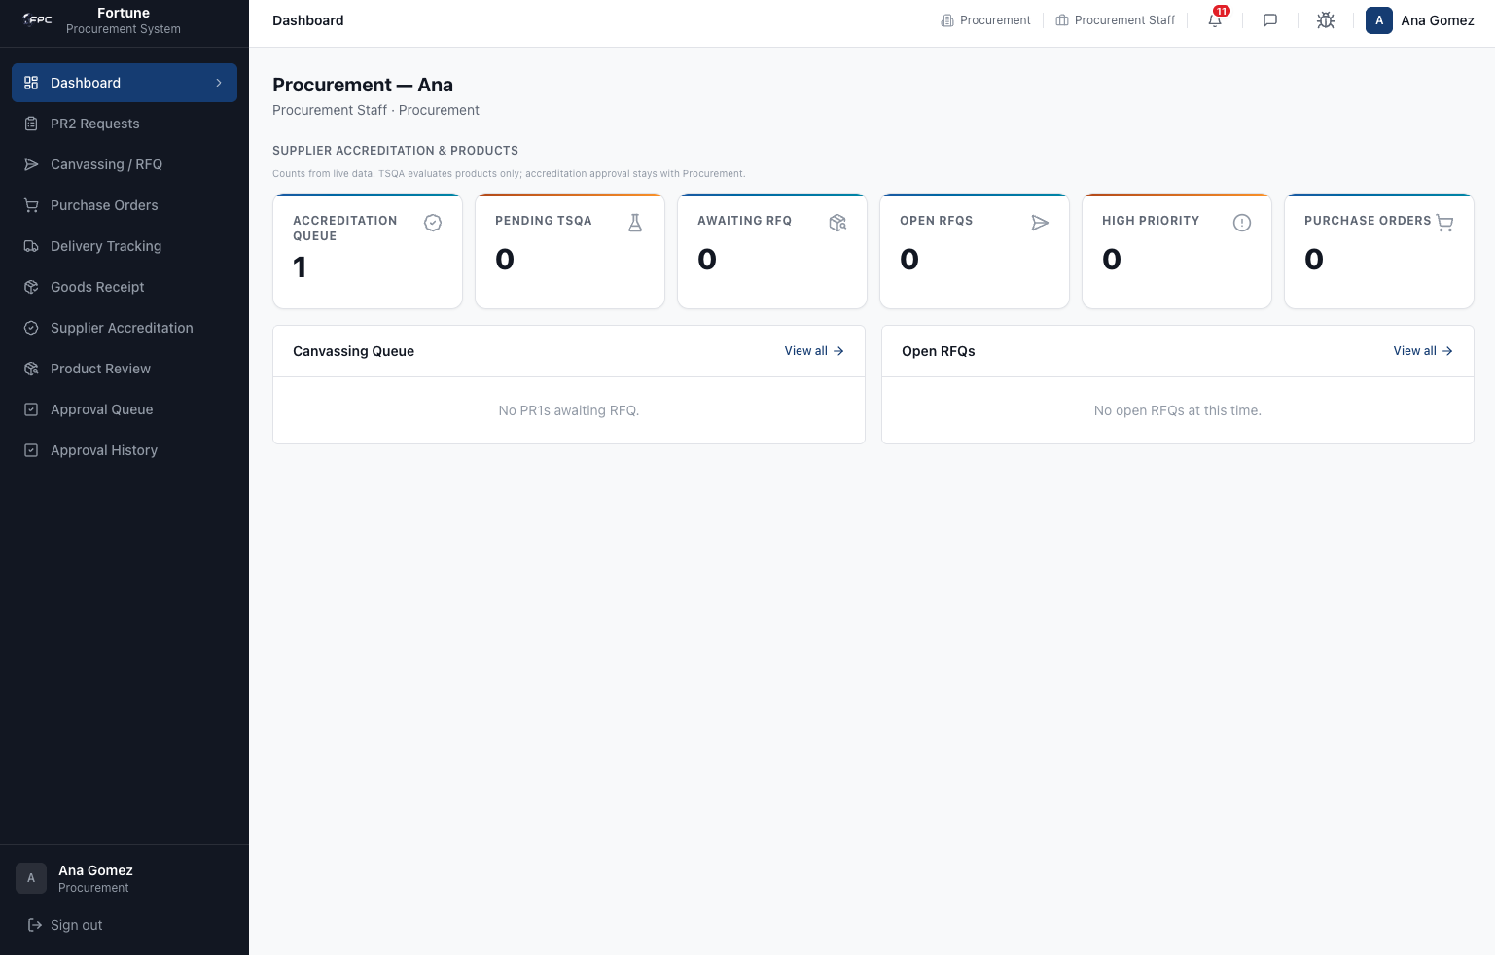
Dashboard Description: Procurement; Procurement Staff · Procurement

KPI Cards
The dashboard displays the following summary cards:
Card Name | Displayed Information
Accreditation Queue | Total number of supplier accreditation applications awaiting procurement review
Pending TSQA | Total number of products awaiting TSQA evaluation
Awaiting RFQ | Total number of approved requests awaiting RFQ creation
Open RFQs | Total number of active Request for Quotation records
High Priority | Total number of high-priority procurement requests
Purchase Orders | Total number of Purchase Orders currently tracked in the system

Recent Activity
The dashboard contains two procurement work queue sections.

Canvassing Queue
Displays procurement requests awaiting RFQ processing and supplier canvassing activities.
The section includes a View All option that opens the RFQ module.

Open RFQs
Displays active Request for Quotation (RFQ) records currently under procurement management.
The section includes a View All option that opens the RFQ module.

Sidebar Navigation
The Procurement Dashboard provides direct access to the following modules:
- Dashboard
- PR2 Requests
- Canvassing / RFQ
- Purchase Orders
- Delivery Tracking
- Goods Receipt
- Supplier Accreditation
- Product Review
- Approval Queue
- Approval History

Top Navigation Bar
The top navigation area contains:
Component | Function
Dashboard Breadcrumb | Indicates current page location
Procurement Breadcrumb | Displays organizational context
Procurement Staff Breadcrumb | Displays active user role
Notifications | Opens notification center
Messages | Opens internal messaging
Bug Track | Opens Bug Tracking module
User Profile | Opens user profile page

Dashboard Actions
The following actions are available directly from the dashboard:
Action | Function
Collapse Sidebar | Hides or expands the sidebar navigation panel
View All (Canvassing Queue) | Opens the RFQ module
View All (Open RFQs) | Opens the RFQ module
Notifications | Opens unread system notifications
Sign Out | Ends the current user session

Accessible Modules
Procurement Staff can access the following modules directly from dashboard links and navigation menus:
Module | Purpose
Supplier Accreditation | Review and process supplier accreditation applications
Product Review | Review supplier-submitted products and route products for TSQA evaluation when required
Canvassing Queue | Manage RFQs and collect supplier quotations
Purchase Orders | Manage Purchase Orders and monitor supplier fulfillment
Delivery Tracking | Monitor delivery progress and shipment status
Goods Receipt | Access Goods Receipt processing records
PR2 Requests | View and manage PR2-related activities
Approval Queue | Review procurement approvals awaiting action
Approval History | Review completed procurement approval actions

Workflow Information Displayed
The dashboard displays the following procurement workflow indicators:
- Accreditation Queue
- Pending TSQA
- Awaiting RFQ
- Open RFQs
- High Priority
- Purchase Orders
The dashboard may also display informational queue messages such as:
- "No PR1s awaiting RFQ."
- "No open RFQs at this time."

Notes
- All KPI cards are clickable and open their corresponding procurement modules.
- RFQ-related KPI cards direct users to the RFQ management module.
- Supplier Accreditation and Product Review activities are accessible directly from KPI cards.
- The dashboard provides visibility into supplier onboarding, product evaluation, RFQ management, and Purchase Order activities.
- Dashboard visibility is controlled by Procurement Staff role permissions.
- The dashboard serves as the primary operational workspace for procurement personnel.

Approver Dashboard
The Approver Dashboard is the primary landing page for users assigned to approval workflows. It provides a centralized view of procurement documents awaiting action, approval activity, and approval history.
Dashboard Title: Dashboard
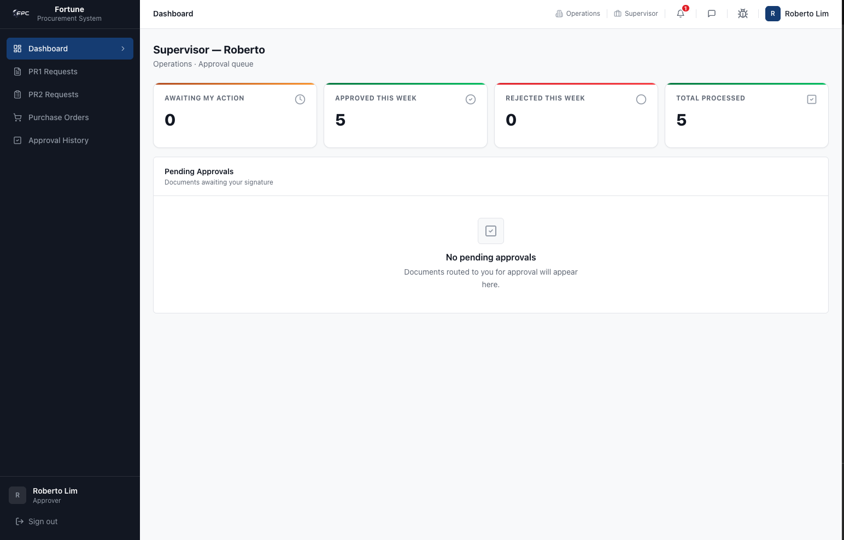
Dashboard Description: Executive Office · Director Approval Dashboard

KPI Cards
The dashboard displays the following summary cards:
Card Name | Displayed Information
Awaiting My Action | Total number of documents awaiting approval action
Approved This Week | Total number of documents approved during the current week
Rejected This Week | Total number of documents rejected during the current week
Total Processed | Total number of documents processed by the approver

Recent Activity
The dashboard contains a Pending Approvals work queue.

Pending Approvals
Displays procurement documents currently awaiting approval by the logged-in approver.
Visible information may include:
Field | Description
Reference  Number | Procurement document reference number
Document Type | Type of procurement document
Submitted By | User who submitted the document
Status | Current approval status
When no records are available, the dashboard displays:
- No pending approvals.
- Documents routed to you for approval will appear here.

Sidebar Navigation
The Approver Dashboard provides direct access to the following modules:
- Dashboard
- PR1 Requests
- PR2 Requests
- Purchase Orders
- Approval History
No expandable child menus are currently present within the Approver sidebar.

Top Navigation Bar
The top navigation area contains:
Component | Function
Dashboard Breadcrumb | Indicates current page location
Executive Office Breadcrumb | Displays organizational context
Director Breadcrumb | Displays active approval position
Notifications | Opens notification center
Messages | Opens internal messaging
Bug Track | Opens Bug Tracking module
User Profile | Opens user profile page

Dashboard Actions
The following actions are available directly from the dashboard:
Action | Function
Collapse Sidebar | Hides or expands the sidebar navigation panel
Notifications | Opens unread system notifications
Sign Out | Ends the current user session

Accessible Modules
Approvers can access the following modules directly from dashboard links and navigation menus:
Module | Purpose
PR1 Requests | Review and process PR1 approval requests
PR2 Requests | Review and process PR2 approval requests
Purchase Orders | Review and process Purchase Order approvals
Approval History | Review completed approval actions and decisions
Approval Queue | View documents currently assigned for approval

Workflow Information Displayed
The dashboard displays the following approval workflow indicators:
- Awaiting My Action
- Approved This Week
- Rejected This Week
- Total Processed
- Pending Approvals
The dashboard may also display informational messages such as:
- "No pending approvals."
- "Documents routed to you for approval will appear here."

Notes
- KPI cards are informational only and are not clickable.
- Approval requests assigned to the current approver appear in the Pending Approvals section.
- Approvers can only act on workflow steps assigned to their role and position.
- Approval History provides visibility into completed approval actions.
- Dashboard visibility is controlled by workflow assignments and role permissions.
- The dashboard serves as the primary workspace for approval activities.

Supplier Dashboard
The Supplier Dashboard is the primary landing page for users assigned the Supplier role. It provides a centralized view of supplier accreditation status, product catalog information, active quotation requests, purchase order activities, and supplier-related procurement workflows.
Dashboard Title: Dashboard
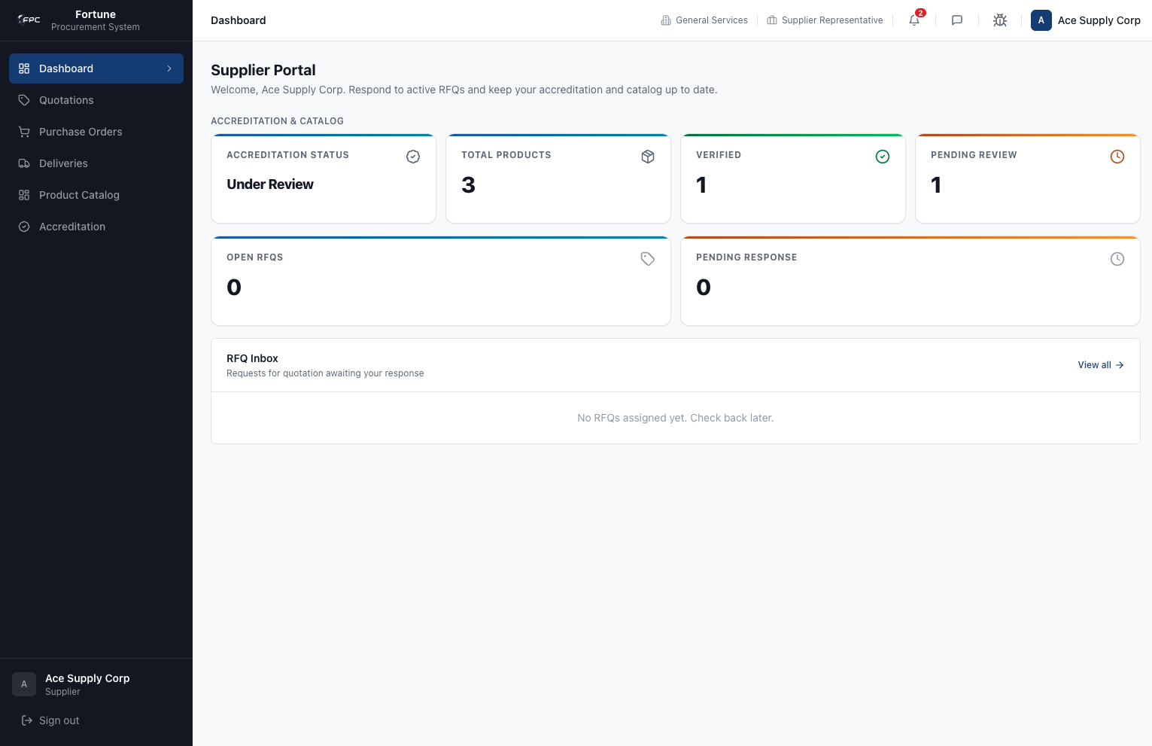
Dashboard Description: Supplier Portal — Respond to active RFQs and keep your accreditation and catalog up to date.

KPI Cards
The dashboard displays the following summary cards:
Card Name | Displayed Information
Accreditation Status | Current accreditation review status of the supplier organization
Total Products | Total number of products registered in the supplier catalog
Verified | Total number of products successfully verified and approved
Pending Review | Total number of products awaiting procurement or TSQA review
Open RFQs | Total number of active Request for Quotation (RFQ) records awaiting supplier action
Pending Response | Total number of quotation requests that have not yet received a supplier response

Recent Activity
The dashboard contains an RFQ work queue.

RFQ Inbox
Displays Requests for Quotation (RFQs) currently assigned to the supplier and awaiting quotation submission.
Visible information may include:
Field | Description
RFQ Number | Request for Quotation reference number
Request Date | Date the RFQ was issued
Due Date | Deadline for quotation submission
Status | Current RFQ status
Action | Open and respond to quotation request
The section includes a View All option that opens the Quotations module.
When no RFQs are available, the dashboard displays:
- No RFQs assigned yet.
- Check back later.

Sidebar Navigation
The Supplier Dashboard provides direct access to the following modules:
- Dashboard
- Quotations
- Purchase Orders
- Deliveries
- Product Catalog
- Accreditation
No expandable child menus are currently present within the Supplier sidebar.

Top Navigation Bar
The top navigation area contains:
Component | Function
Dashboard Breadcrumb | Indicates the current page location
General Services Breadcrumb | Displays organizational context
Supplier Representative Breadcrumb | Displays the active supplier user role
Notifications | Opens notification center
Messages | Opens internal messaging
Bug Track | Opens Bug Tracking module
User Profile | Opens supplier profile page

Dashboard Actions
The following actions are available directly from the dashboard:
Action | Function
Collapse Sidebar | Hides or expands the sidebar navigation panel
Notifications | Opens unread system notifications
View All (RFQ Inbox) | Opens the Quotations module
Sign Out | Ends the current user session

Accessible Modules
Suppliers can access the following modules directly from dashboard links and navigation menus:
Module | Purpose
Quotations | Review RFQs and submit supplier quotations
Purchase Orders | Review issued Purchase Orders and acknowledge receipt
Deliveries | Update and monitor delivery status of Purchase Orders
Product Catalog | Create, update, and manage supplier product records
Accreditation | Submit and track supplier accreditation applications

Workflow Information Displayed
The dashboard displays the following supplier workflow indicators:
- Accreditation Status
- Total Products
- Verified Products
- Pending Product Reviews
- Open RFQs
- Pending Responses
The dashboard may also display informational messages such as:
- "No RFQs assigned yet."
- "Check back later."

Notes
- All KPI cards are clickable and open their corresponding modules.
- Accreditation Status opens the Accreditation module.
- Product-related KPI cards open the Product Catalog module.
- RFQ-related KPI cards open the Quotations module.
- Suppliers can only view records belonging to their own organization.
- Product approval and accreditation approval are separate processes.
- Product verification may require Procurement and TSQA review before products become available for procurement activities.
- Dashboard visibility is controlled by Supplier role permissions.
- The dashboard serves as the primary workspace for supplier quotation management, accreditation monitoring, and product catalog maintenance.

TSQA Dashboard
The TSQA Dashboard is the primary landing page for users assigned the TSQA Reviewer role. It provides a centralized view of Raw Material Scientific Evaluation (RSE) records, product review assignments, and scientific evaluation activities.
Dashboard Title: Dashboard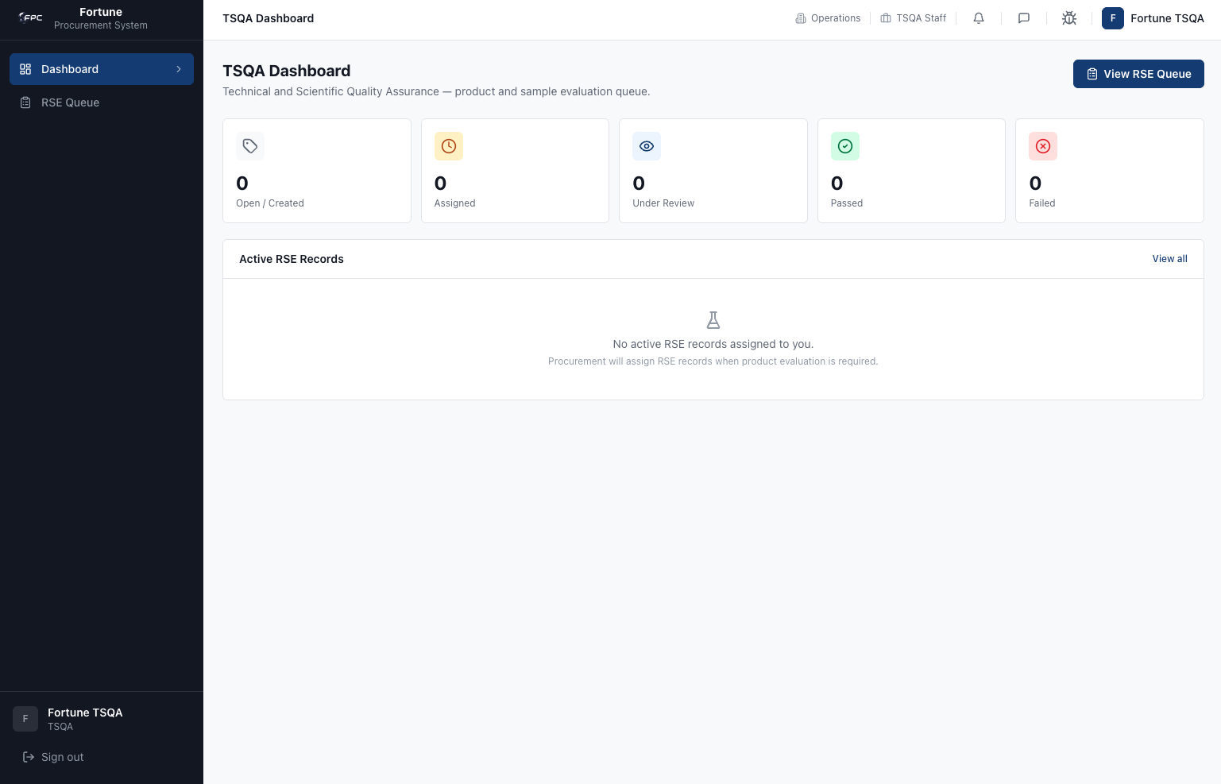

Dashboard Description: Technical and Scientific Quality Assurance — product and sample evaluation queue.

KPI Cards
The dashboard displays the following summary cards:
Card Name | Displayed Information
Open / Created | Total number of open or newly created RSE records
Assigned | Total number of RSE records assigned to the TSQA Reviewer
Under Review | Total number of RSE records currently under scientific evaluation
Passed | Total number of RSE records that successfully passed evaluation
Failed | Total number of RSE records that failed evaluation
All visible KPI cards display count-based metrics. Clickability is not verified from the visible interface.

Recent Activity

Active RSE Records
This section displays RSE records currently assigned to the logged-in TSQA Reviewer.
Field | Description
Active RSE Records | Section title for the assigned RSE record list
View All | Opens the RSE Queue module
Empty State Message | "No active RSE records assigned to you."
Supporting Message | "Procurement will assign RSE records when product evaluation is required."
Visible Columns: Not present
Status Indicators: Not present
Actions Available: View All
View All Functionality: Opens the RSE Queue module.

Sidebar Navigation
The TSQA Dashboard provides direct access to the following modules:
- Dashboard
- RSE Queue
No expandable child menus are currently present within the TSQA sidebar.

Top Navigation Bar
Component | Function
Dashboard Breadcrumb | Indicates the current page location
Operations Breadcrumb | Displays organizational context
TSQA Reviewer Breadcrumb | Displays the active TSQA role
Notifications | Opens notification center
Messages | Opens internal messaging
Bug Track | Opens Bug Tracking module
User Profile | Opens the user profile page

Dashboard Actions
The following actions are available directly from the dashboard:
Action | Function
Collapse Sidebar | Hides or expands the sidebar navigation panel
View RSE Queue | Opens the RSE Queue module
View All | Opens the RSE Queue module from the Active RSE Records section
Notifications | Opens unread system notifications
Messages | Opens internal messaging
Bug Track | Opens the Bug Tracking module
User Profile | Opens the user profile page
Sign Out | Ends the current user session

Accessible Modules
TSQA Reviewers can access the following modules directly from dashboard links and navigation menus:
Module | Purpose
Dashboard | Displays TSQA metrics and assigned RSE activity
RSE Queue | Review and process Raw Material Scientific Evaluation records
Messages | Access internal messaging
Bug Track | Report and monitor application issues
User Profile | Manage profile information and account settings

Workflow Information Displayed
The dashboard displays the following TSQA workflow indicators:
- Open / Created
- Assigned
- Under Review
- Passed
- Failed
The Active RSE Records section may display the following informational messages:
- "No active RSE records assigned to you."
- "Procurement will assign RSE records when product evaluation is required."

Notes
- The TSQA Dashboard focuses exclusively on Raw Material Scientific Evaluation (RSE) activities.
- The RSE Queue is accessible from both the sidebar navigation and dashboard action links.
- KPI cards provide visibility into the current scientific review workload.
- No active RSE records are displayed when no assignments exist.
- No table columns are visible when the Active RSE Records queue is empty.
- Product review activities originate from Procurement and are routed to TSQA when scientific evaluation is required.
- TSQA Reviewers are responsible for conducting scientific assessments and recording pass/fail evaluation results.
- Dashboard visibility is controlled by TSQA Reviewer role permissions.
- The dashboard serves as the primary workspace for scientific product evaluation and quality assurance review activities.

Functional Instructions

Role: Employee / Requestor
The Employee / Requestor role represents general company staff members who initiate purchase requests (PR1), evaluate proposed substitute items from suppliers, and monitor delivery progress. The primary account used is the employee role account (employee@fortune.com).

1.1 Dashboard

Module Purpose
Provides a central overview of requisition statuses, alert notifications, and quick shortcuts.

Module UI Map
Component Type | Element Label / Value | Description / Action
Welcome Header | Welcome back, employee! | Displays logged-in user name
KPI Card | Total Requests | Total count of requests submitted
KPI Card | Pending Approval | Count of requests currently in approval workflow
KPI Card | Approved | Count of successfully approved requests
KPI Card | Rejected | Count of rejected requests
Table | Recent Requests Table | Columns: PR1 No., Purpose, Submitted, Priority, Status, View link
Button | New PR1 | Navigates to creation form
Banner | You have substitute items awaiting decision | Displays if pending substitutes exist
Sidebar Menu | Dashboard, My Requests, Delivery Status, Substitute Review | Core module links
Header Icons | Message Center (badge count), Bug Track, Profile Dropdown, Sign out | Utility actions

Step-by-Step Workflows
1. Select Dashboard from the sidebar. Review total pending request counters. If the substitute items warning banner is visible, click on it to navigate to the Substitute Review workspace.
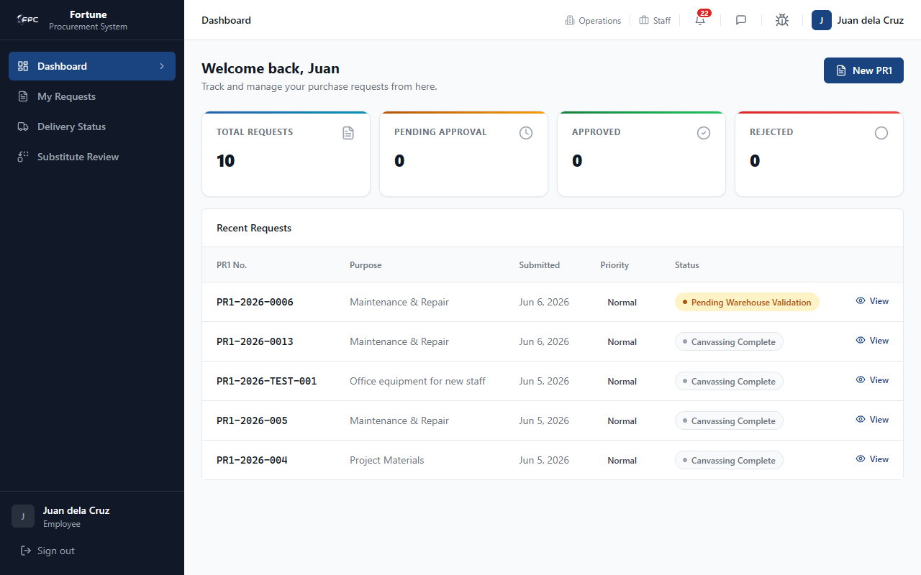
Caption: Employee Dashboard - The landing workspace for the employee. It displays four key performance indicator (KPI) metric cards for Total Requests, Pending Approval, Approved, and Rejected, alongside the Recent Requests table which lists the 5 most recent requisitions with columns for PR1 No., Purpose, Date Submitted, Priority, and Status.

Status Glossary
Status Badge | Description
Pending Approval | Yellow status badge indicating that the request is currently routing through approvals.
Approved | Green status badge indicating that the request is fully approved.
Rejected | Red status badge indicating that the request has been rejected and cannot be edited.

Expected Outcome
Successful loading of metrics, tables, and warnings on dashboard landing.

1.2 My Requests (/pr1)

Module Purpose
Lists all purchase requisitions created by the requisitioner, supporting searching and filtering.

Module UI Map
Component Type | Element Label / Value | Description / Action
Search Bar | PR1 number or purpose... | Input field for text queries
Filter Dropdown | STATUS | Filters table rows by requisition status
Date Pickers | DATE CREATED FROM / DATE CREATED TO | Filter rows by creation date range
Button | Apply Filters | Submits search and filter parameters
Button | Clear | Resets search and filter inputs
Button | New PR1 | Navigates to creation form

Step-by-Step Workflows
1. Type a query in the search input or select status filters, then click the Apply Filters button. The table updates dynamically. Click Clear to reset.
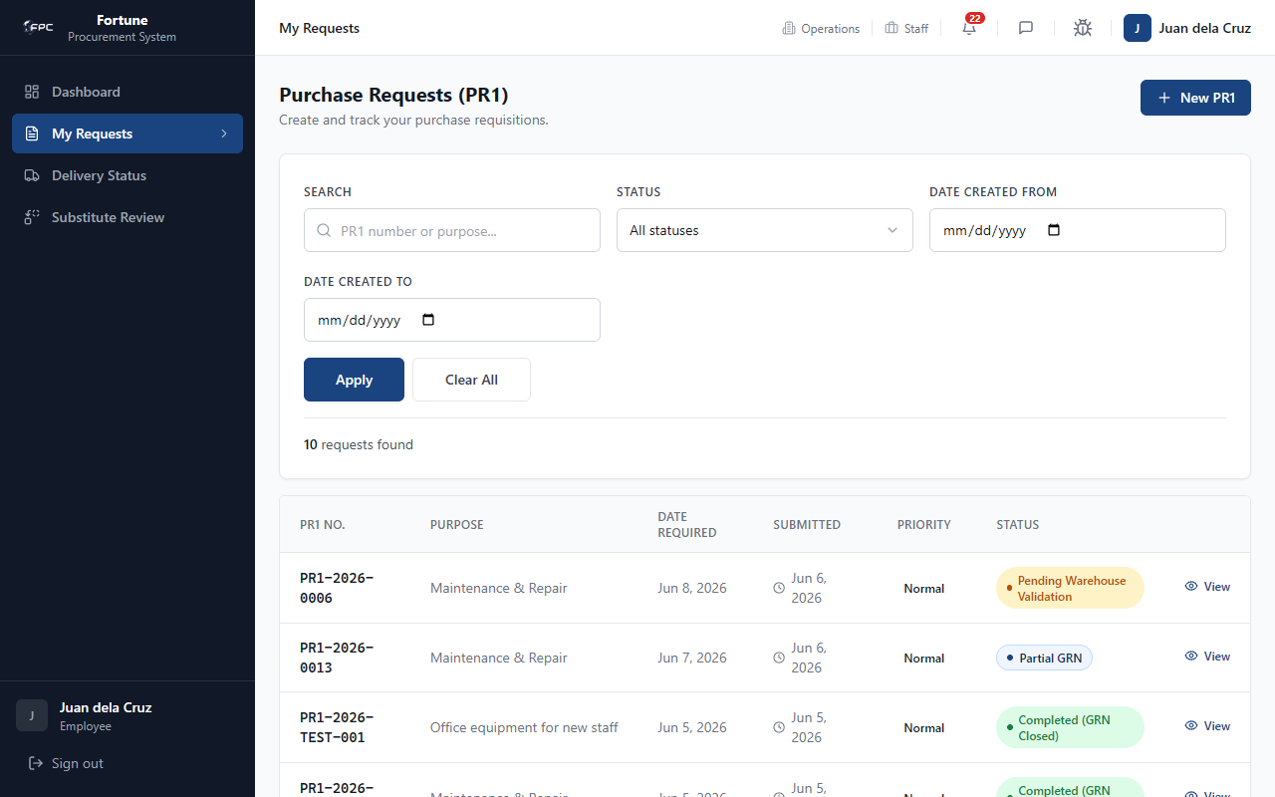
Caption: Purchase Requisitions (PR1) List View - Shows the historical list of all requests submitted by the employee. It includes search inputs for text-based queries on PR1 numbers and purposes, a dropdown to filter by document status, and date pickers to filter by creation ranges.

Status Glossary
Status Badge | Description
Draft | Grey badge showing the request is saved locally but not yet submitted.
Pending Warehouse Validation | Amber badge showing the request is awaiting warehouse stock verification.
PR2 — Pending Approval | Orange badge indicating Phase 1/Phase 2 approvals are active.
Canvassing Complete | Blue badge indicating supplier bidding has closed and winners are awarded.
Completed (GRN Closed) | Green badge showing items are received at the warehouse and the request is closed.

Expected Outcome
Requisition table correctly updates rows based on filter queries.

1.3 Creating a New PR1 (/pr1/new)

Module Purpose
Enables creating and submitting new purchase requisitions.

Module UI Map
Component Type | Element Label / Value | Description / Action
Read-only Info | REQUISITIONER / DEPARTMENT / DATE | Employee / Operations / Today's Date
Input Suffix | PR1-2026- [e.g. 001] | Custom suffix text input for PR1 sequence
Dropdown Select | PURPOSE * | Select request business category
Date Picker | DATE REQUIRED * | Target delivery date required
Table | Items Requested Table | Columns: Item Code, Description, Unit, SOH, Req. Qty, Raw Mat. Checkbox
Button | Add Item | Appends a new line item row to the table
Button | Submit PR1 | Validates and submits the request
Button | Save Draft | Saves request as draft without submitting

Step-by-Step Workflows
Workflow 1: Empty Form Validation
1. Leave all inputs empty and click Submit PR1. Browser highlights required fields and displays validation bubbles: 'Purpose is required' and 'At least one item is required'.
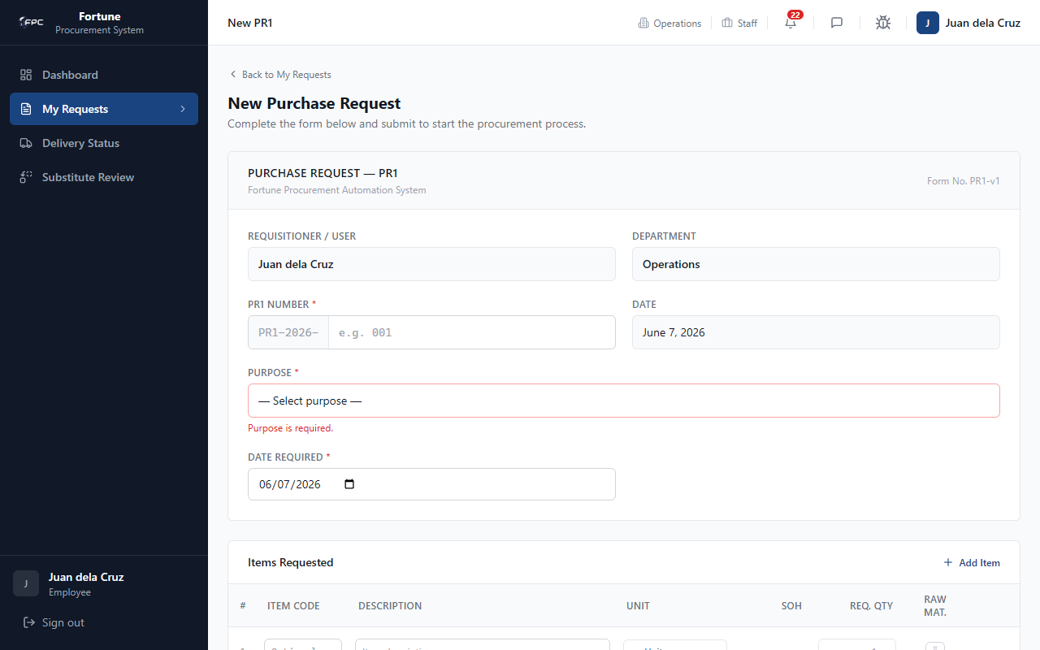
Caption: New PR1 Form (Validation State) - The interface displayed when a user attempts to submit an empty form. The browser triggers validation error highlights under the Purpose dropdown and displays a notice stating that at least one item must be added to the items requested table.
Workflow 2: Submitting a PR1
1. Enter custom sequence suffix, select a Purpose, choose required date, click Add Item, enter description, unit, and quantity. Check 'Raw Mat.' if applicable. Click Submit PR1.
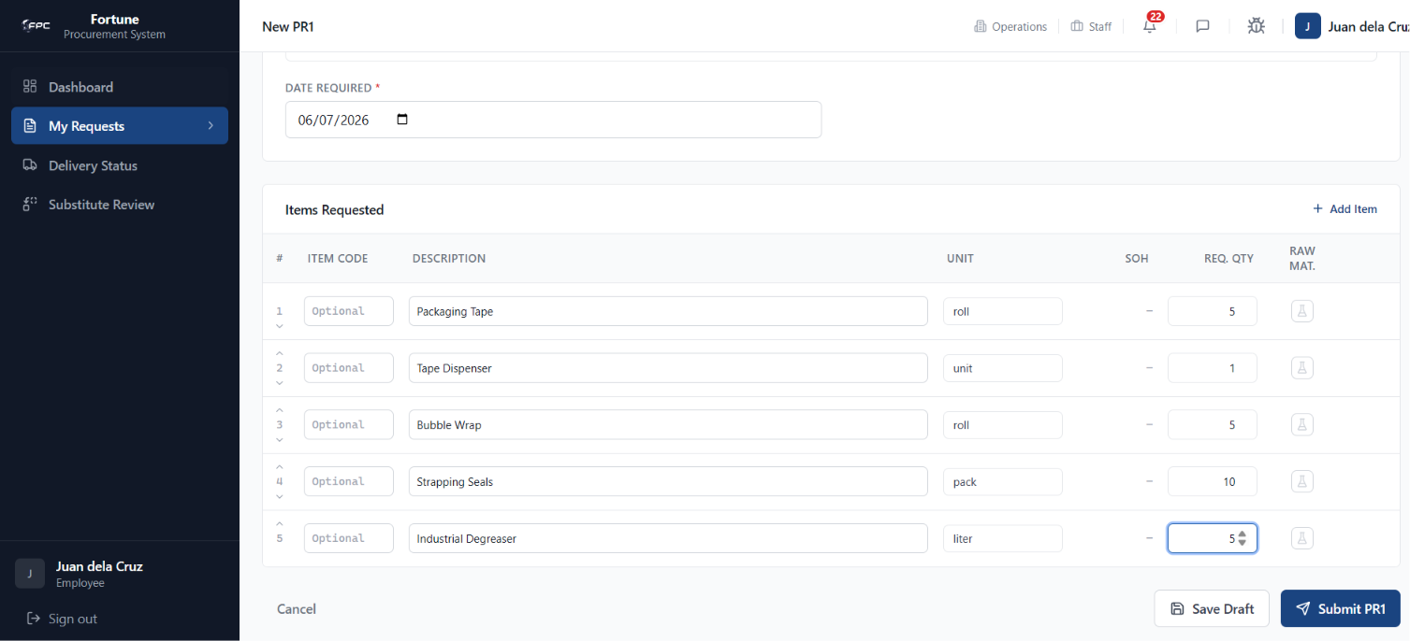
Caption: New PR1 Form (Populated State) - Illustrates the completed request form. It shows the requisitioner and department metadata fields, custom sequence input (e.g. 001), selected purpose (Operations), required date, and a populated table of requested items with item code, description, unit, and requested quantity.

Expected Outcome
Form submission creates a new PR1 record, setting status to 'Pending Warehouse Validation'.

1.4 Viewing PR1 Details (/pr1/{pr1Id})

Module Purpose
Displays detailed information, line items, and approval signatory logs for a specific PR1.

Module UI Map
Component Type | Element Label / Value | Description / Action
Header Block | PR1 No. & Status Badges | Displays document number, priority, and current status
Details Panel | REQUEST HEADER | Requisitioner, department, purpose, dates, and references
Table | ITEMS REQUESTED | Columns: #, Item Code, Description, Type, Unit, SOH, Req. Qty, Warehouse Route
Timeline | SIGNATORIES Tracker | Chronological sign-off steps and active actor indicators
Button | Print | Opens standard browser print view of the requisition

Step-by-Step Workflows
1. Click on a PR1 No. or View link in any list page. Inspect details. Scroll down to the Signatories timeline to see who has reviewed/approved the request.
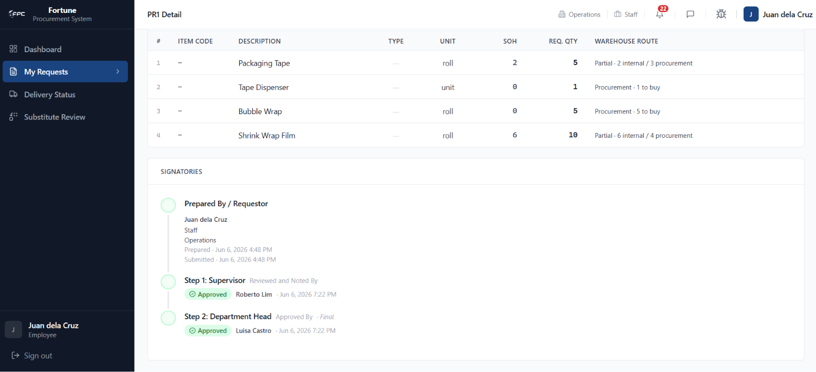
Caption: Requisition Details Page - Displays the details of a specific PR1. The upper portion shows the requisitioner information and item routing decisions, while the bottom section displays the Signatories timeline tracker highlighting approved steps and pending signatories in the workflow.

Expected Outcome
Detailed request parameters and signature history loaded successfully.

1.5 Substitute Review (/substitutes)

Module Purpose
Lists all requisitions with proposed alternative supplier products.

Module UI Map
Component Type | Element Label / Value | Description / Action
KPI Counter | Pending Decision / Accepted / Rejected | Departmental substitute decision counters
Search Input | SEARCH | Filter items by PR1 number, purpose, or supplier
Filter Dropdown | STATUS | Filter cards by substitute status (All, Decided, Pending)
Cards Grid | Substitute Cards | Groups items by PR1. Shows description and number of options offered

Step-by-Step Workflows
1. Click Substitute Review in the sidebar. Locate card with pending substitutes. Click the card to open side-by-side details.
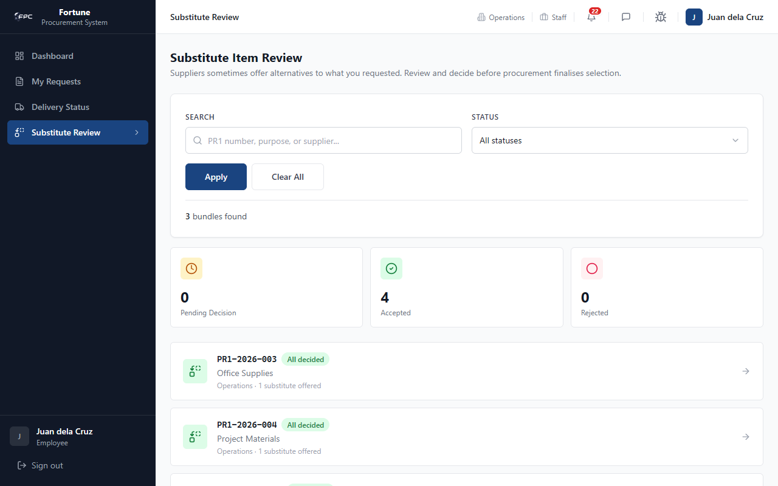
Caption: Substitute Review Dashboard - A queue listing all purchase requests that contain alternative supplier products. Requisitioners can see cards indicating the number of options offered by suppliers and click on them to navigate to the comparison details page.

Expected Outcome
Substitute review queue and metrics populated.

1.6 Substitute Item Details Comparison (/substitutes/{pr1Id})

Module Purpose
Enables comparing requested items side-by-side with proposed alternatives and submitting decisions.

Module UI Map
Component Type | Element Label / Value | Description / Action
Left Panel | YOU REQUESTED | Displays original requested item name, description, and quantity
Right Panel | SUPPLIER IS OFFERING | Displays alternative product description, lead time, and remarks
Text Field | Price Hidden Label | Masks the cost details from general employee view
Textarea | Notes | Input field to enter justification for decision
Button | Accept Substitute | Approves the proposed supplier item
Button | Reject Substitute | Declines the proposed item, returning to source request
Button | Change decision to... | Resets decision state to allow re-selection

Step-by-Step Workflows
1. Review comparison cards. Prices display as 'Price hidden'. Enter remarks in the notes box, then click Accept Substitute or Reject Substitute. The status updates immediately. To reverse selection, click the Change decision button.
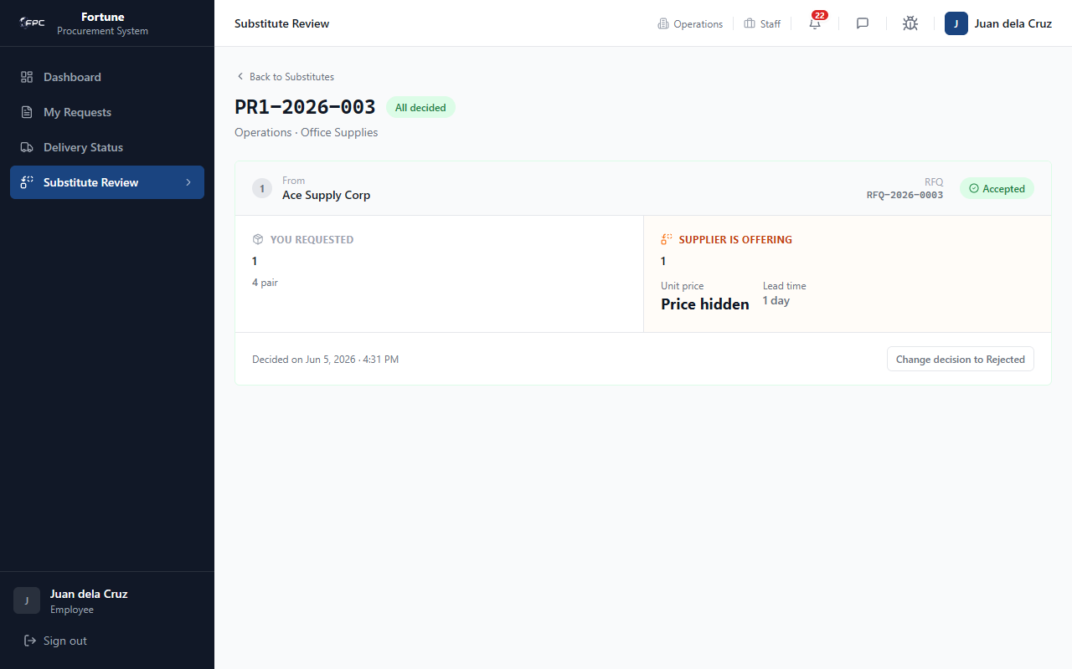
Caption: Substitute Item Comparison - A side-by-side split screen workspace. The left panel shows the original item requested by the employee. The right panel displays the alternative product offered by the supplier (including unit price, lead time, and remarks) with the price hidden from the general employee view to prevent bias.

Status Glossary
Status Badge | Description
Pending | Yellow badge showing that no decision has been taken on the alternative.
Accepted | Green badge showing the substitute item is approved for procurement.
Rejected | Red badge showing the substitute item is rejected and the system must source the original.

Expected Outcome
Decisions are saved, updating downstream canvassing routes.

1.7 Delivery Status (/delivery)

Module Purpose
Tracks shipping milestones and transit logs for approved purchase orders.

Module UI Map
Component Type | Element Label / Value | Description / Action
Tabs | All, Pending, Scheduled, In Transit, Delayed, Delivered | Filters delivery cards by active status
Search Input | SEARCH | Filter by PO number, purpose, supplier, or warehouse
Cards Grid | Delivery List Cards | Displays PO number, status badge, supplier, and estimated arrival

Step-by-Step Workflows
1. Navigate to Delivery Status. Search by PO number. Click the card chevron to open detail timelines.
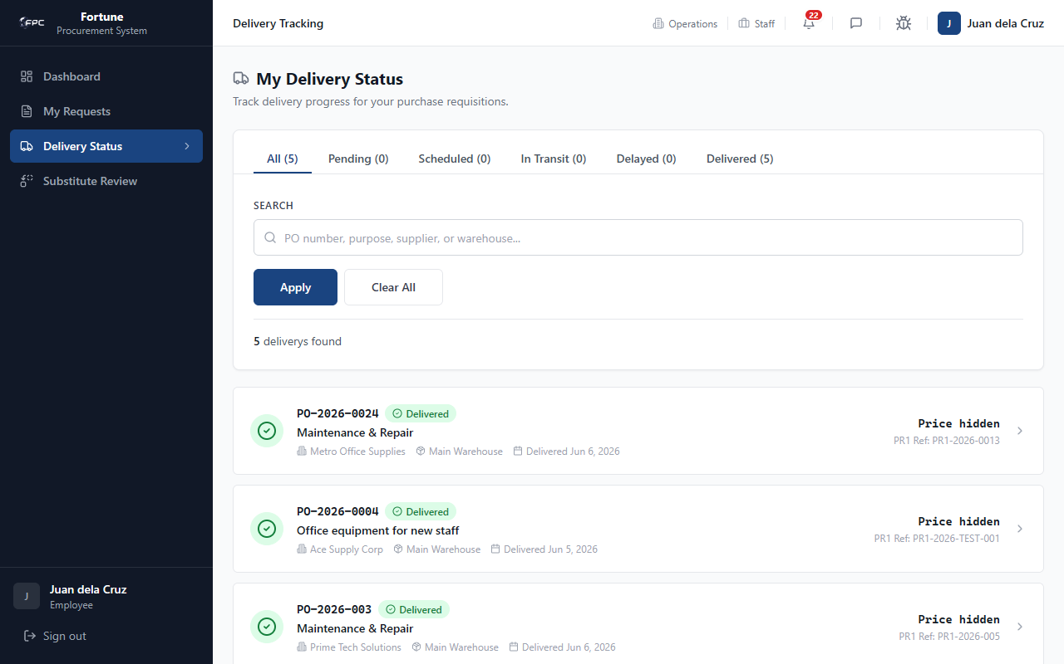
Caption: Delivery Status Tracker - Lists active deliveries and shipping milestones for approved purchase orders. Requisitioners can click tabs (All, Pending, Scheduled, In Transit, Delayed, Delivered) to filter the list and search for specific PO numbers or suppliers.

Expected Outcome
Delivery list populates according to status tabs.

1.8 Delivery Details (/delivery/{deliveryId})

Module Purpose
Displays destination parameters and transit history timelines for deliveries.

Module UI Map
Component Type | Element Label / Value | Description / Action
Information Block | DELIVERY INFO | Supplier, Requisitioner, Deliver To, Address
Dates Panel | KEY DATES | Actual Delivery Date, Estimated Arrival Date
Timeline | STATUS HISTORY | Chronological log showing status transitions, actors, and remarks
Label | Price hidden | Masks pricing columns from general employee view

Step-by-Step Workflows
1. Open delivery card. Review transit milestones. This screen is read-only for employees; no buttons or actions are present.
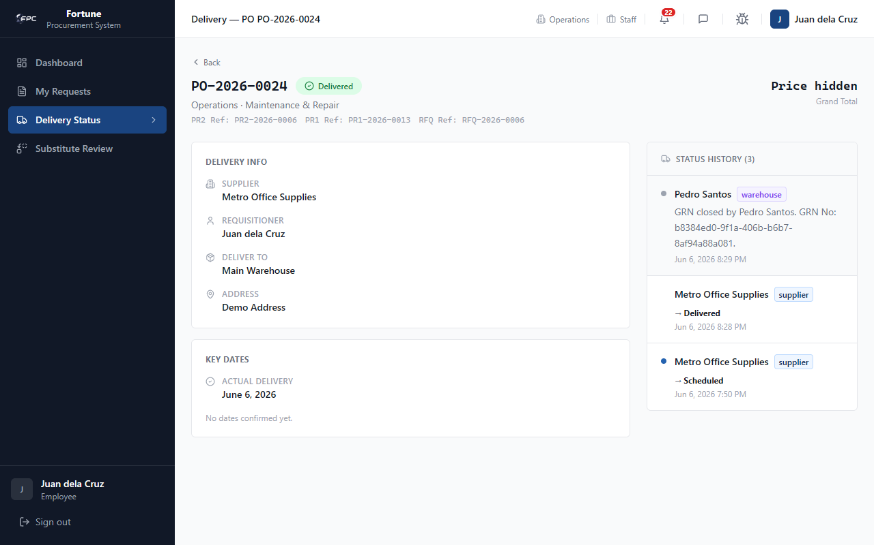
Caption: Delivery Details - Displays the read-only shipment details for requisitioners. It maps out supplier information, destination addresses, actual delivery dates, and a chronological history timeline log tracking every status transit step and coordinator note.

Expected Outcome
Detailed shipment metrics are displayed in a secure, read-only view.

1.9 Messages

Module Purpose
Enables chat communication with procurement staff and other team members.

Module UI Map
Component Type | Element Label / Value | Description / Action
Sidebar | Conversation List | Shows active 1-to-1 chats with preview text
Search Input | User Search | Find colleagues to start a new conversation
Thread Panel | Message Thread | Type and send messages; view read status
Upload | Attachment | Attach files (max 10 MB, up to 5 per message)

Step-by-Step Workflows
1. Click the messages icon in the top header. 2. Use User Search to find a colleague. 3. Select a conversation or start a new one. 4. Type your message and press Send.
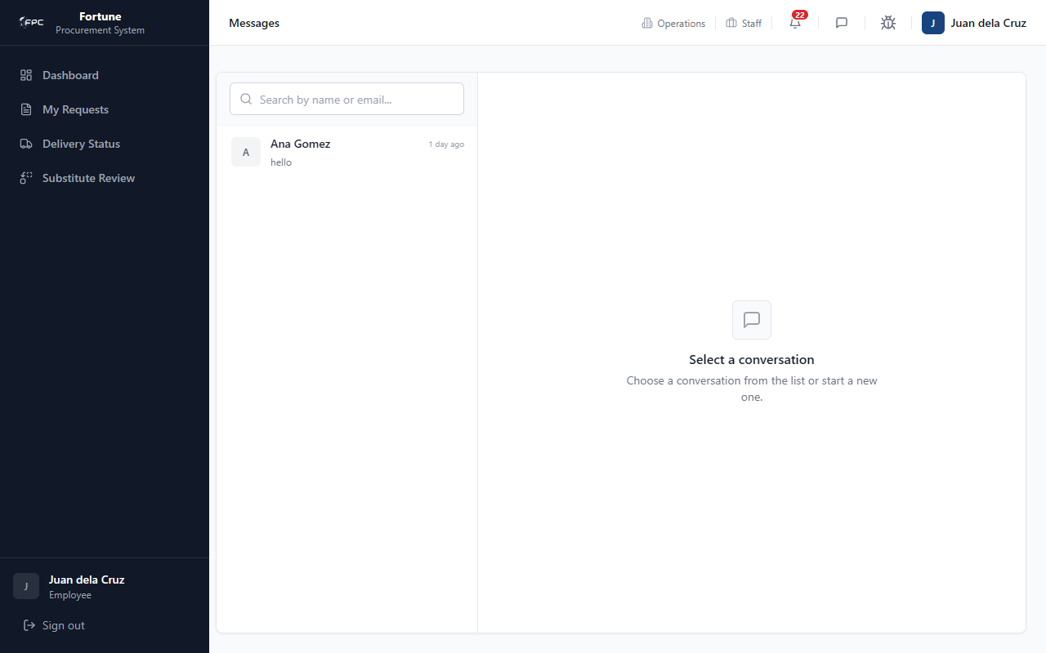
Caption: Message Center - The internal chat interface showing a left sidebar for active 1-to-1 conversations (with user search input) and a main chat screen where users can converse, view online indicators, and exchange attachments with procurement staff.

Expected Outcome
Messages are delivered to the selected recipient and appear in both users' conversation lists.

1.10 Profile Settings

Module Purpose
Allows users to update their display name and change their account password.

Module UI Map
Component Type | Element Label / Value | Description / Action
Input | Full Name | Editable display name
Read-only | Role / Department / Position | Assigned account metadata
Input | Current Password | Required to change password
Input | New Password / Confirm | Set a new password
Button | Save Name / Change Password | Submit profile updates

Step-by-Step Workflows
1. Click your avatar in the top header. 2. Update your name and click Save Name, or enter current and new passwords and click Change Password.
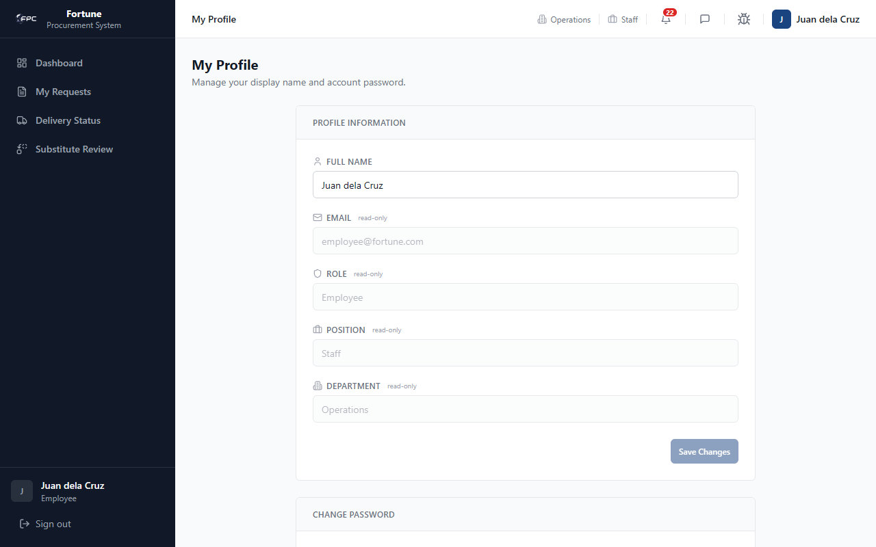
Caption: User Profile Settings - The account management interface showing editable name inputs and read-only role metadata (Employee, Operations department). The right side includes fields to update current and new passwords with visibility toggle icons.

Expected Outcome
Profile name or password updates are saved; you remain logged in with updated credentials.

1.11 Bug Reporting Tool

Module Purpose
Enables reporting interface bugs or errors to system administrators.

Module UI Map
Component Type | Element Label / Value | Description / Action
Input | Title / URL / Severity | Required bug summary fields
Textarea | Description / Expected Behavior | Detailed issue explanation
Button | Submit Bug Report | Sends report to admin notification email

Step-by-Step Workflows
Workflow 1: Validation
1. Click Submit without filling fields. Browser highlights required inputs.
Workflow 2: Submit a Bug
1. Fill title, URL, severity, description, and expected behavior. Click Submit Bug Report.
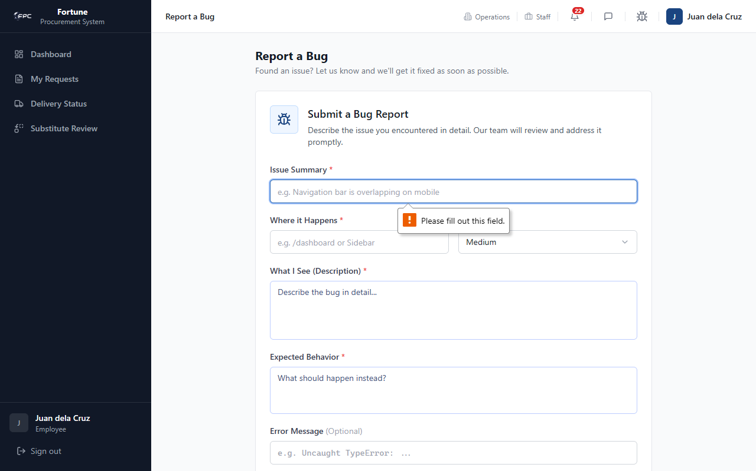
Caption: Bug Reporting Tool (Validation State) - The bug ticket submission form highlighting empty field validation indicators when a user clicks submit without filling in the issue summary, URL location, severity, description, or expected behavior.
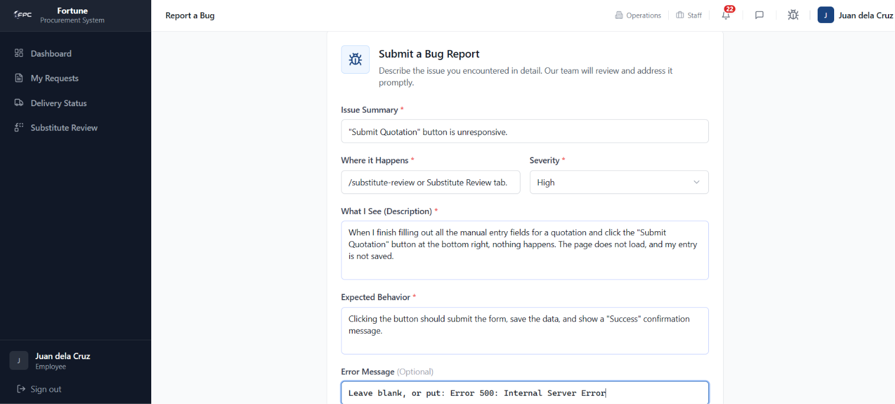
Caption: Bug Reporting Tool (Populated State) - Shows the form filled with bug details, including a detailed error log from the browser console, ready for transmission to the system administrators.

Expected Outcome
Bug report is saved and an email alert is sent to the configured admin address.

Role: Warehouse
The Warehouse role handles PR1 stock-on-hand (SOH) validation and processes incoming supplier deliveries by completing Goods Receipt Notes (GRN). The primary account is warehouse@fortune.com (Warehouse Staff position).

2.1 Dashboard

Module Purpose
Provides warehouse personnel with an overview of incoming items that need SOH validation and open goods receipt logs.

Module UI Map
Component Type | Element Label / Value | Description / Action
KPI Card | PENDING VALIDATION | Count of PR1 requests needing SOH checks
KPI Card | VALIDATED TODAY | Requisitions checked during the current shift
KPI Card | OPEN GRN | Active goods receipts awaiting resolution
KPI Card | GRN COMPLETED | Total completed receipts
Panel List | Pending Validation Queue Preview | Quick view of PR1s needing check
Panel List | Open Goods Receipts Preview | Quick view of outstanding GRNs
Link | View all | Redirects to full queue pages

Step-by-Step Workflows
1. Open the dashboard. Review pending validation and open GRN counts. 2. Click View all in the Pending Validation Queue to open the warehouse queue.
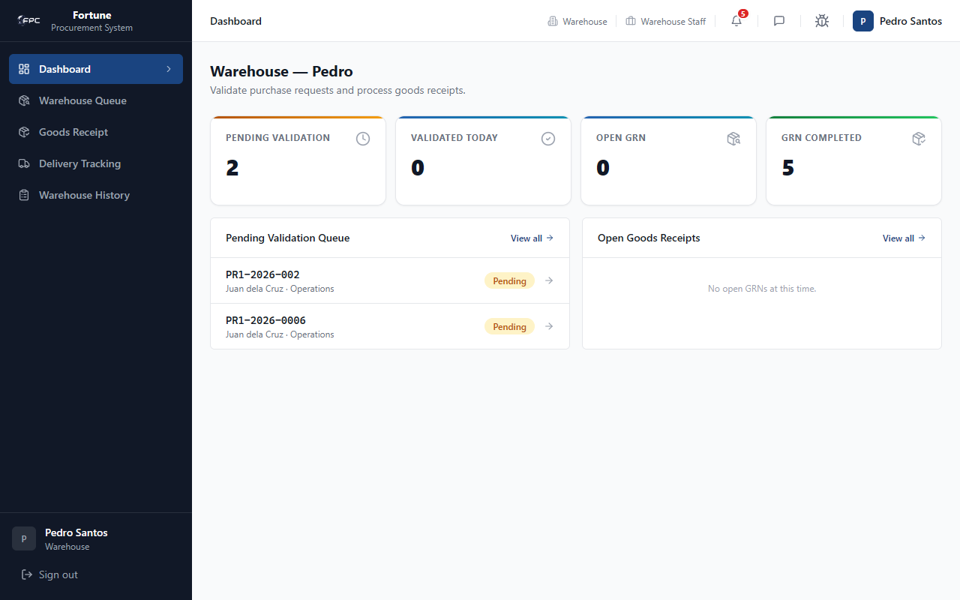
Caption: Warehouse Dashboard - Landing page showing KPI count cards for SOH Pending Validation, Validated Today, Open GRNs, and Completed GRNs. It also features quick work queue panels to preview pending validation PR1 requests and open goods receipts.

Expected Outcome
Dashboard metrics and queue previews load; View all navigates to the correct module.

2.2 Warehouse Queue (/warehouse)

Module Purpose
Lists PR1 requisitions awaiting warehouse stock verification and provides access to the SOH validation workspace.

Module UI Map
Component Type | Element Label / Value | Description / Action
Search Box | SEARCH | Filter by PR1 number, requestor, department, or purpose
Dropdown Filter | PRIORITY | Filter table rows by priority
Button | Apply / Clear All | Execute or reset filters
Table | Queue Table | Columns: PR1 NO., REQUESTOR, DEPARTMENT, PURPOSE, PRIORITY, DATE REQUIRED, SUBMITTED
Link | Validate | Opens SOH verification page for the PR1

Step-by-Step Workflows
1. Navigate to Warehouse Queue. 2. Search or filter for a PR1. 3. Click Validate on the target row.
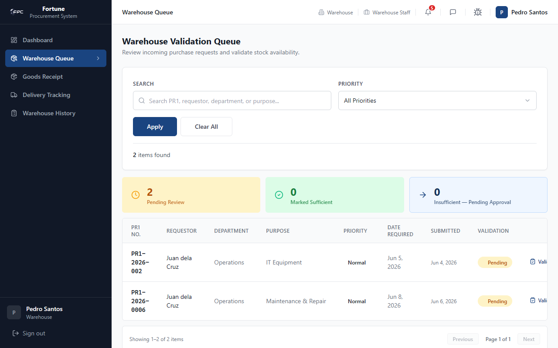
Caption: Warehouse Queue - Lists all PR1 requests awaiting stock validation. Staff can search and filter by PR1 number, requisitioner, or department, and click the 'Validate' action link to inspect physical inventory levels.

Expected Outcome
Filtered queue displays matching PR1s; Validate opens the SOH verification detail page.

2.3 SOH Verification Details (/warehouse/{pr1Id})

Module Purpose
Enables warehouse staff to verify physical stock on hand (SOH) per line item and route items to internal fulfillment or procurement.

Module UI Map
Component Type | Element Label / Value | Description / Action
Header Panel | PR1 Details Block | Displays requestor, department, and required date
Number Input | VERIFIED SOH | Enter physical stock count per line
Select | Availability / Route | Internal, Procurement, or Partial split
Number Input | Internal / Procurement Qty | Split quantities for partial routing
Text Input | NOTES | Optional validation notes
Label | OUTCOME | Shows Sufficient or Insufficient per line
Button | Save Progress | Saves draft validation
Button | Submit Validation | Finalizes validation and advances PR1 workflow

Step-by-Step Workflows
Workflow 1: Validate Stock
1. Enter verified SOH for each line item. 2. Set route (Internal / Procurement / Partial). 3. Add notes if needed. 4. Click Submit Validation.
Outcomes:
- All items internal → PR1 Resolved Internally (employee notified).
- Any item needs procurement → PR1 Pending Approval (Supervisor notified).
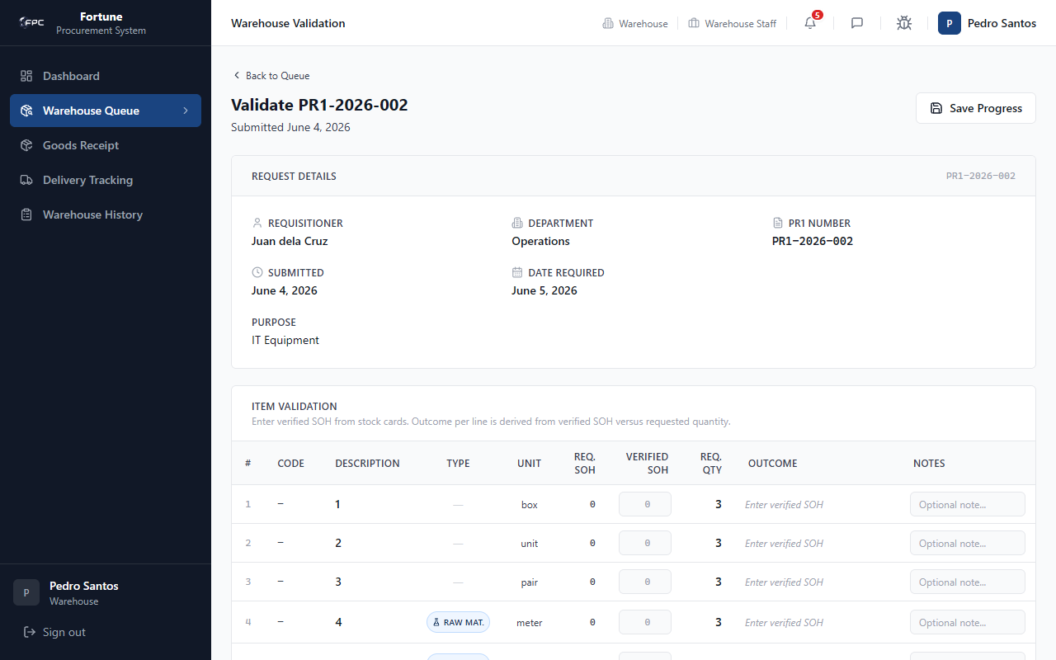
Caption: SOH Verification details - The workspace for warehouse validation. It displays requested quantities and allows staff to enter verified Stock-on-Hand (SOH) counts. The system dynamically calculates and shows the routing outcome (Sufficient/Insufficient) for each line item.

Status Glossary
Status / Decision | Description
Sufficient | All items can be fulfilled from warehouse stock
Insufficient | One or more items require procurement
Internal route | Item fulfilled from stock — no RFQ needed
Procurement route | Item routed to canvassing / RFQ path

Expected Outcome
Validation is recorded; PR1 status updates and notifications are sent to the requisitioner or approvers.

2.4 Goods Receipt (/grn)

Module Purpose
Enables recording and closing Goods Receipt Notes (GRN) against delivered purchase orders.

Module UI Map
Component Type | Element Label / Value | Description / Action
Tabs | All GRNs, Open, Closed | Filter GRN list by status
Search Box | SEARCH | Filter by GRN, PO, supplier, department, or warehouse
Table | GRN Table | Columns: GRN Number, PO Reference, Status, Supplier, Received By, Date
Detail Fields | Qty Ordered / Received / Rejected | Per-line receipt quantities
Button | Save Progress / Close GRN | Save draft or finalize receipt
Button | Print GRN | Opens printable GRN document

Step-by-Step Workflows
Workflow 1: Open GRN List
1. Navigate to Goods Receipt. 2. Use tabs or search to find a GRN.
Workflow 2: Close a GRN
1. Open an open GRN. 2. Enter received and rejected quantities per line. 3. Fill DR number, DR date, and remarks. 4. Click Close GRN.
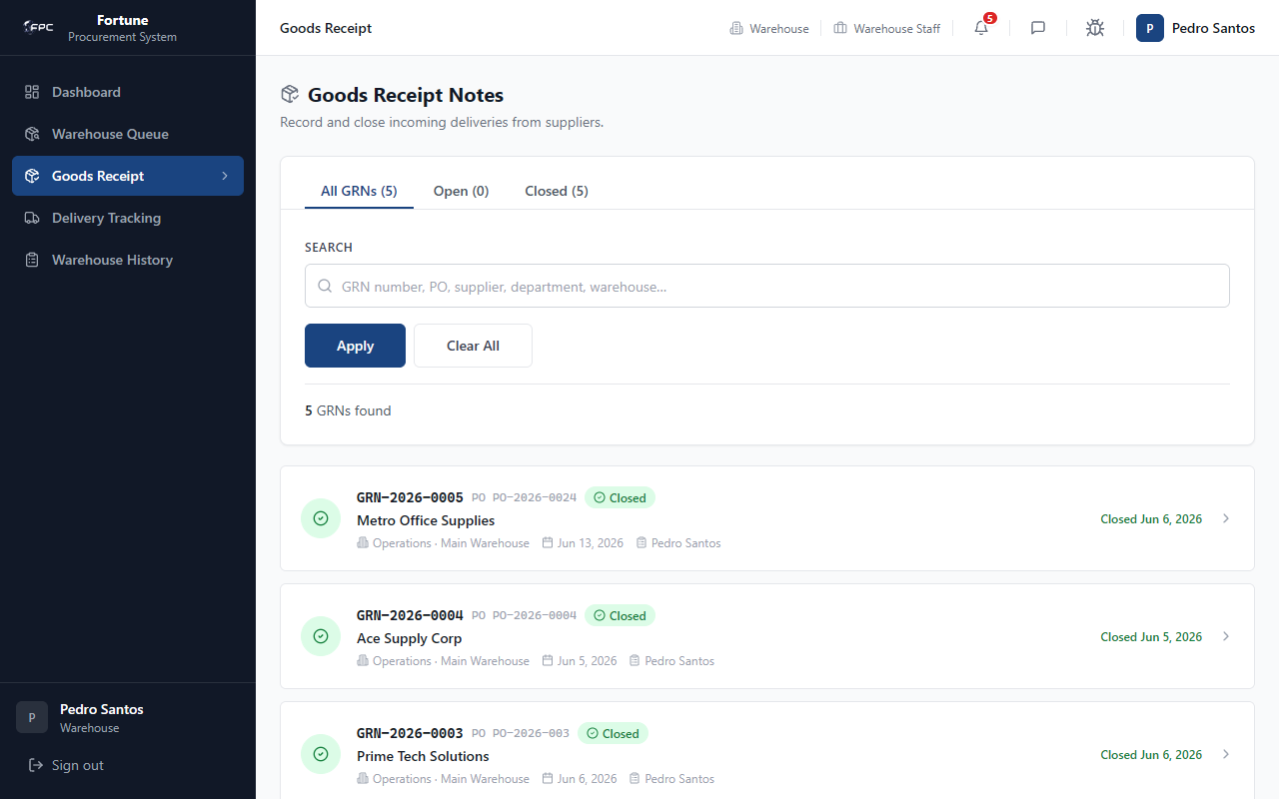
Caption: Goods Receipt List - A tabbed queue (All, Open, Closed) showing all Goods Receipt Notes. Warehouse staff can search for specific POs, suppliers, or GRN numbers, and view metadata columns such as Received By and Closed Date.
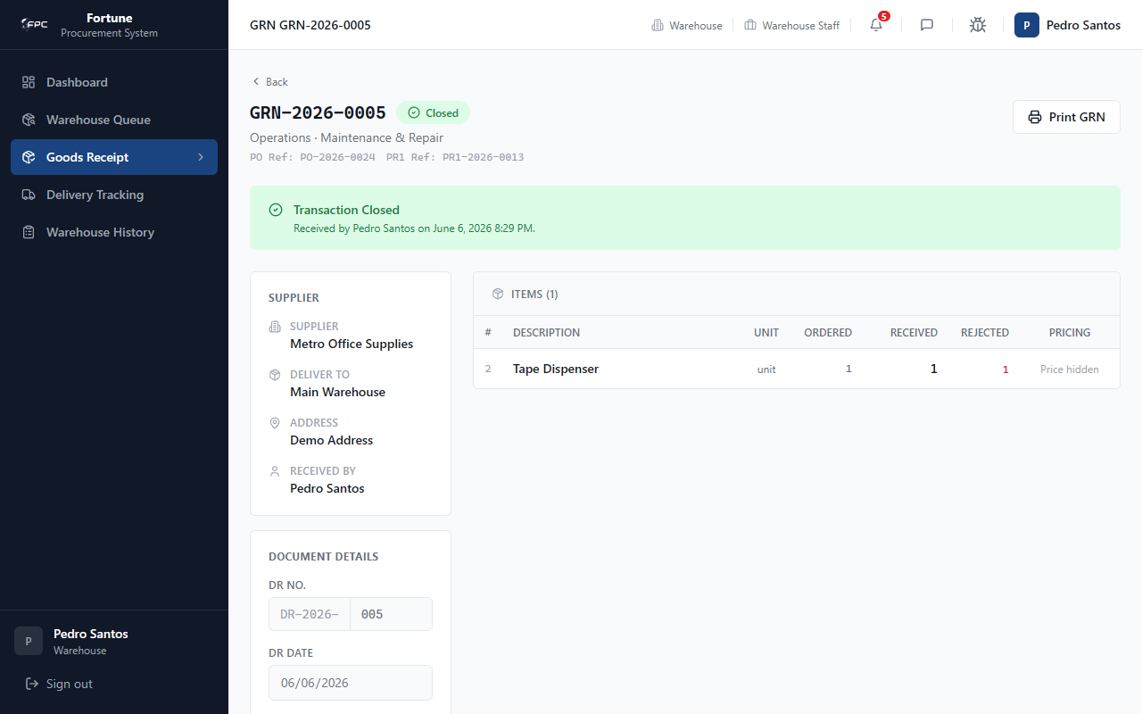
Caption: GRN Detail View - Displays a finalized receipt. It includes supplier details, Delivery Receipt (DR) number, and a table showing the ordered, received, and rejected quantities for each item, along with the closed status banner.

Status Glossary
Status Badge | Description
Open | GRN created; receipt in progress
Closed | Receipt finalized; delivery marked delivered

Expected Outcome
GRN closes successfully; requisitioner is notified and request lifecycle shows GRN Closed when all POs are complete.

2.5 Delivery Tracking (/delivery)

Module Purpose
Enables monitoring of supplier shipments from PO acknowledgment through warehouse delivery.

Module UI Map
Component Type | Element Label / Value | Description / Action
Tabs | All, Pending, Scheduled, In Transit, Delayed, Delivered | Filter by delivery status
Search Box | SEARCH | Filter by PO number, supplier, or warehouse
Table | Delivery List | PO number, status badge, supplier, dates
Panel | Status History | Chronological log of status changes with actor and timestamp
Link | View GRN | Opens related goods receipt

Step-by-Step Workflows
1. Navigate to Delivery Tracking. 2. Filter by status tab or search by PO number. 3. Click a delivery row to view status history and linked GRN.
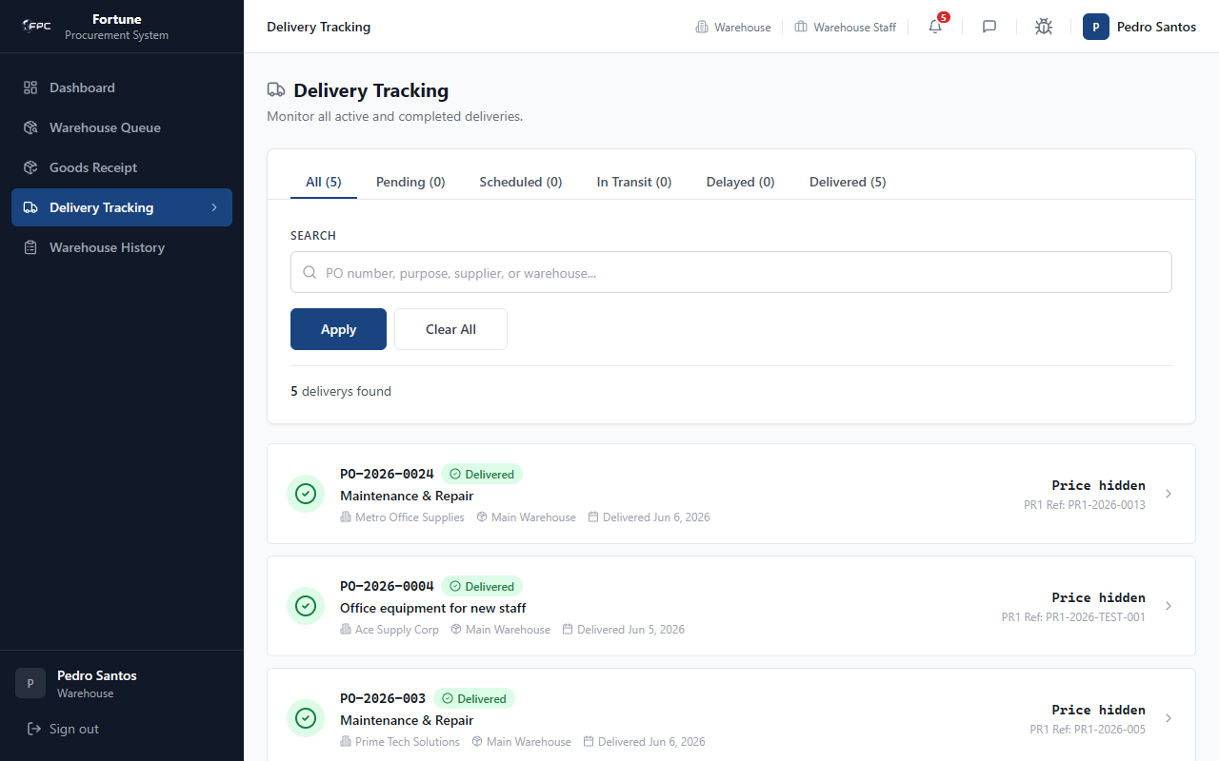
Caption: Warehouse Delivery List - A read-only list showing active and historic shipments. It allows warehouse personnel to filter and monitor delivery dates and supplier dispatch statuses.
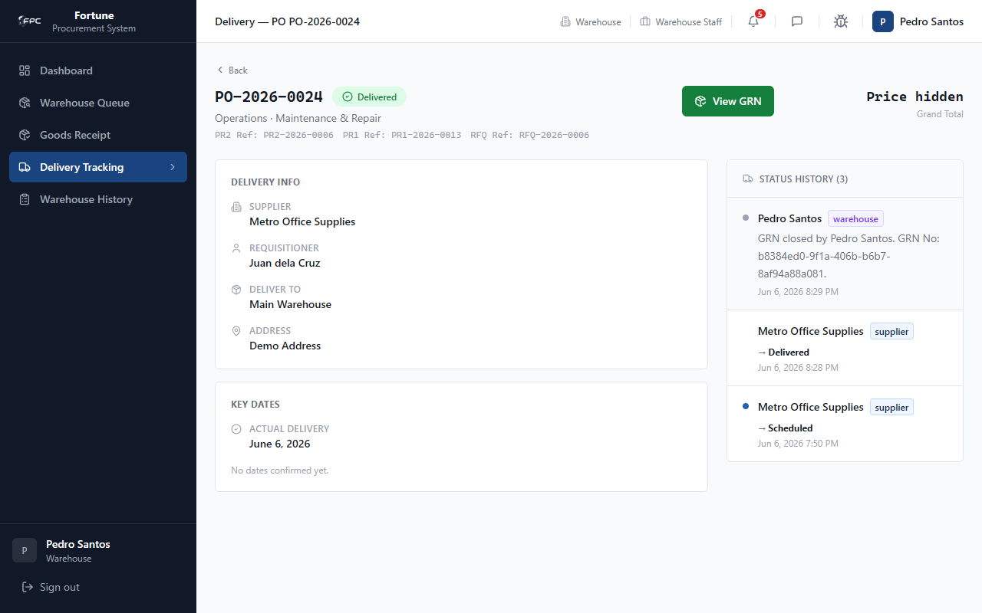
Caption: Delivery Details (Warehouse) - Displays shipping detail parameters and the status history logs, giving warehouse operators full visibility into supplier dispatch activities and estimated arrival dates.

Status Glossary
Status Badge | Description
Pending | Delivery record created; not yet scheduled
Scheduled | Shipment date confirmed
In Transit | Goods en route; DR uploaded by supplier
Delivered | Received at warehouse

Expected Outcome
Delivery timeline is visible; warehouse can proceed to GRN when goods arrive.

2.6 Warehouse History (/warehouse/history)

Module Purpose
Provides a searchable log of all completed warehouse validations.

Module UI Map
Component Type | Element Label / Value | Description / Action
Search Box | SEARCH | Filter by PR1, requestor, or department
Table | History Table | Columns: PR1 No., Requestor, Department, Validator, Date, Decision

Step-by-Step Workflows
1. Navigate to Warehouse History. 2. Search or browse past validations. 3. Review decision (Sufficient / Insufficient) and validator name.
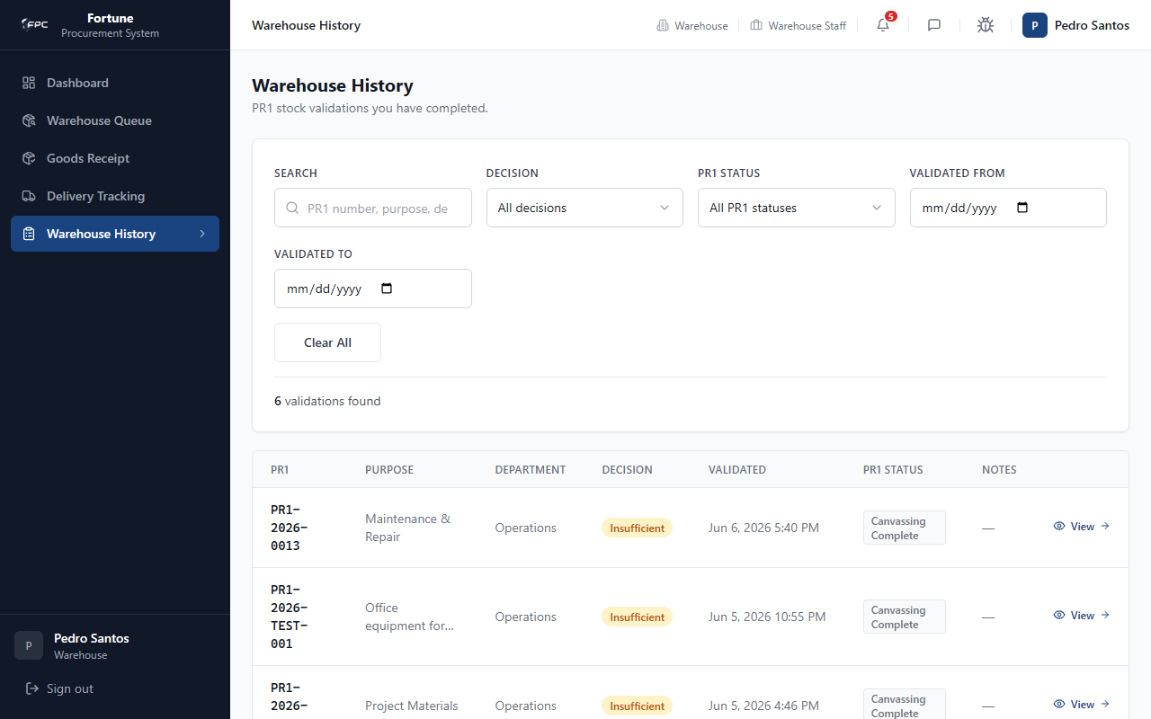
Caption: Warehouse History Log - A table recording historic validations processed by the warehouse. It details the PR1 number, requisitioner, department, validator, decision date, and overall validation outcome.

Expected Outcome
Historical validation records display with correct decision and timestamp.

2.7 Utilities

Module Purpose
Shared tools for messaging, profile management, and bug reporting.

Step-by-Step Workflows
Messages: Click header chat icon → search user → send message.
Profile: Click avatar → update name or password.
Bug Track: Click bug icon → fill form → submit.
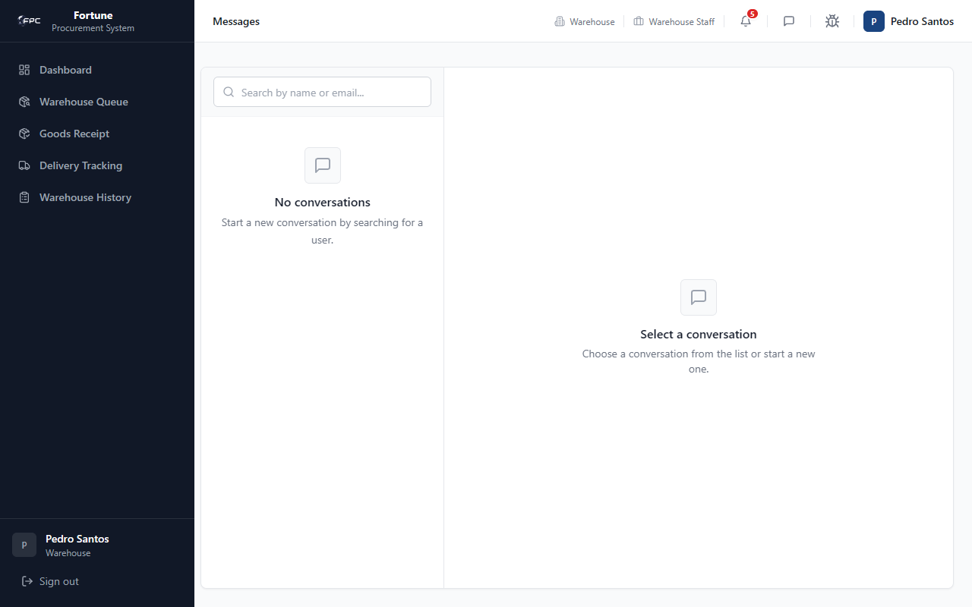
Caption: Warehouse Messages - The internal chat window showing the empty state when no active chat conversation is selected in the sidebar.
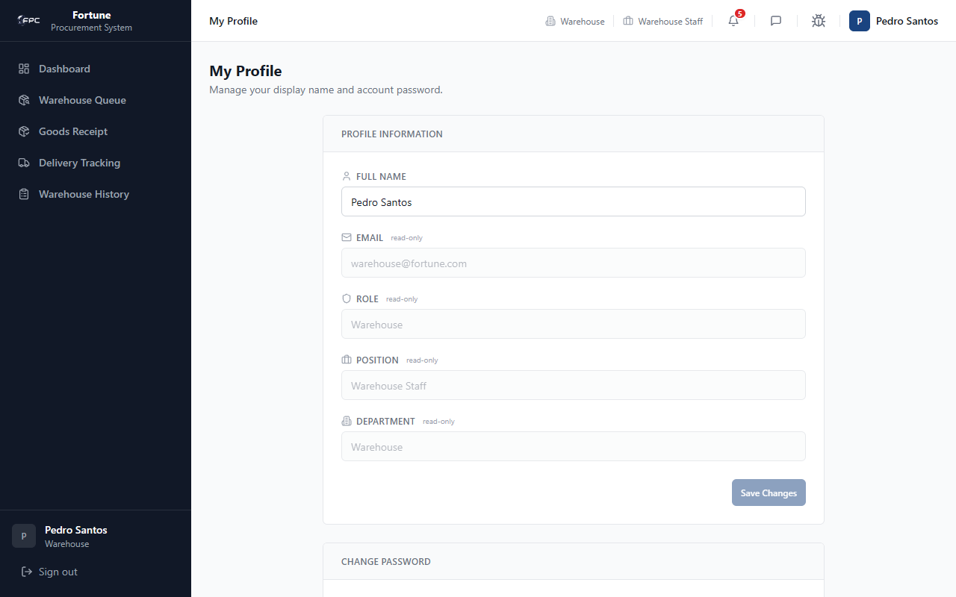
Caption: Warehouse Profile - Account details displaying the logged-in warehouse operator's full name, read-only role (warehouse), and position (Warehouse Staff).
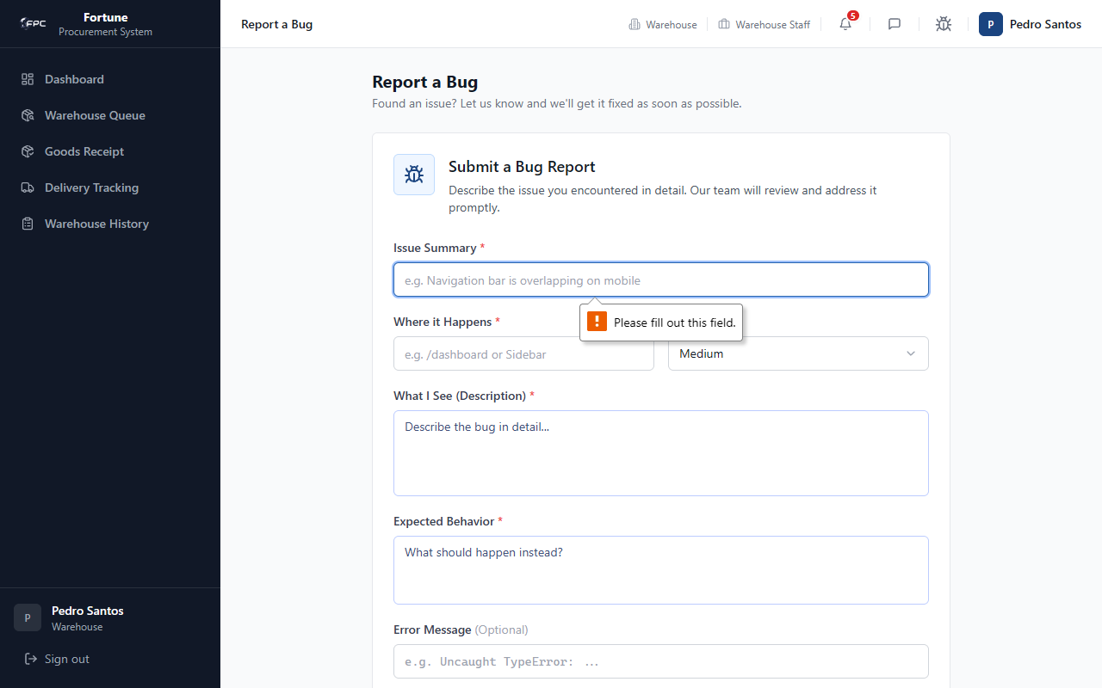
Caption: Warehouse Bug Report (Empty State) - Displays validation alerts when the operator attempts to submit a bug ticket with missing information.
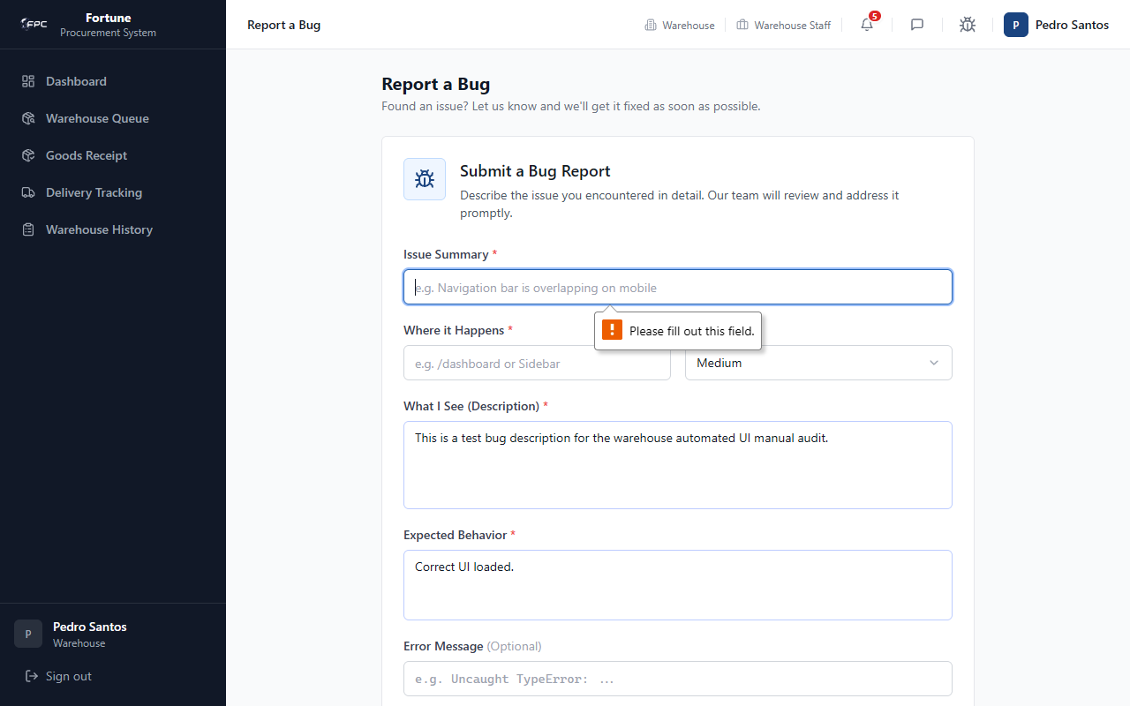
Caption: Warehouse Bug Report (Populated State) - A completed bug report filled with warehouse interface issues, ready for submission to developers.

Expected Outcome
Utility actions complete without affecting procurement workflow documents.

Role: Procurement
The Procurement role acts as the core administrator for purchasing. Responsibilities include creating RFQs, canvassing supplier quotations, awarding winners, generating and routing PR2 memos, issuing Purchase Orders, approving supplier accreditations, and verifying catalog products. The primary account is the procurement officer account (procurement@fortune.com, Procurement Staff position).

3.1 Dashboard

Module Purpose
Provides an operational overview of accreditation queue, TSQA backlog, RFQ workload, and purchase order status.

Module UI Map
Component Type | Element Label / Value | Description / Action
KPI Card | Accreditation Queue | Supplier applications awaiting review
KPI Card | Pending TSQA | Products routed to scientific evaluation
KPI Card | Awaiting RFQ | Approved PR1s without RFQ issued
KPI Card | Open RFQs | Active quotation rounds
KPI Card | High Priority | PR1s flagged high priority
KPI Card | Purchase Orders | PO count visible to user
Panel | Canvassing Queue / Open RFQs | Quick links to /rfq

Step-by-Step Workflows
1. Review KPI cards to plan daily work. 2. Click View all on Canvassing Queue to process PR1s awaiting RFQ. 3. Click View all on Open RFQs to manage active bids.
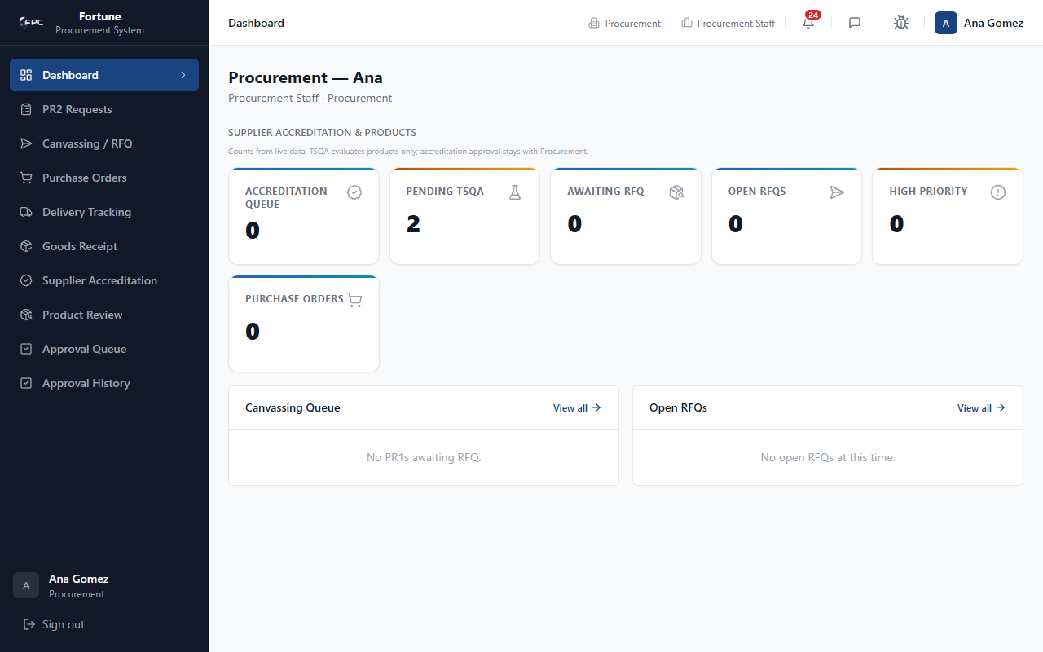
Caption: Procurement Dashboard - The operational landing page displaying stat cards for the Accreditation Queue, Pending TSQA, Awaiting RFQ, Open RFQs, High Priority, and Purchase Orders, with quick links to canvassing and RFQ lists.

Expected Outcome
Dashboard counts reflect live data; quick links navigate to the correct queues.

3.2 PR2 Requests (/pr2)

Module Purpose
Lists Purchase Request 2 (PR2) documents generated from closed RFQs and tracks them through two-phase approval before PO generation.

Module UI Map
Component Type | Element Label / Value | Description / Action
Search | PR2 number or purpose... | Free-text filter
Dropdown | STATUS | Draft, Pending Phase 1/2, Phase 2 Approved, Cancelled
Table | PR2 List | PR2 number, status, purpose, department, date required
Button | Submit for Approval | On detail page when status = Draft
Panel | Approval Signatures | Shows Phase 1 and Phase 2 workflow steps

Step-by-Step Workflows
Workflow 1: Review PR2 List
1. Navigate to PR2 Requests. 2. Filter by status or search.
Workflow 2: Submit PR2 for Approval
1. Open a Draft PR2. 2. Review items and pricing. 3. Click Submit for Approval. 4. Phase 1 approval starts (Procurement Staff → Procurement Manager → Director).
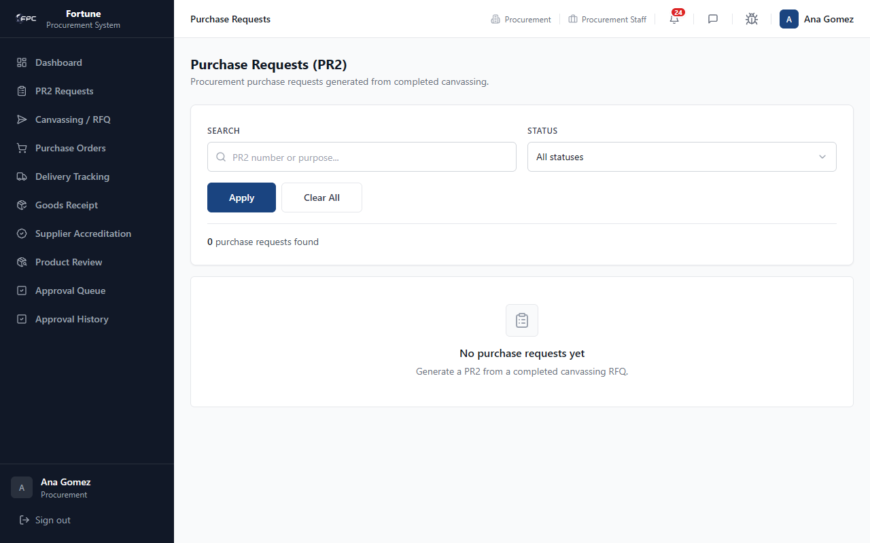
Caption: PR2 Requests List - Lists PR2 memos with phase, priority, purpose, and requesting department. Procurement staff submit draft PR2s for Phase 1 approval.

Status Glossary
Status Badge | Description
Draft | PR2 generated; not yet submitted
Pending Phase 1 Approval | Phase 1 workflow active
Pending Phase 2 Approval | Phase 2 workflow active (auto-starts after Phase 1)
Phase 2 Approved | Ready for PO generation

Expected Outcome
Submitted PR2 enters Phase 1 approval; approvers receive notifications.

3.3 Canvassing / RFQ (/rfq)

Module Purpose
Manages Request for Quotation (RFQ) batches: invite suppliers, collect quotes, award winners, and generate PR2.

Module UI Map
Component Type | Element Label / Value | Description / Action
Section | Awaiting RFQ | PR1s with for_canvassing status and no RFQ
Section | RFQ Issued | PR1s with active or closed RFQ batches
Button | Create RFQ / Open RFQ | Create or open RFQ detail
Button | Assign Suppliers | Invite accredited suppliers
Button | Issue RFQ | Opens RFQ to suppliers (notifications + email)
Table | Quotation Comparison | Side-by-side supplier quotes per line item
Button | Award / Save Selection | Select winning supplier per item
Button | Close RFQ / Generate PR2 | Finalize canvassing and create PR2

Step-by-Step Workflows
Workflow 1: Issue RFQ
1. Find PR1 in Awaiting RFQ. 2. Create RFQ → Assign Suppliers → Issue RFQ.
Workflow 2: Award and Close
1. Review supplier quotes on RFQ detail. 2. Ensure substitutes are accepted by employee if alternatives quoted. 3. Award each line item. 4. Close RFQ → Generate PR2.
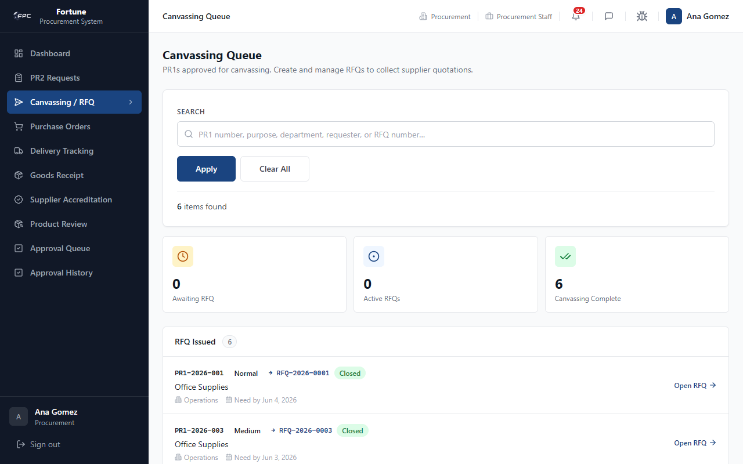
Caption: Canvassing Queue - Lists PR1s that have passed warehouse validation and are ready for Request for Quotation (RFQ) processing. It displays RFQ numbers, priority badges, and the status of current quotation batches.
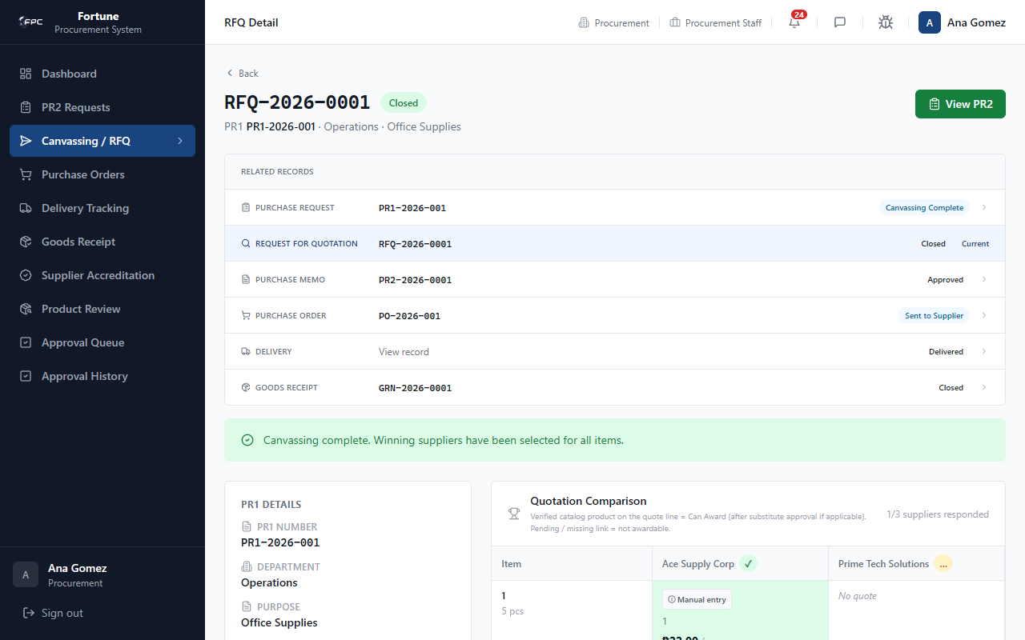
Caption: RFQ Bid Comparison - The canvassing workspace. It compares quotations submitted by suppliers side-by-side per line item. Procurement officers can view item details, review supplier alternatives, and trigger the Award action for winning quotes.

Status Glossary
Status Badge | Description
Draft | RFQ created but not issued
Open | Suppliers can submit quotes
Closed | Winners selected; PR2 can be generated

Expected Outcome
Closed RFQ sets PR1 to canvassing_complete; PR2 is generated for approval.

3.4 Purchase Orders (/po)

Module Purpose
Manages purchase order creation from approved PR2s and tracks PO approval through to supplier acknowledgment.

Module UI Map
Component Type | Element Label / Value | Description / Action
Button | + Generate PO | Opens /po/new wizard
Stat Cards | Total / Draft / For Approval / Approved | PO workload summary
Table | PO List | PO number, status, supplier, department, requisitioner
Form | Generate PO | Select PR2+supplier group; enter PO number and terms
Button | Submit for Approval | Starts PO approval workflow on detail page

Step-by-Step Workflows
Workflow 1: Generate PO
1. Click + Generate PO. 2. Select approved PR2 and supplier. 3. Enter PO number and delivery terms. 4. Click Create PO.
Workflow 2: Submit for Approval
1. Open draft PO. 2. Review items and totals. 3. Click Submit for Approval (Buyer → Procurement Manager → Finance Director).
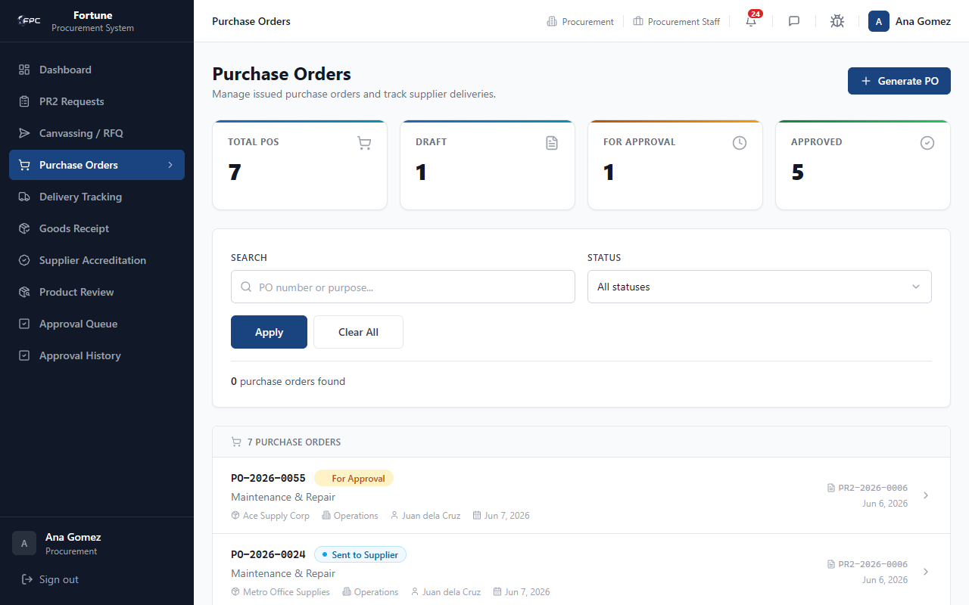
Caption: Purchase Orders List - A grid displaying issued POs, their status badges (Draft, For Approval, Sent to Supplier, Delivered), grand totals, suppliers, requisitioners, and date requirements.
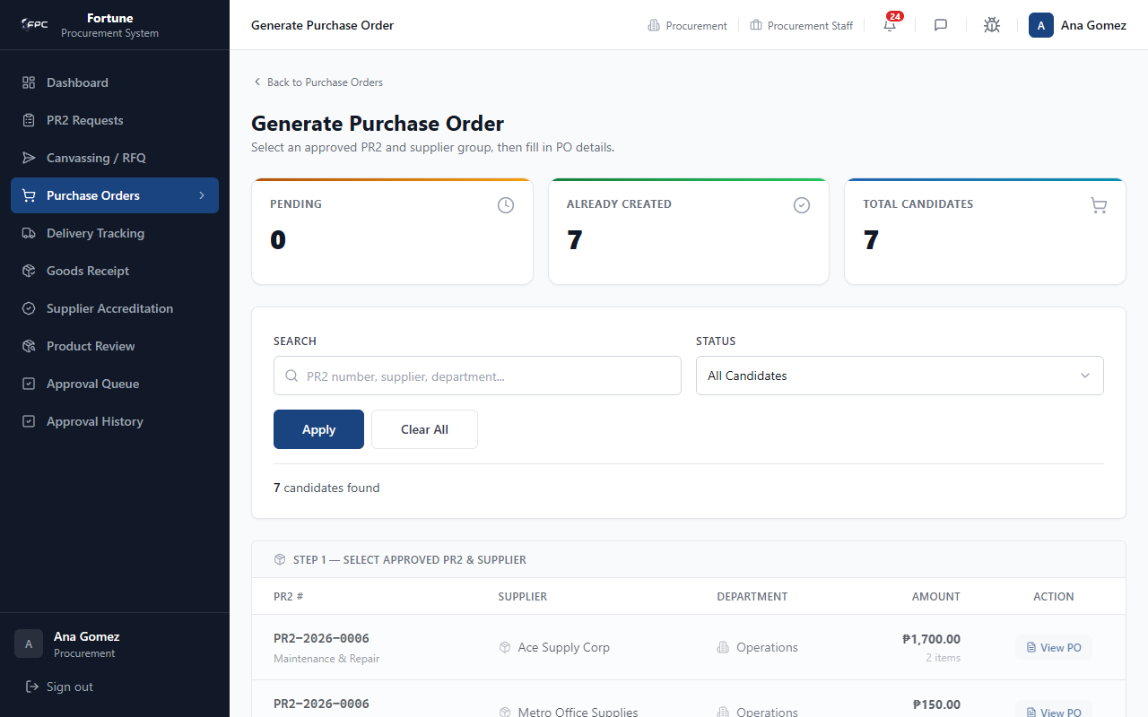
Caption: Generate Purchase Order - The PO creation form. It is pre-filled with the selected supplier details, billing terms, and line items from the approved PR2. Procurement officers can enter custom PO numbers, delivery terms, and remarks.

Status Glossary
Status Badge | Description
Draft | PO created; editable
For Approval | In internal approval workflow
Approved | Finance Director approved; awaiting supplier ack
Sent | Supplier acknowledged; delivery created

Expected Outcome
Approved PO is sent to supplier; acknowledgment creates delivery record.

3.5 Delivery Tracking (/delivery)

Module Purpose
Monitors shipment status from supplier dispatch through warehouse receipt (read-only for procurement).

Module UI Map
Component Type | Element Label / Value | Description / Action
Tabs | All, Pending, Scheduled, In Transit, Delayed, Delivered | Status filters
Search | PO number, supplier... | Free-text filter
Table | Delivery List | PO, status, supplier, dates, amount
Panel | Status History | Actor, action, timestamp per transition

Step-by-Step Workflows
1. Navigate to Delivery Tracking. 2. Filter by status or search PO. 3. Open delivery detail to review status history. 4. Procurement may mark Delivered to trigger GRN.
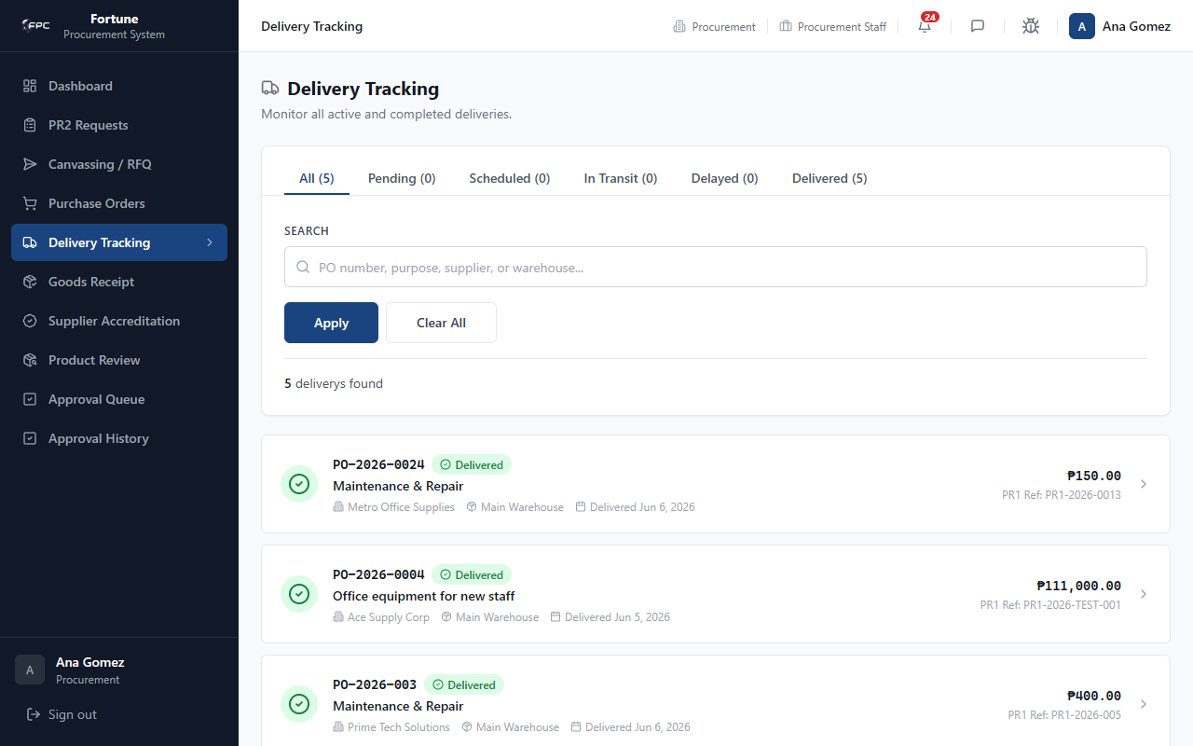
Caption: Procurement Delivery List - Lists all dispatches. It displays PO numbers, estimated deliveries, transit status badges, and total amounts, filtered by status tabs.
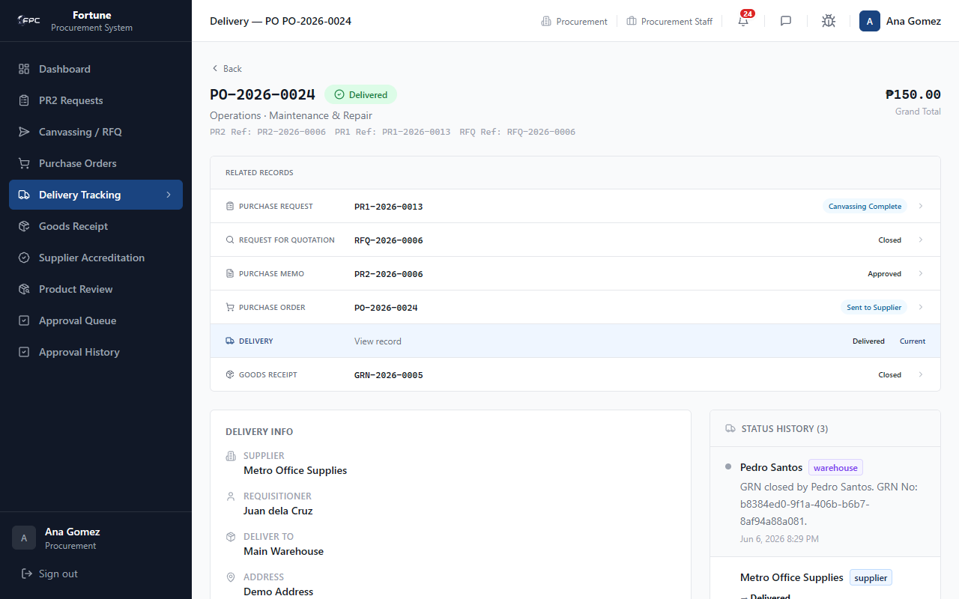
Caption: Delivery Details (Procurement) - Displays destination parameters and the complete transit status log (e.g. Scheduled -> In Transit -> Delivered) detailing the actor, action, and timestamp for each milestone.

Expected Outcome
Delivery status visible end-to-end; warehouse notified when ready for GRN.

3.6 Goods Receipt (/grn)

Module Purpose
Provides read access to GRN records for procurement oversight of completed receipts.

Module UI Map
Component Type | Element Label / Value | Description / Action
Tabs | All, Open, Closed | Filter GRN list
Table | GRN List | GRN number, PO ref, status, supplier, received by
Detail | Items Table | Ordered, received, rejected quantities and values

Step-by-Step Workflows
1. Navigate to Goods Receipt. 2. Filter by Open or Closed. 3. Open GRN detail to verify received vs rejected quantities.
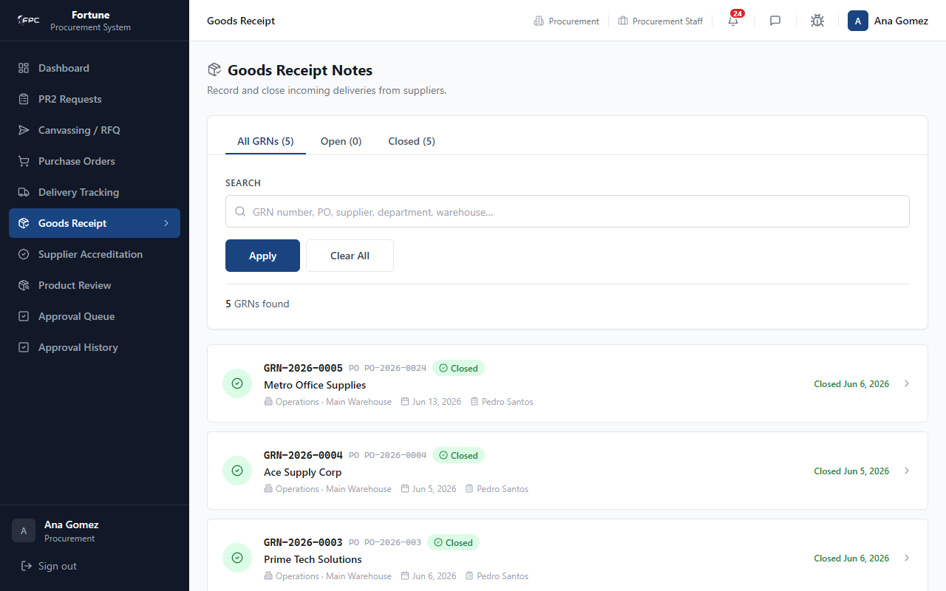
Caption: Goods Receipt Log (Procurement) - Lists all GRN records showing transaction states (Open, Closed), PO references, suppliers, and received dates.
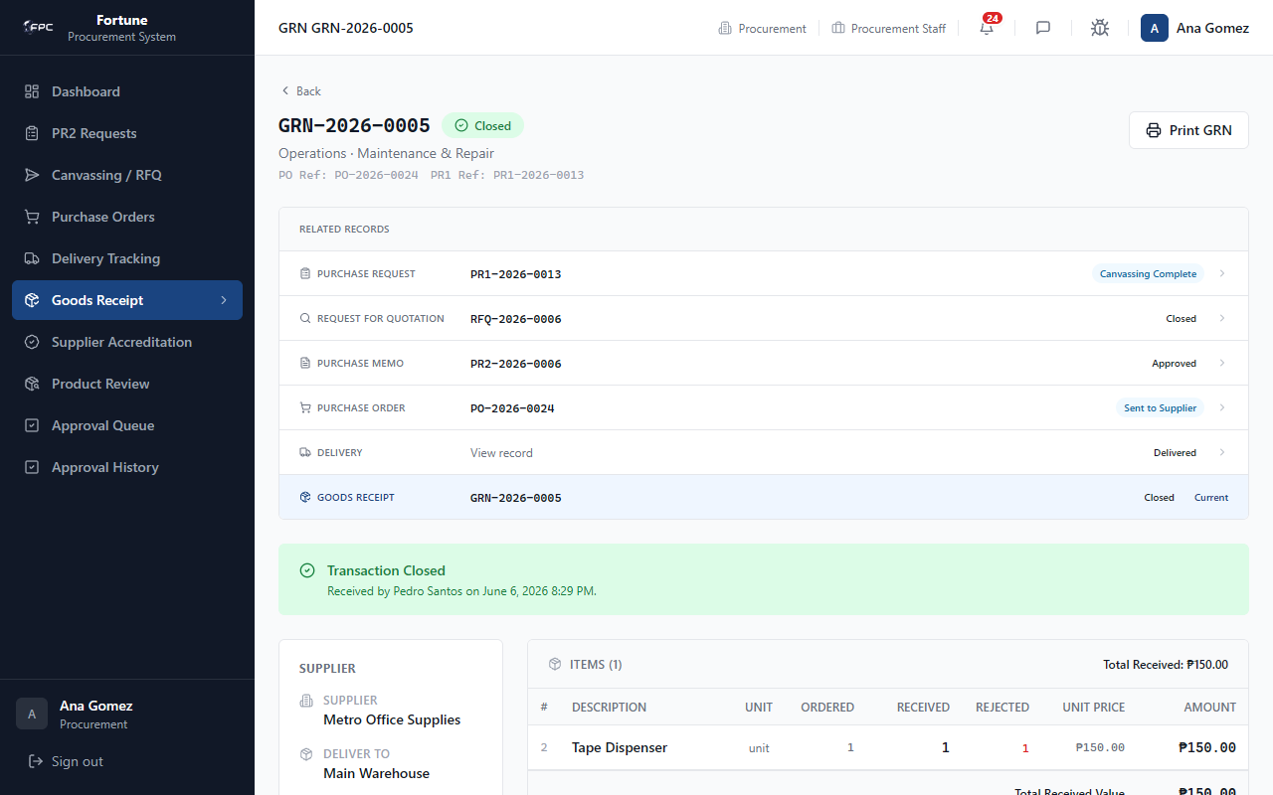
Caption: GRN Detail View (Procurement) - Displays the finalized goods receipt showing actual received versus rejected quantities and total received commercial values.

Expected Outcome
GRN details confirm receipt completion for procurement tracking.

3.7 Supplier Accreditation (/accreditation)

Module Purpose
Reviews supplier company accreditation applications and compliance documents before suppliers can participate in RFQs.

Module UI Map
Component Type | Element Label / Value | Description / Action
Tabs | Pending, Approved, Rejected, All | Filter applications
Table | Application List | Supplier name, email, status, submitted date
Button | Mark Under Review | Begin active review
Button | Approve / Reject | Final accreditation decision
Button | Request Missing Documents | Return to supplier for resubmission

Step-by-Step Workflows
1. Open Supplier Accreditation. 2. Click Pending tab. 3. Open application and review documents. 4. Approve (supplier can join RFQs) or Reject with remarks.
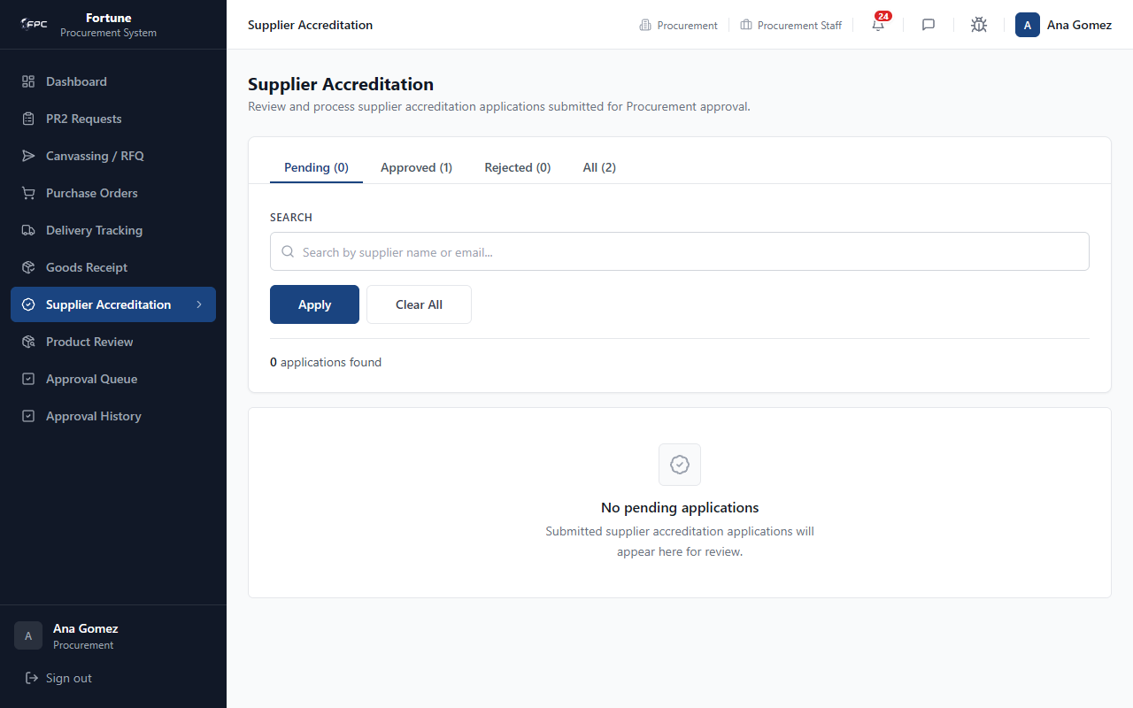
Caption: Supplier Accreditation Queue - A dashboard showing supplier accreditation applications. It lists supplier company names, emails, and submission dates, allowing procurement officers to click and review legal files.

Status Glossary
Status Badge | Description
Submitted | Awaiting procurement review
Under Review | Actively being evaluated
Approved | Supplier accredited for RFQs
Rejected | Application denied

Expected Outcome
Approved suppliers become eligible for RFQ invitation.

3.8 Product Review (/accreditation/products)

Module Purpose
Reviews supplier catalog products and decides whether they can be used in RFQ awards — verify directly, route to TSQA, or reject.

Module UI Map
Component Type | Element Label / Value | Description / Action
Tabs | Pending, Under TSQA, Verified, Rejected, All | Filter product queue
Table | Product List | Product name, supplier, code, status, submitted date
Link | Review | Opens product detail page
Button | Mark Under Review | Begin evaluation
Button | Verify Directly | Approve without TSQA — product awardable on RFQs
Button | Reject | Deny product; requires remarks
Button | Create RSE for TSQA | Route to scientific evaluation

Step-by-Step Workflows
Workflow 1: Verify Directly
1. Open Pending tab → click Review. 2. Read specifications and documents. 3. Click Verify Directly.
Workflow 2: Route to TSQA
1. From product detail, click Create RSE for TSQA. 2. Assign reviewer if prompted.
Workflow 3: Reject
1. Click Reject → enter remarks → confirm.
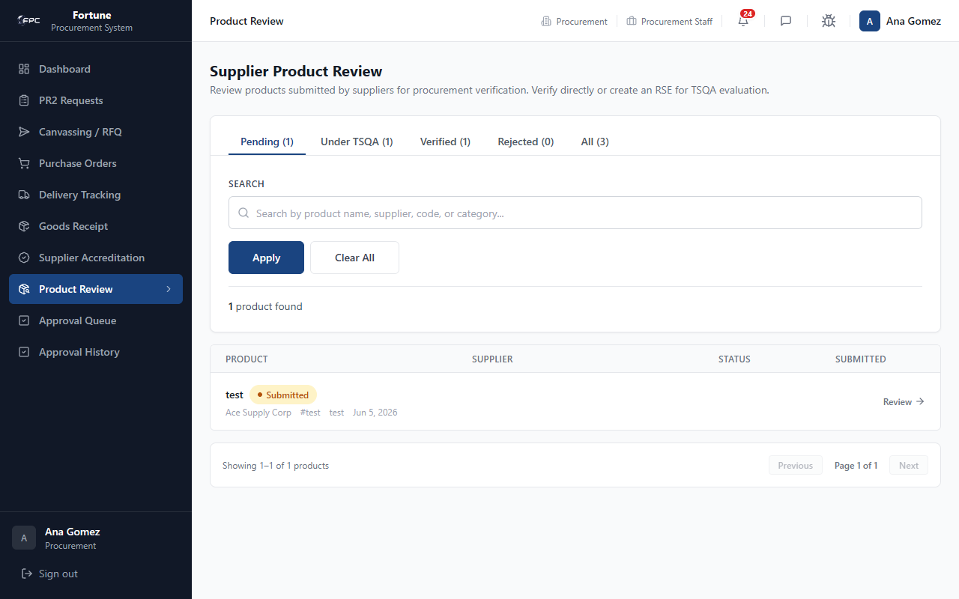
Caption: Product Review List - Lists product catalog items submitted by suppliers. It displays verification status badges (Pending, Under TSQA, Verified, Rejected) and options to review detail pages.
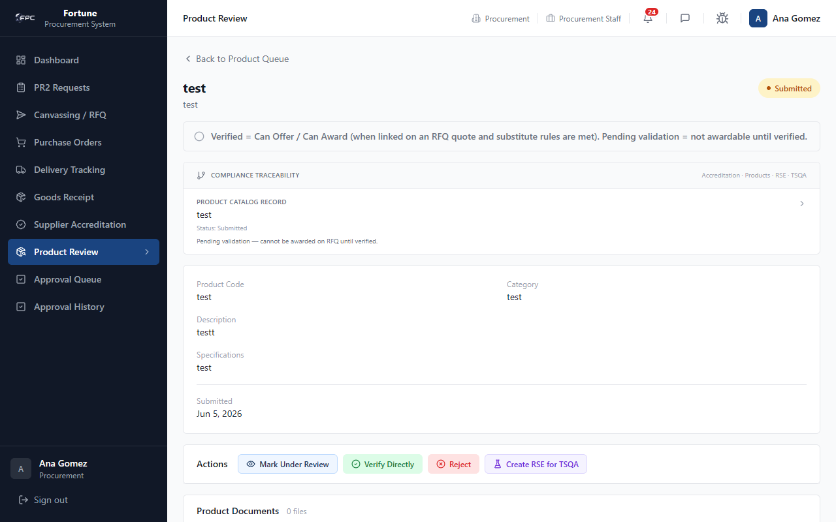
Caption: Product Review Detail - Displays product specifications. Procurement officers can verify products directly (making them eligible for RFQs), reject them, or click Create RSE to route raw materials to the TSQA team.

Status Glossary
Status Badge | Description
Submitted | Awaiting procurement first action
Under Review | Procurement actively evaluating
Pending TSQA | RSE created; awaiting TSQA verdict
Verified | Can be awarded on RFQs
Rejected | Not usable; supplier must resubmit

Expected Outcome
Verified products become awardable; TSQA-routed products update after RSE pass/fail.

3.9 Approval Queue & History

Module Purpose
Shows PR2 and PO documents awaiting procurement sign-off and logs all past approval actions.

Module UI Map
Component Type | Element Label / Value | Description / Action
Tabs/Sections | PR1 / PR2 / PO | Grouped approval queues on /approvals
Table | Awaiting My Action | Documents at your workflow step
Button | Approve / Reject / Request Revision | Sign-off actions with remarks
History Table | Past Actions | Document, action, step, signed date, remarks

Step-by-Step Workflows
Workflow 1: Act on Pending Approval
1. Open Approval Queue. 2. Click Review on your step. 3. Approve or Reject with remarks.
Workflow 2: Review History
1. Open Approval History. 2. Filter by document type or date. 3. Click View for read-only detail.
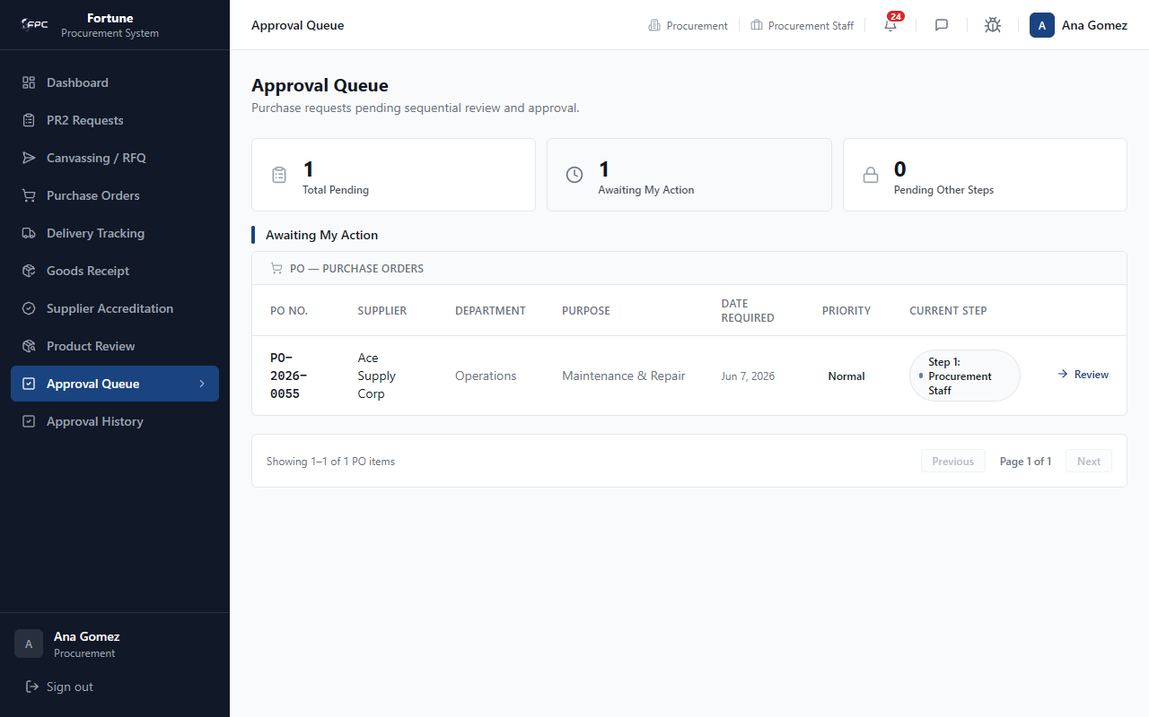
Caption: Approval Queue (Procurement) - Shows documents currently awaiting review. It highlights pending PR2 and PO documents, displaying their current signatory workflow steps.
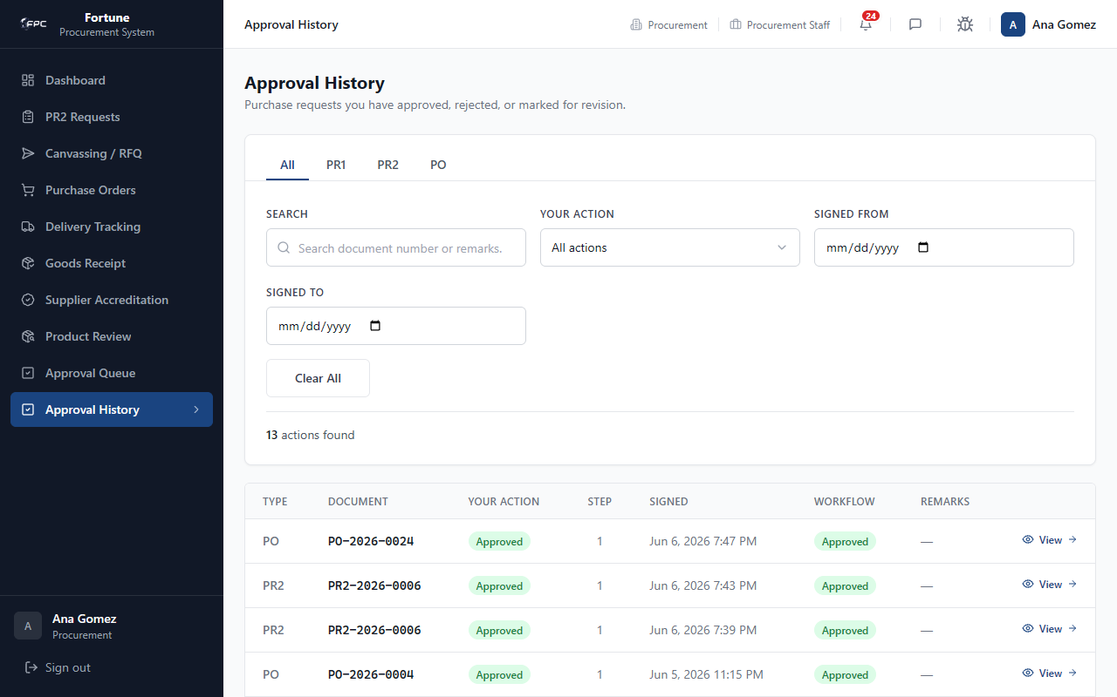
Caption: Approval History (Procurement) - Displays a detailed log of all past approvals, detailing the document type, user action, signing timestamp, and custom remarks.

Expected Outcome
Approval actions advance workflow; history records all signed steps.

3.10 Utilities

Module Purpose
Shared messaging, profile, and bug reporting tools.

Step-by-Step Workflows
Messages: Header icon → search colleague → chat.
Profile: Avatar → update name/password.
Bug Track: Header icon → submit bug form.
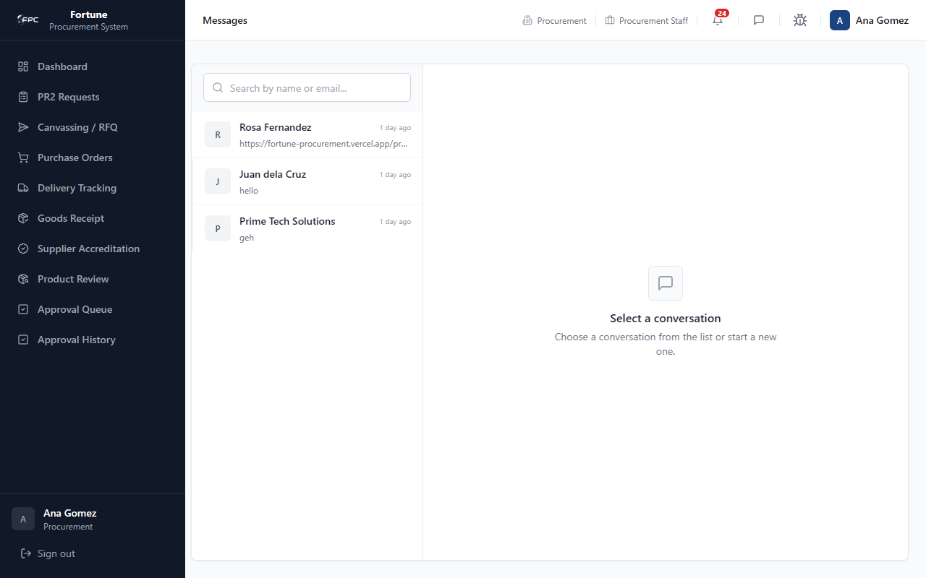
Caption: Procurement Messages - Chat panel showing active conversations with team members and supplier representatives.
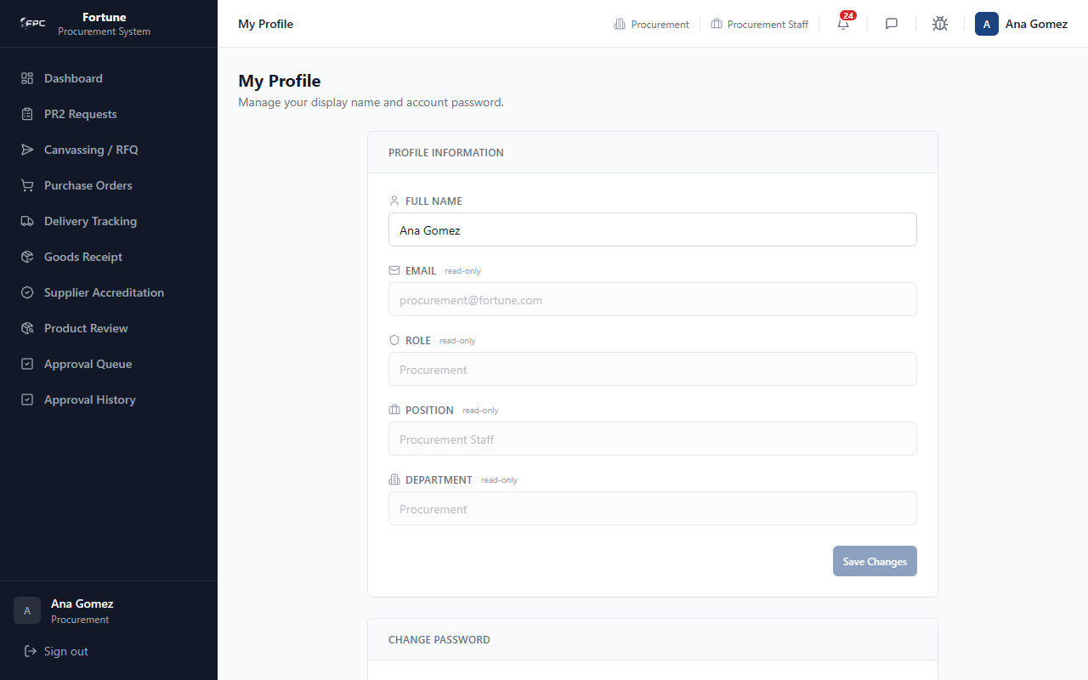
Caption: Procurement Profile - Account details showing the logged-in officer's metadata (Procurement Staff).
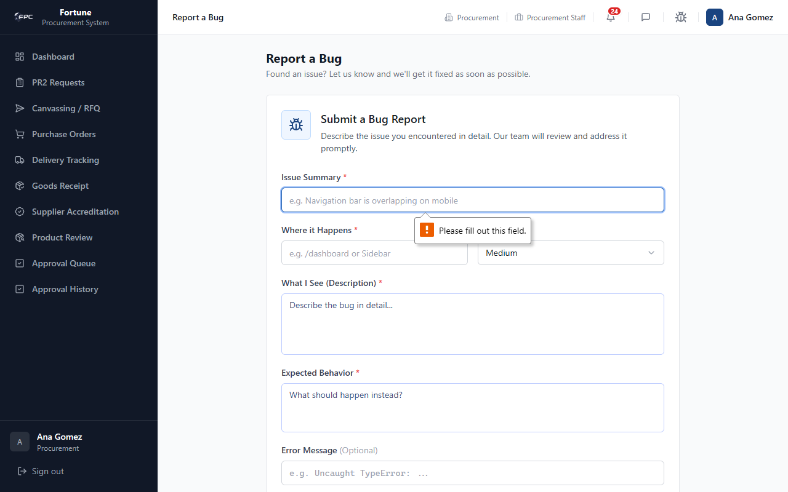
Caption: Procurement Bug Report (Validation) - Interface validation warnings displayed when required bug fields are left blank.
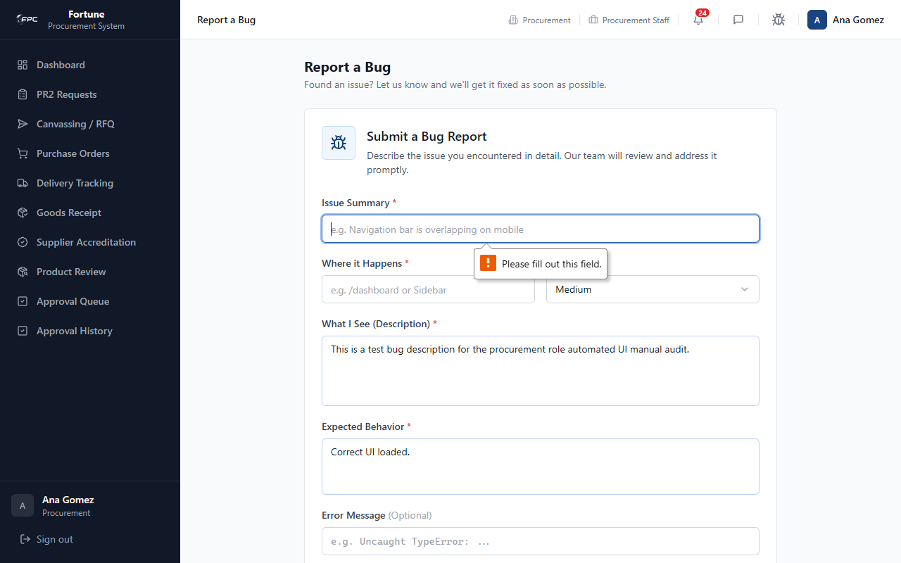
Caption: Procurement Bug Report (Populated) - Shows the populated bug report form containing detailed error text, ready to submit.

Expected Outcome
Utility actions complete without affecting procurement documents.

Role: Approver
The Approver role represents departmental and organizational decision-makers who hold approval sign-off authority. This includes Supervisor, Department Head, Director, and Finance Director. Accounts sign off on PR1s, PR2s, and POs.

4.1 Dashboard

Module Purpose
Central hub showing pending approval workload, weekly statistics, and quick access to documents awaiting your signature.

Module UI Map
Component Type | Element Label / Value | Description / Action
KPI Card | Awaiting My Action | Documents at your current workflow step
KPI Card | Approved This Week | Your approvals this week
KPI Card | Rejected This Week | Your rejections this week
Table | Pending Approvals | PR1/PR2/PO cards with Review link

Step-by-Step Workflows
1. Log in and land on Dashboard. 2. Check Awaiting My Action count. 3. Click Review on a pending card to open the approval workspace.
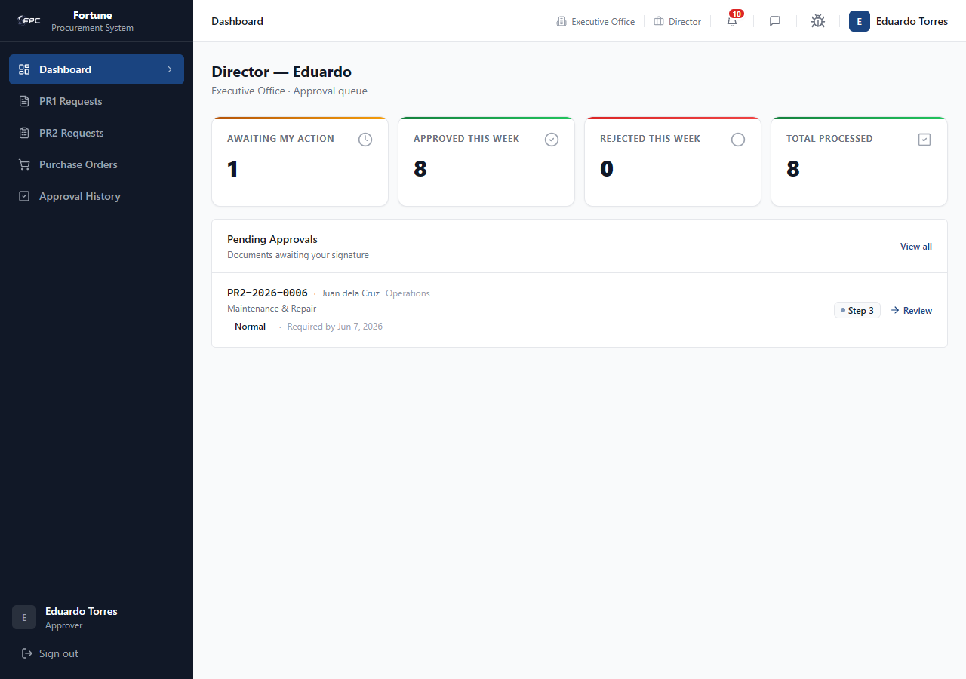
Caption: Approver Dashboard - Landing page for the approver. It lists summary cards (Awaiting My Action, Approved This Week, Rejected This Week) and a queue of pending approval documents.

Expected Outcome
Review link opens the correct approval detail page for your step.

4.2 PR1 Requests (/approvals/pr1)

Module Purpose
Queue for PR1 purchase requisitions requiring supervisor and department head sign-off after warehouse validation.

Module UI Map
Component Type | Element Label / Value | Description / Action
Stat Cards | Pending / Approved / Rejected / Total | PR1 approval counts
Search | PR1 number, requestor, purpose... | Free-text filter
Dropdown | STATUS | Pending, Approved, Rejected, All
Table | PR1 List | PR1 no., requestor, department, purpose, priority, status
Link | Review | Opens /approvals/{instanceId}
Panel | Approval Timeline | Supervisor → Department Head steps
Button | Approve / Reject / Request Revision | Decision actions; remarks required for reject/revision

Step-by-Step Workflows
Workflow 1: Approve PR1
1. Open PR1 Requests → click Review. 2. Review items and warehouse SOH. 3. Click Approve (remarks optional).
Workflow 2: Reject or Request Revision
1. Enter mandatory remarks. 2. Click Reject or Request Revision.
Approval chain: Supervisor (Step 1) → Department Head (Step 2, final) → PR1 moves to For Canvassing.
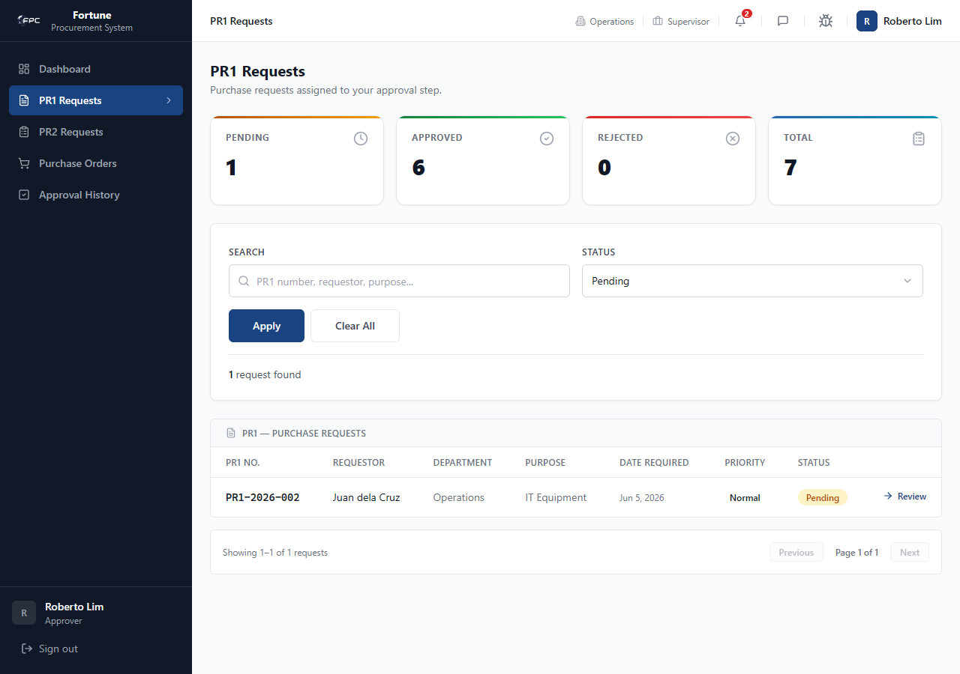
Caption: PR1 Approvals Queue - Lists all PR1 requests routing through approvals, with options to filter by priority, department, and submission date.
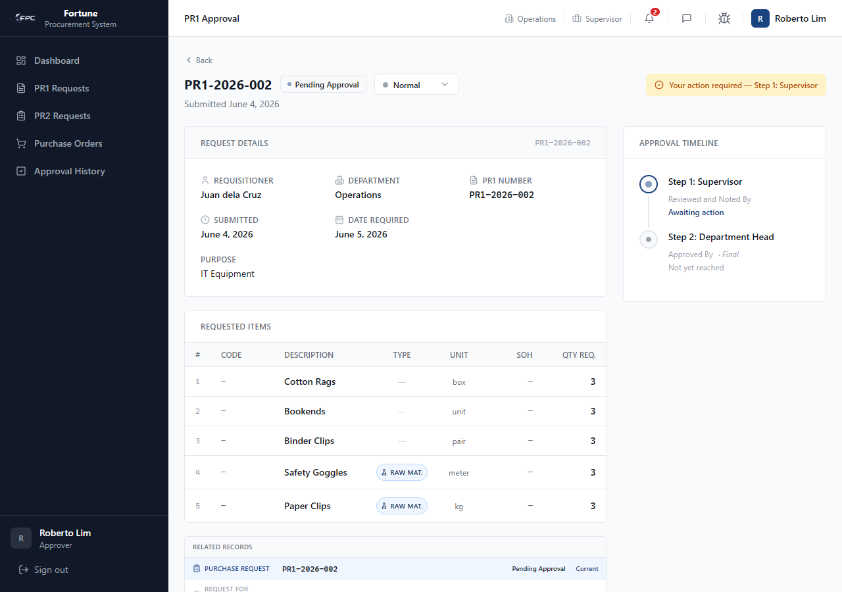
Caption: PR1 Approval Detail - Shows the requestor details, purpose, required date, and the items grid featuring verified warehouse SOH and requested quantities.
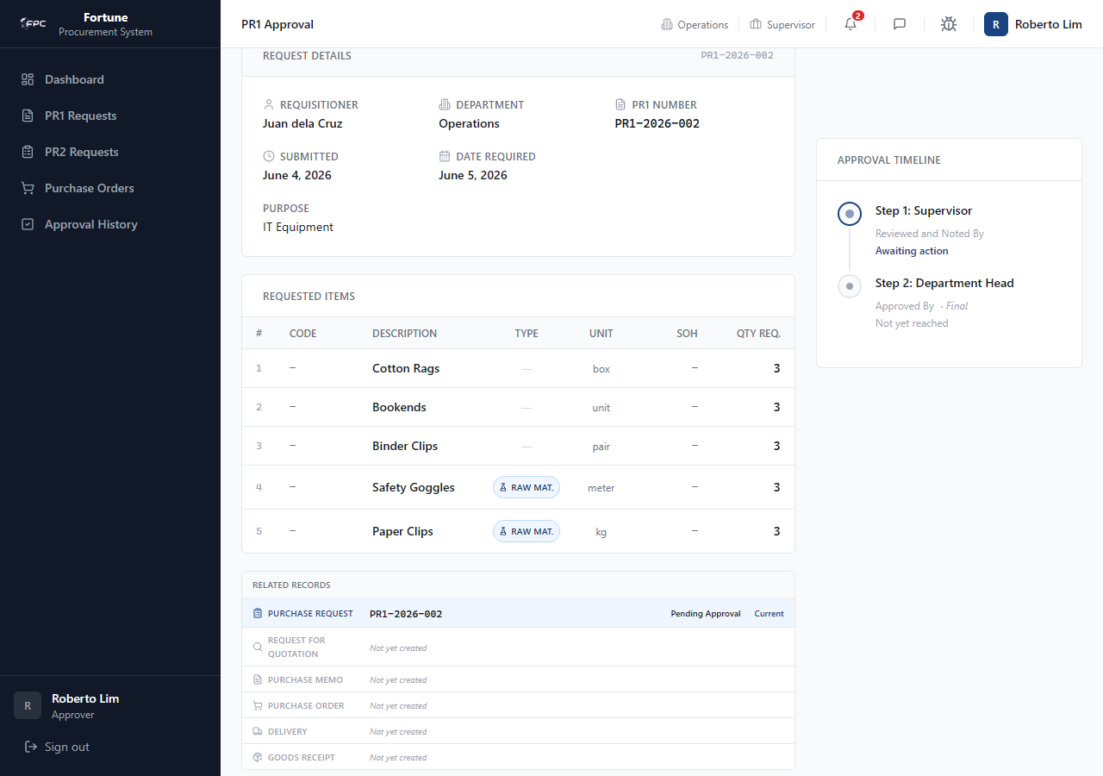
Caption: PR1 Approval Timeline - A chronological progress stepper showing who has signed off on the PR1 (e.g. Supervisor, Department Head) and who is the active pending signatory.
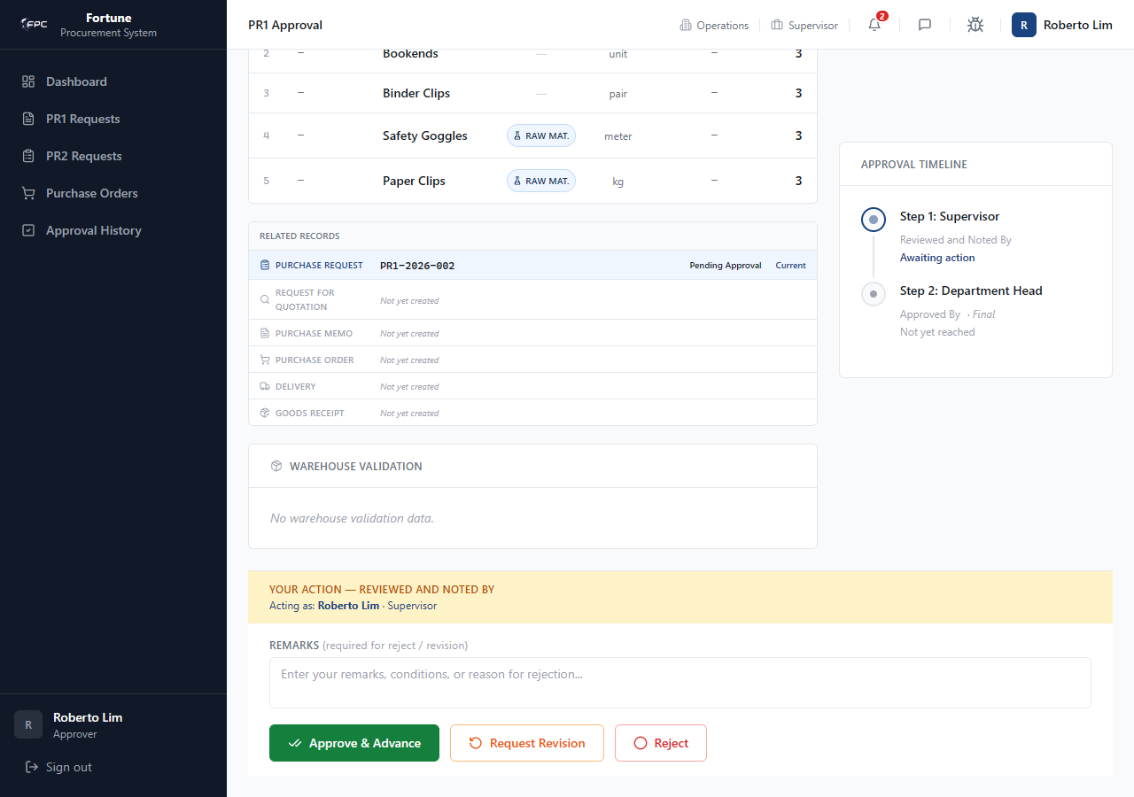
Caption: PR1 Approval Actions - The decision panel. Approvers can click Approve or Reject (which opens a mandatory remarks input field) or Request Revision.

Expected Outcome
Final approval sets PR1 to For Canvassing and notifies procurement.

4.3 PR2 Requests (/approvals/pr2)

Module Purpose
Queue for PR2 purchase memos requiring sign-off during Phase 1 and Phase 2 approval workflows.

Module UI Map
Component Type | Element Label / Value | Description / Action
Table | PR2 List | PR2 no., phase, priority, purpose, department, current step
Panel | Related Records | PR1 → RFQ → PR2 traceability chain
Table | Items Grid | Awarded items, supplier, unit price, total
Toggle | Other Supplier Quotes | Compare competing bids per line
Button | Approve / Reject / Request Revision | Phase 1 or Phase 2 sign-off

Step-by-Step Workflows
Phase 1: Procurement Staff → Procurement Manager → Director.
Phase 2 (auto-starts): Buyer → Procurement Manager → Director.
1. Open PR2 → Review items and quotes. 2. Approve to advance step or Reject/Request Revision with remarks.
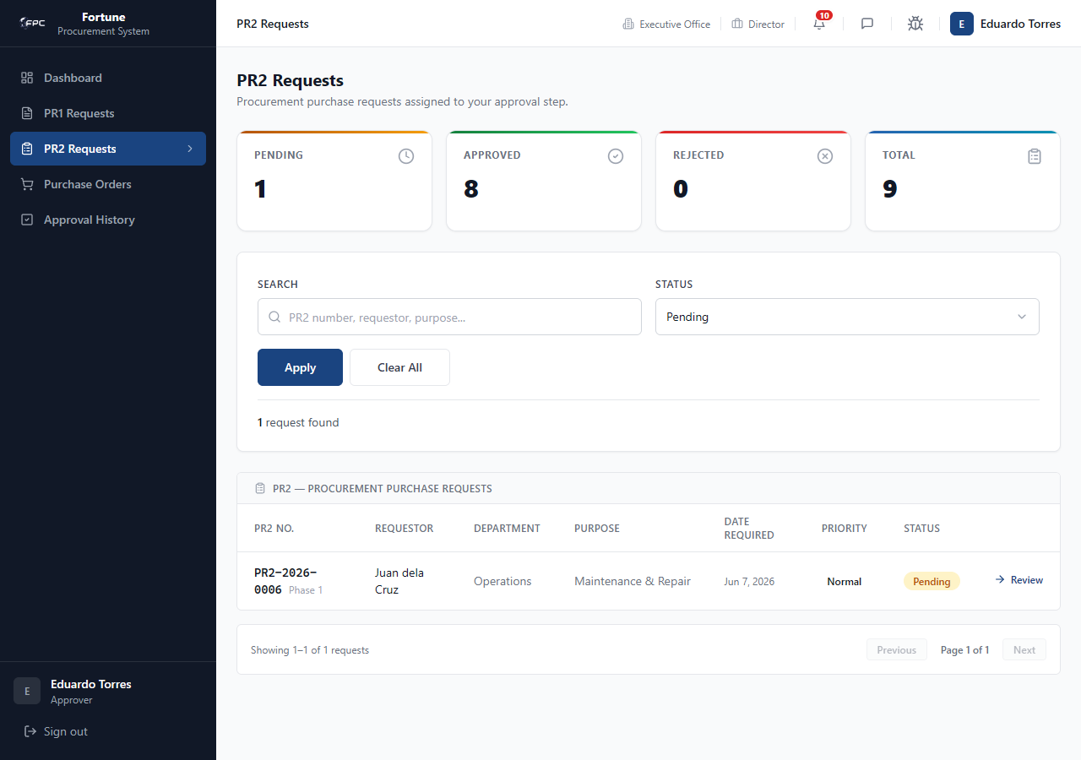
Caption: PR2 Approvals Queue - Lists PR2 memos awaiting sign-off, detailing the phase, priority, purpose, and requesting department.
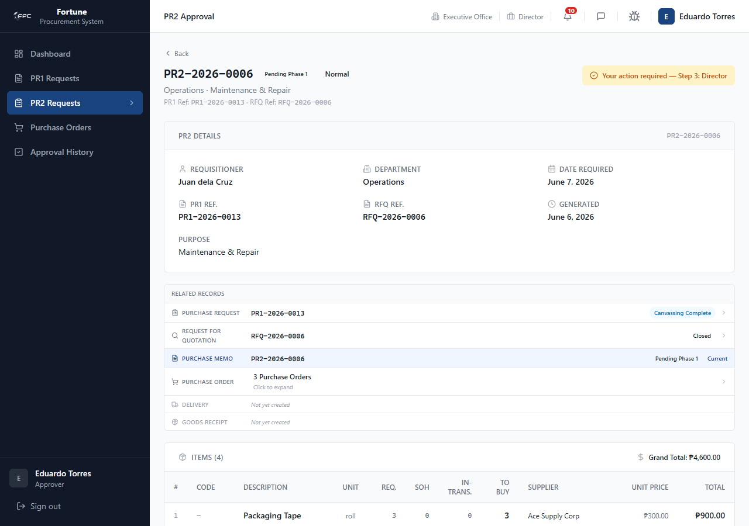
Caption: PR2 Approval Detail - Displays the PR2 header information and its active related records chain (linking PR1, RFQ, and PR2).
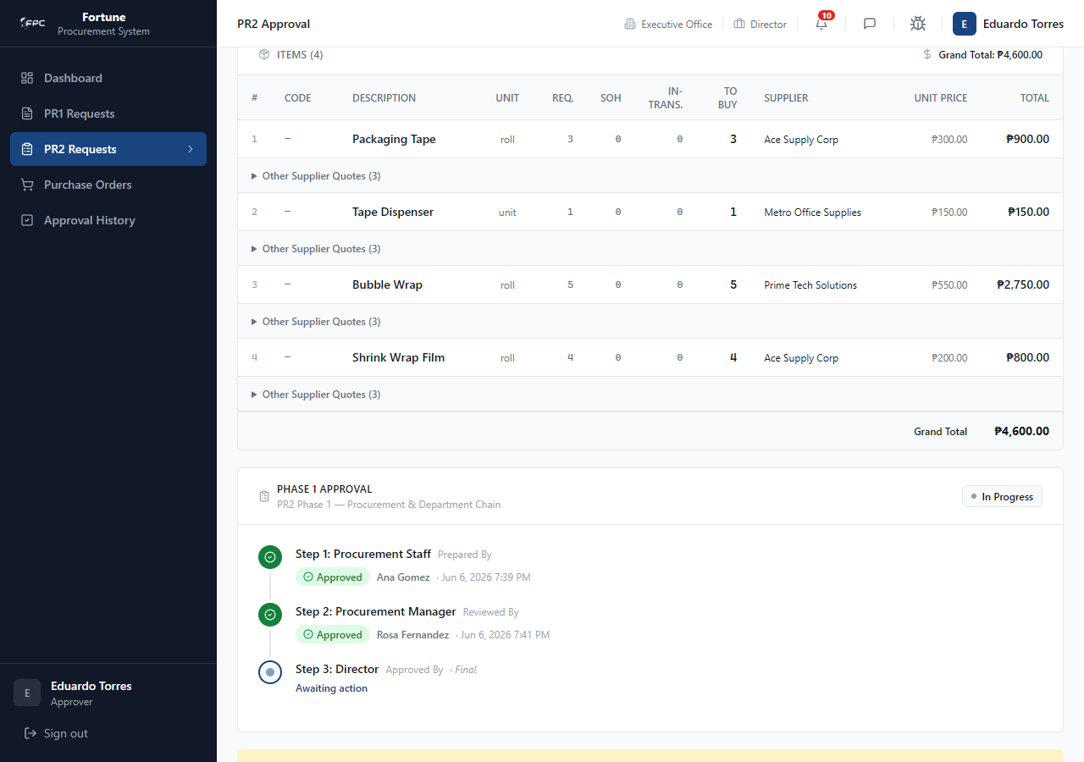
Caption: PR2 Items Grid - Displays awarded items, selected suppliers, unit costs, and total prices, with a toggle to view competing supplier canvass quotes.
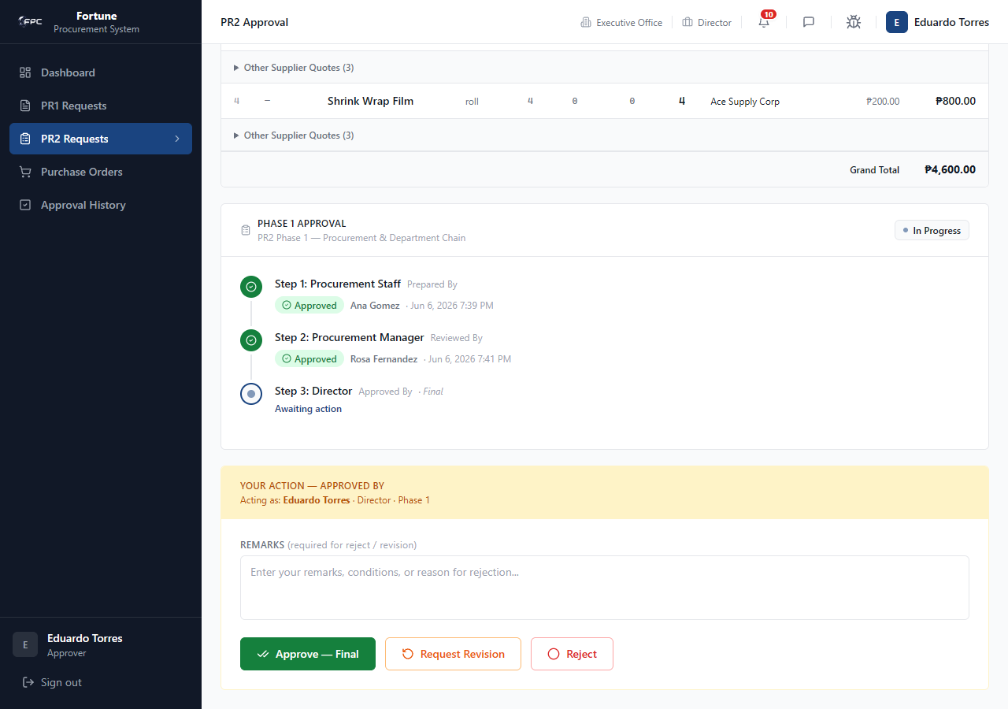
Caption: PR2 Approval Actions - The decision controls allowing Directors or Managers to sign off on the active Phase 1 or Phase 2 approval step.

Expected Outcome
Phase 2 final approval sets PR2 to Phase 2 Approved; employee notified.

4.4 Purchase Orders (/approvals/po)

Module Purpose
Queue for purchase orders requiring Finance Director final internal approval before transmission to supplier.

Module UI Map
Component Type | Element Label / Value | Description / Action
Table | PO List | PO no., supplier, department, purpose, status
Panel | PO Details | Payment terms, delivery address, items, grand total
Panel | Approval Chain | Buyer → Procurement Manager → Finance Director
Button | Approve — Final / Reject | Finance Director decision

Step-by-Step Workflows
1. Open PO Approvals. 2. Click Review on a For Approval PO. 3. Verify items, totals, and prior signatures. 4. Finance Director clicks Approve — Final. 5. PO status becomes Approved; supplier notified to acknowledge.
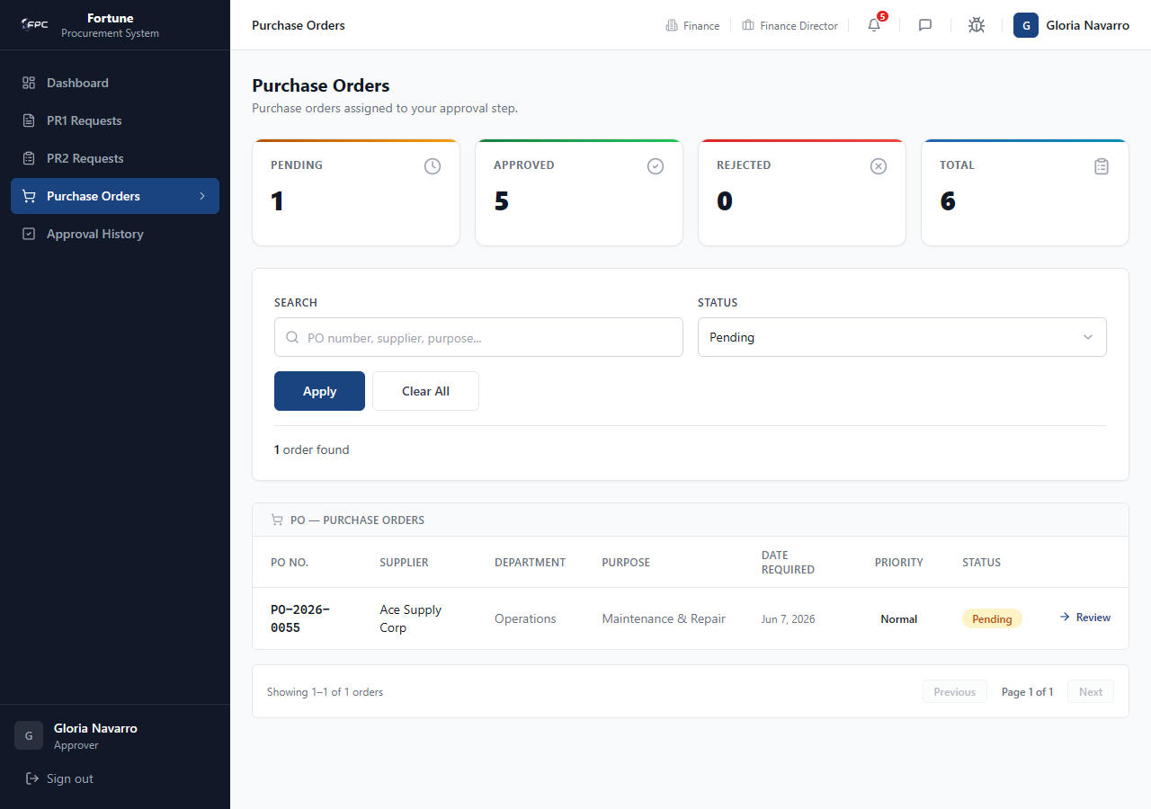
Caption: PO Approvals Queue - Lists Purchase Orders currently routing through approval steps (e.g. Finance Director review).
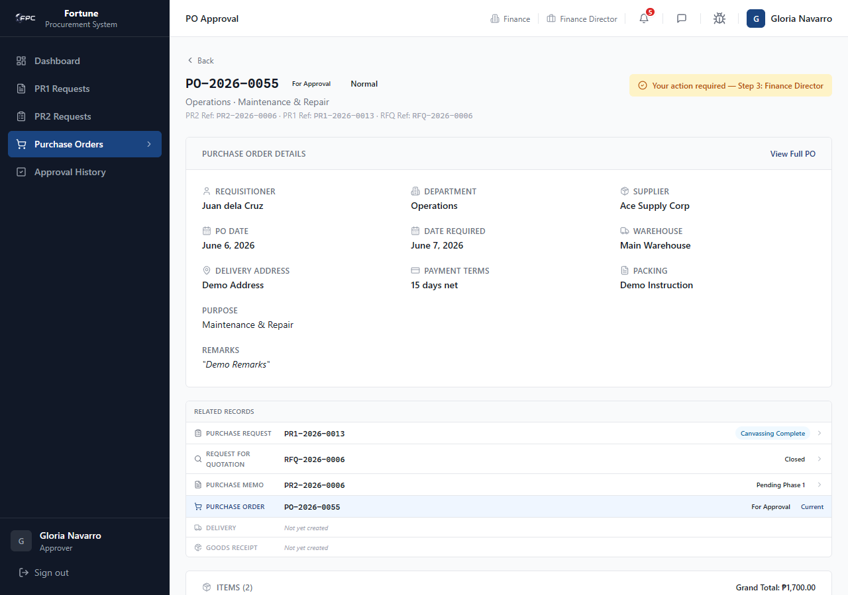
Caption: PO Approval Detail - Displays the purchase order parameters, including payment terms, delivery address, item list, and grand total.
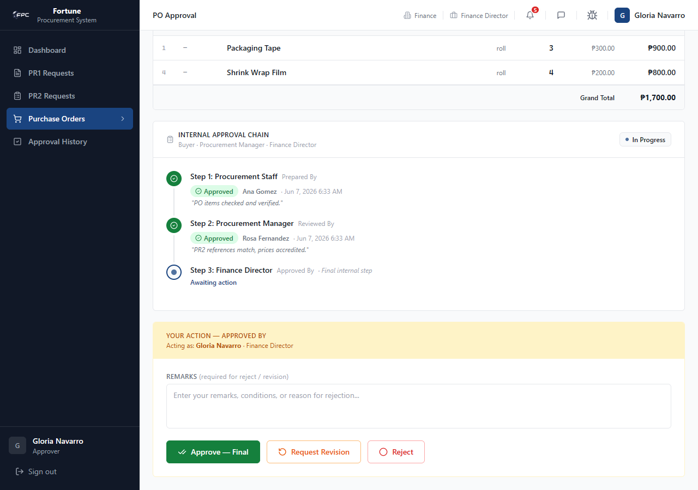
Caption: PO Approval Actions - The decision panel. The Finance Director can click Approve (which finalizes the PO and routes it to the supplier) or Reject.

Expected Outcome
Approved PO is released to supplier portal for acknowledgment.

4.5 Approval Queue (/approvals)

Module Purpose
Unified inbox combining PR1, PR2, and PO approvals awaiting your action or pending at other steps.

Module UI Map
Component Type | Element Label / Value | Description / Action
Tab | Awaiting My Action | Documents at your step — Review link
Tab | Pending Other Steps | Documents at other signatories — View link (read-only)
Sections | PR1 / PR2 / PO tables | Grouped by document type

Step-by-Step Workflows
1. Open Approval Queue. 2. In Awaiting My Action, click Review. 3. Complete sign-off. 4. Switch to Pending Other Steps to monitor documents awaiting other approvers.
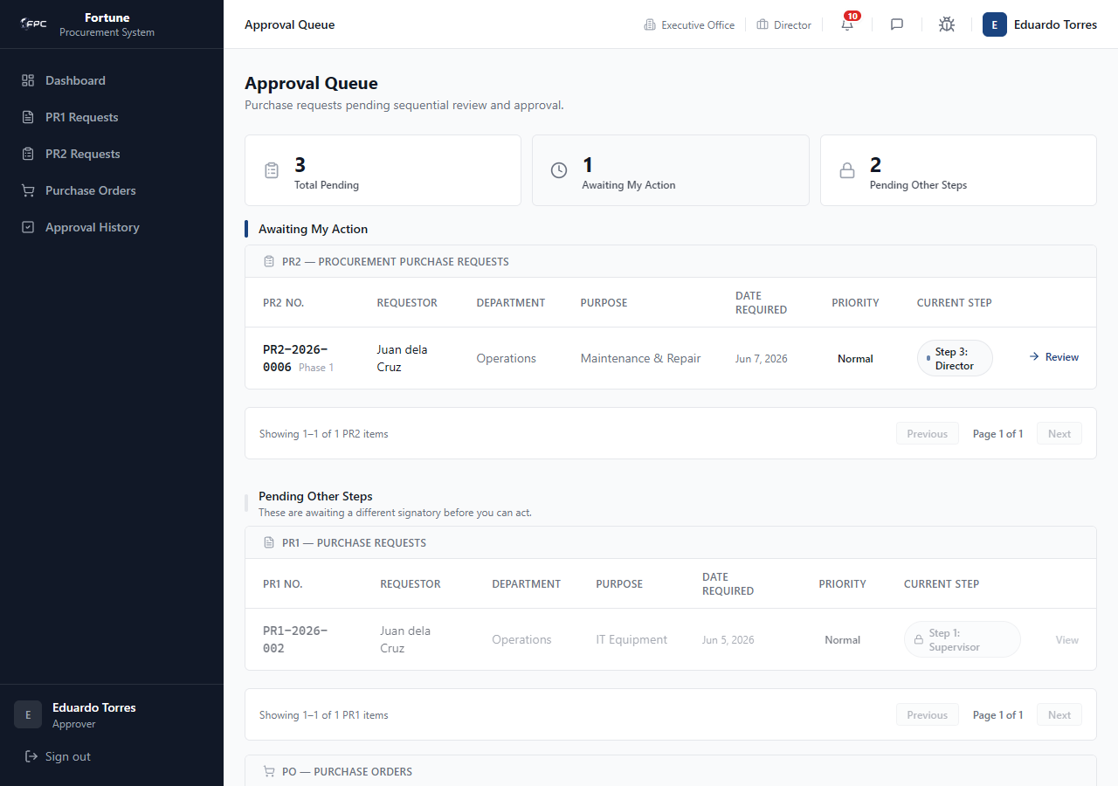
Caption: Unified Approvals Queue - A single dashboard displaying all pending approvals across PR1, PR2, and PO tabs, sorting items by urgency and date.

Expected Outcome
Only documents matching your role and position appear as actionable.

4.6 Approval History (/approvals/history)

Module Purpose
Searchable log of all past approval actions you have signed.

Module UI Map
Component Type | Element Label / Value | Description / Action
Tabs | All, PR1, PR2, PO | Filter by document type
Search | Document number or remarks... | Free-text filter
Dropdown | Action | Approved, Rejected, Revision requested
Date Pickers | Signed From / To | Date range filter
Link | View | Read-only document detail

Step-by-Step Workflows
1. Open Approval History. 2. Filter by type, action, or date. 3. Click View to see full document and completed approval trail.
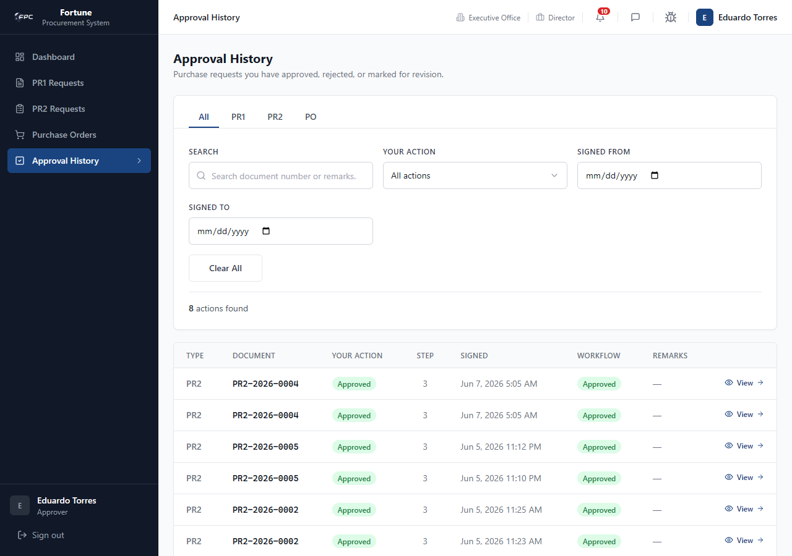
Caption: Approver History Log - Lists all past actions taken by the approver. It includes search filters and date ranges, showing the specific action badge (e.g. Approved, Rejected) and remarks.
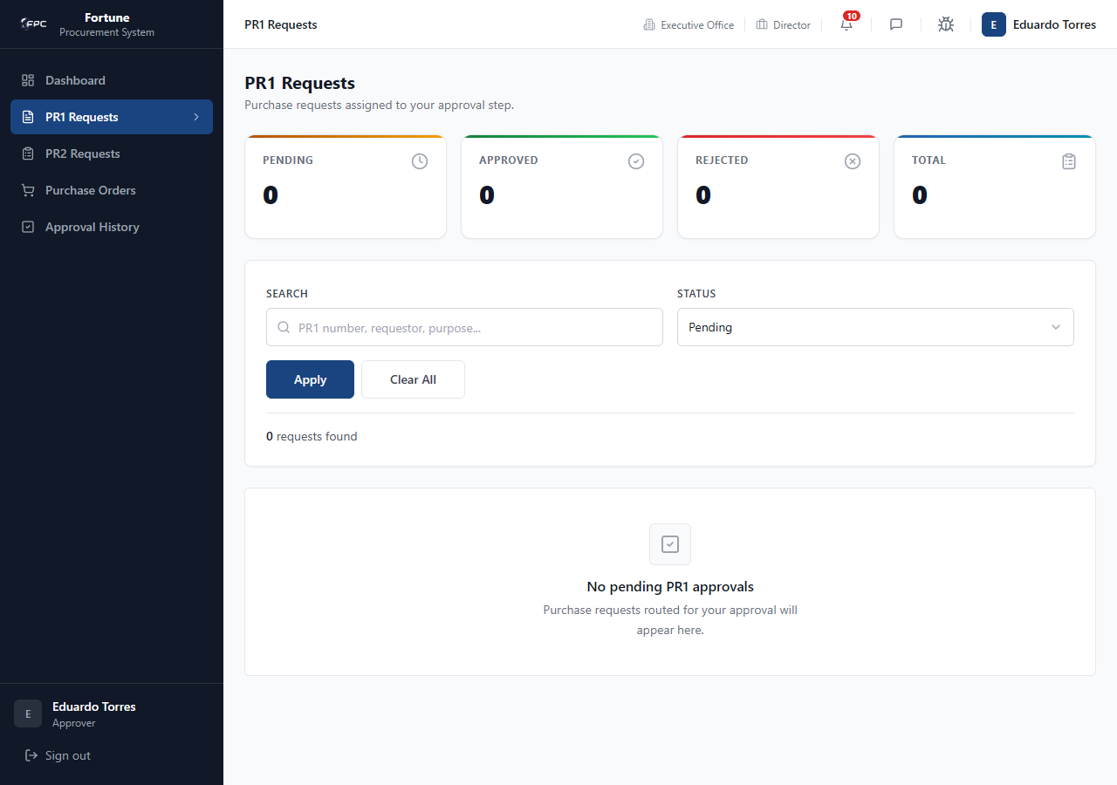
Caption: Completed Request Detail - A read-only card showing a completed PR1, displaying the final signatory approvals and item fulfillment logs.

Expected Outcome
Historical records display with correct action badge and signed timestamp.

4.7 Utilities

Module Purpose
Shared messaging, profile, and bug reporting tools.

Step-by-Step Workflows
Messages: Header icon → select conversation → reply.
Profile: Avatar → update credentials.
Bug Track: View reported bugs; admin can update status.
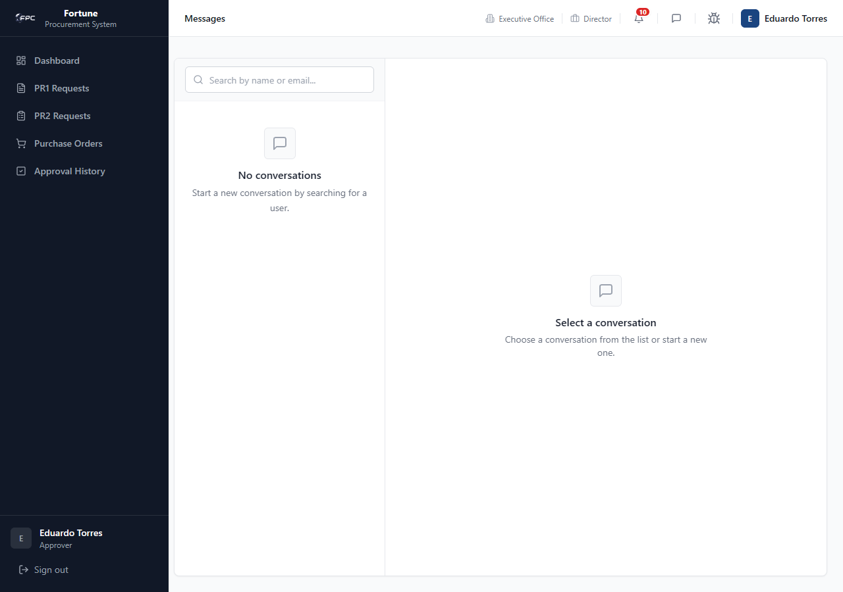
Caption: Approver Messages - Chat window displaying a conversation between the approver and a procurement team member.
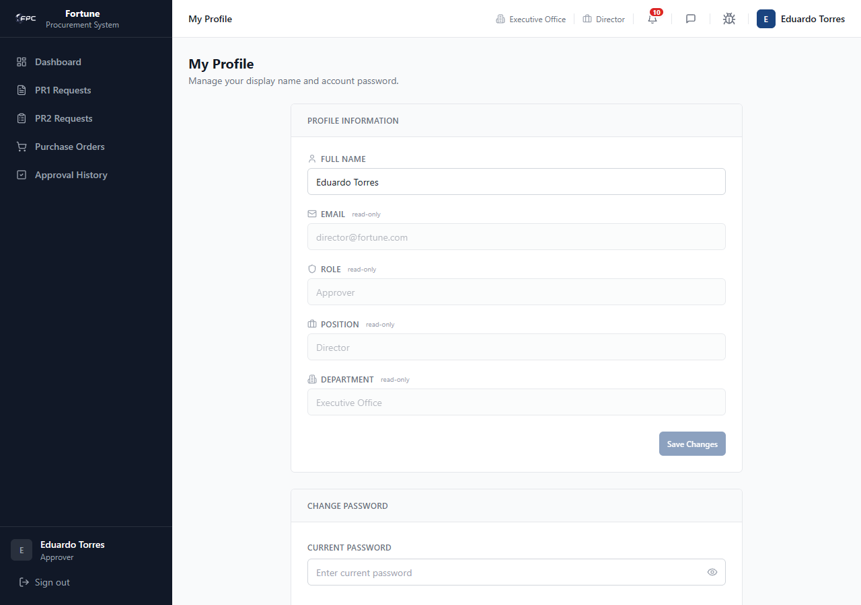
Caption: Approver Profile - Profile page showing display name fields, password inputs, and active user credentials.
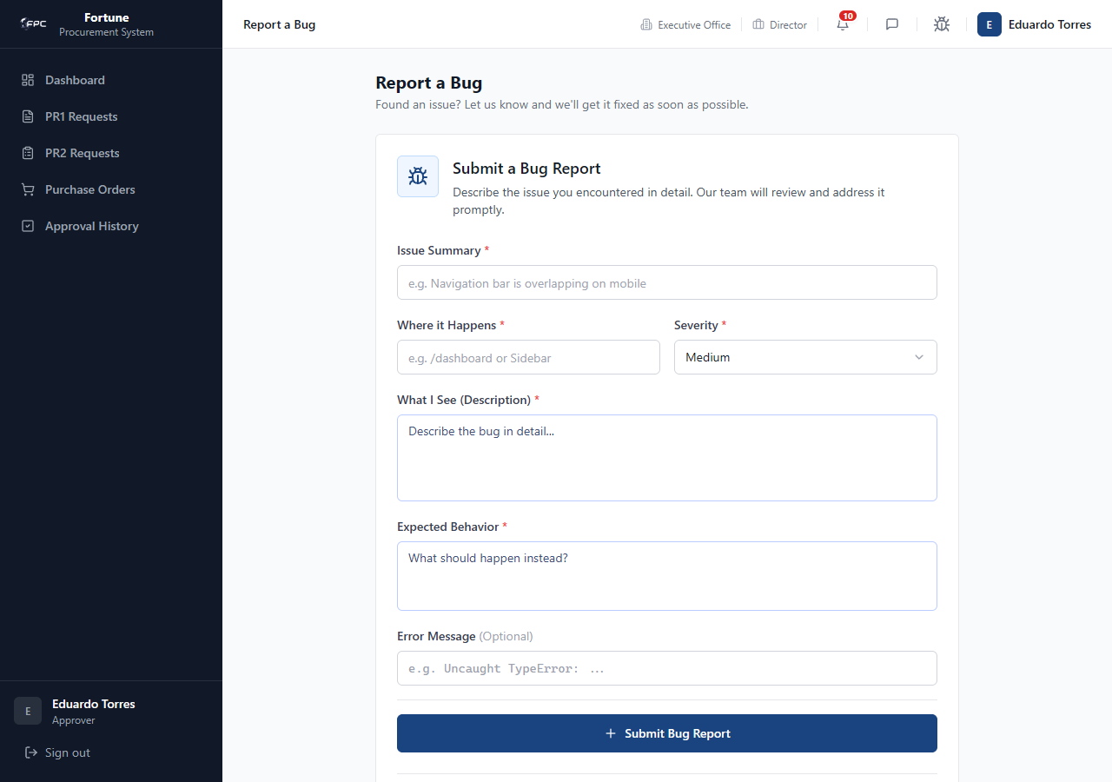
Caption: Approver Bug List - A table listing reported bug tickets with columns for summary, URL, severity, status, and reporter.
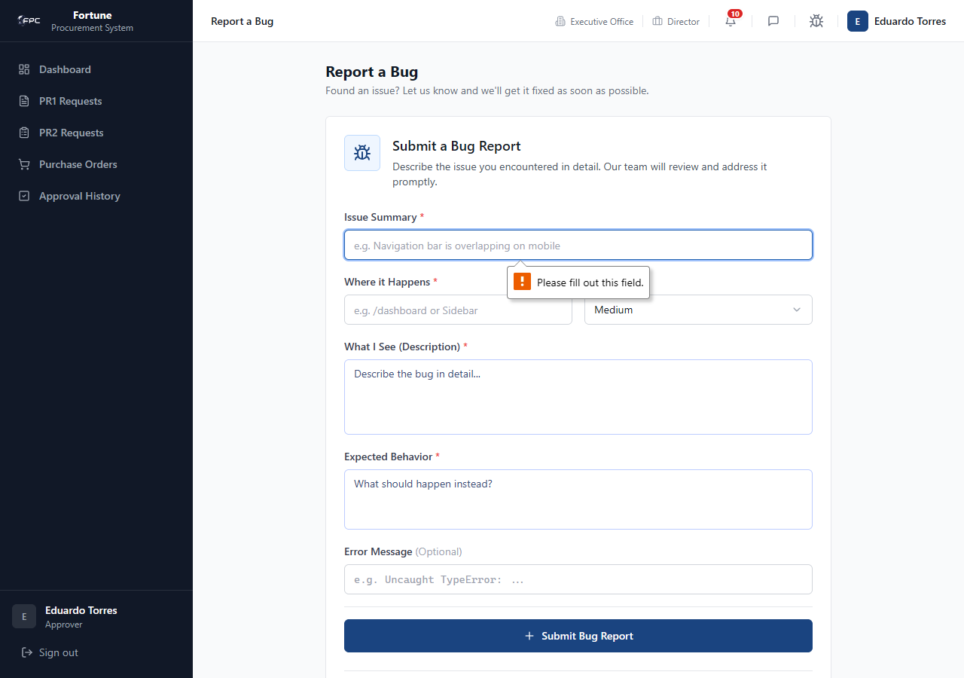
Caption: Bug Ticket Detail - Shows detailed bug information, expected vs actual behavior, and options for administrators to update status.

Expected Outcome
Utility actions complete without affecting approval workflow.

Role: Supplier
The Supplier Representative manages their accreditation details, submits catalog products, reviews incoming RFQs, inputs pricing bids, acknowledges POs, and schedules shipments. The primary account used is supplier@fortune.com (Supplier Role).

5.1 Dashboard (/dashboard)

Module Purpose
Provides a central interface for the supplier to track accreditation status, open RFQs, active POs, and pending delivery shipments.

Module UI Map
Component Type | Element Label / Value | Description / Action
KPI Card | Open RFQs | Count of active bids open for quoting
KPI Card | Active POs | Count of POs awaiting acknowledgment or delivery
KPI Card | Pending Deliveries | Count of shipments in transit or scheduled
Status Card | Accreditation Status | Displays the current supplier validation status (e.g. Accredited, Pending, Under Review)
Panel List | Recent Notifications | List of recent system alerts and updates
Sidebar Menu | Dashboard, Accreditation, Product Catalog, Quotations, Purchase Orders, Deliveries | Core supplier modules
Header Icons | Message Center, Bug Track, Profile Dropdown | Access chat, file bugs, and configure account settings

Step-by-Step Workflows
1. Navigate to the Dashboard. Review the active KPI indicators. If any alerts are visible under notifications, click on them to navigate to the respective module.
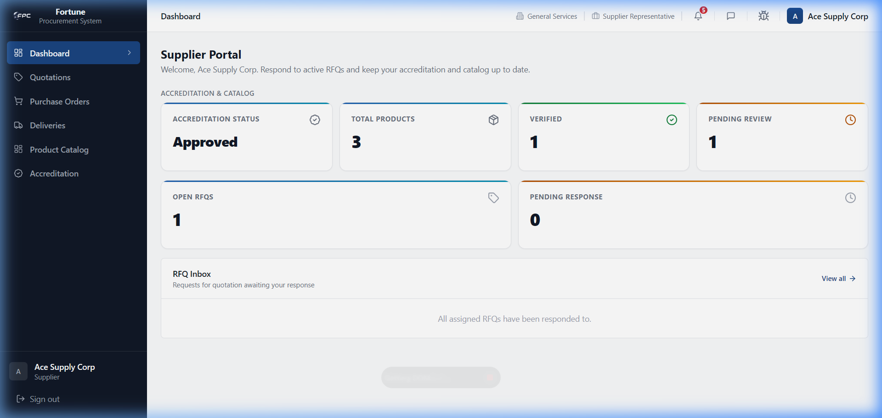
Caption: Supplier Dashboard - Landing page for supplier portal. It shows KPI cards for Open RFQs, Active POs, and Pending Deliveries, alongside the organization's current Accreditation Status.

Expected Outcome
Metrics and status badges load dynamically matching supplier database records.

5.2 Accreditation Details (/supplier/accreditation)

Module Purpose
Allows suppliers to review company profiles and check the status of required compliance certificates.

Module UI Map
Component Type | Element Label / Value | Description / Action
Header Panel | Accreditation Details | Displays Legal Name, Status, Evaluation rating, and Date Accredited
Table | Certification Files | List of compliance documents (DTI Certificate, Mayor's Permit, Tax Clearance, SEC Registration)
Status Badge | Verified / Pending | Individual status indicators for each document slot

Step-by-Step Workflows
1. Select Accreditation from the sidebar. Inspect your registration profile parameters. Scroll down to review the status of submitted compliance files.
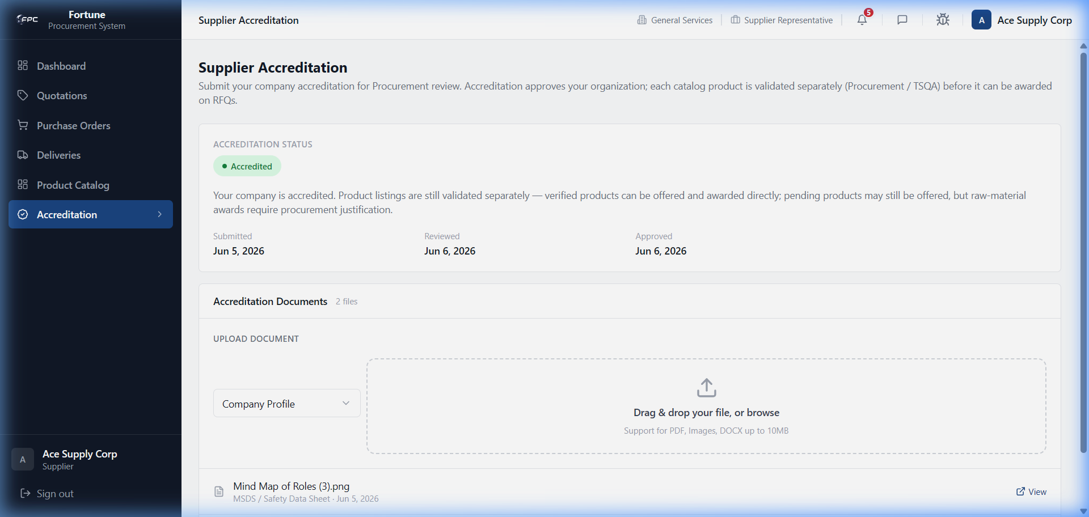
Caption: Supplier Accreditation Profile - Displays contact details, date accredited, legal name, and evaluation ratings.
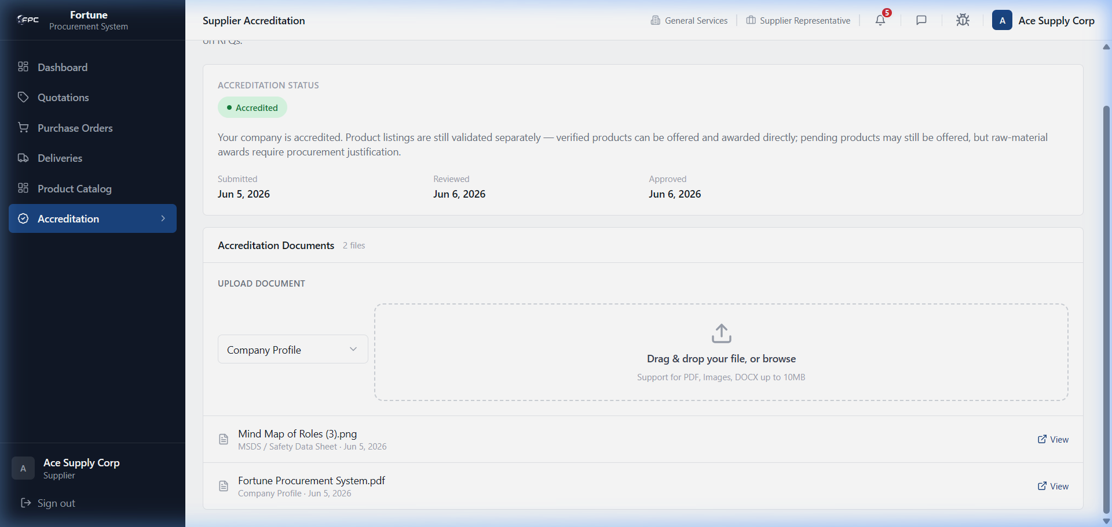
Caption: Accreditation Documents Table - Lists required compliance documents (DTI Certificate, Mayor's Permit, Tax Clearance, SEC Registration) and their verification states.

Status Glossary
Status Badge | Description
Accredited | Green status indicating the supplier is fully approved and can bid on RFQs.
Pending Review | Yellow status indicating submitted compliance documents are undergoing check.
Verified | Green file badge showing a document was audited and approved by procurement.

Expected Outcome
Supplier contact fields and file table load correctly.

5.3 Product Catalog (/supplier/products)

Module Purpose
Enables managing product offerings, adding new items, and checking TSQA verification status.

Module UI Map
Component Type | Element Label / Value | Description / Action
Button | Add Product | Launches the catalog product creation screen
Table | Product Catalog Table | Columns: Image, SKU, Category, Product Name, Unit Price, Stock, Status, Action
Form Fields | Product Code, Name, Category, Description, Unit Price, Stock, Image upload slot | Fields inside the Add Product screen
Button | Submit Product | Saves new product details to database

Step-by-Step Workflows
Workflow 1: Viewing Product Catalog
1. Select Product Catalog from the sidebar. Review active SKUs, unit pricing, stock on hand, and TSQA validation status.
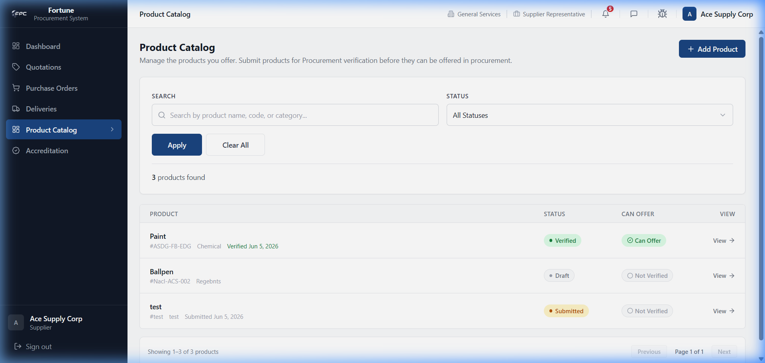
Caption: Supplier Product Catalog - Displays registered products, categories, SKU codes, unit prices, stock levels, and TSQA verification badges.
Workflow 2: Adding a Catalog Product
1. Click the Add Product button. Fill in Code, Name, select a Category, enter Unit Price, and Stock. Click the image upload slot to attach product photos. Click Submit Product.
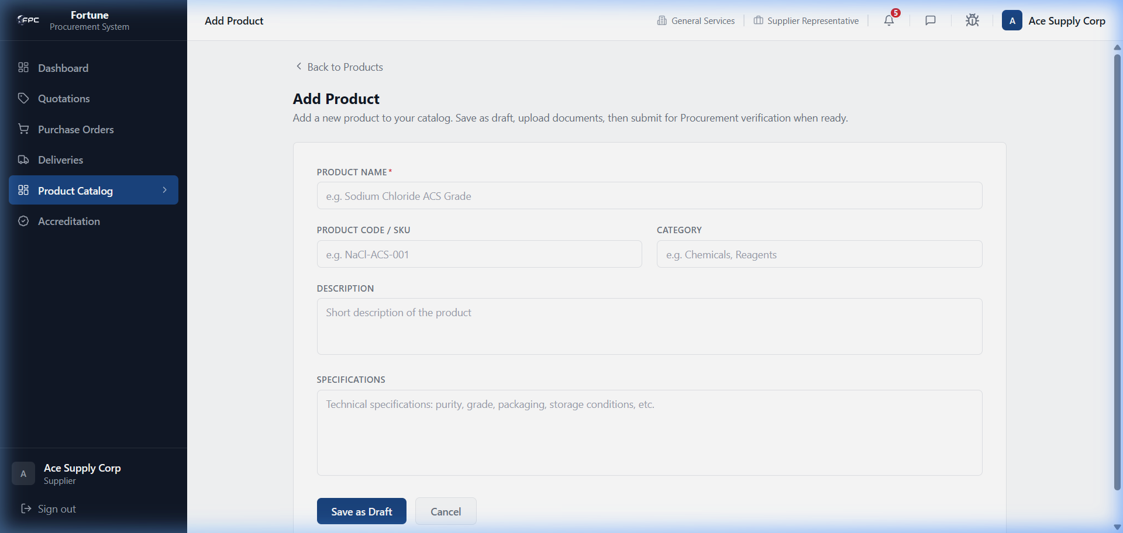
Caption: Add Catalog Product - Form to add new products to the catalog, showing product code, name, category, unit price, stock, and photo upload slot.
Workflow 3: Viewing Product details
1. Click the View link on a catalog product row to open the detailed product view, including its approval logs.
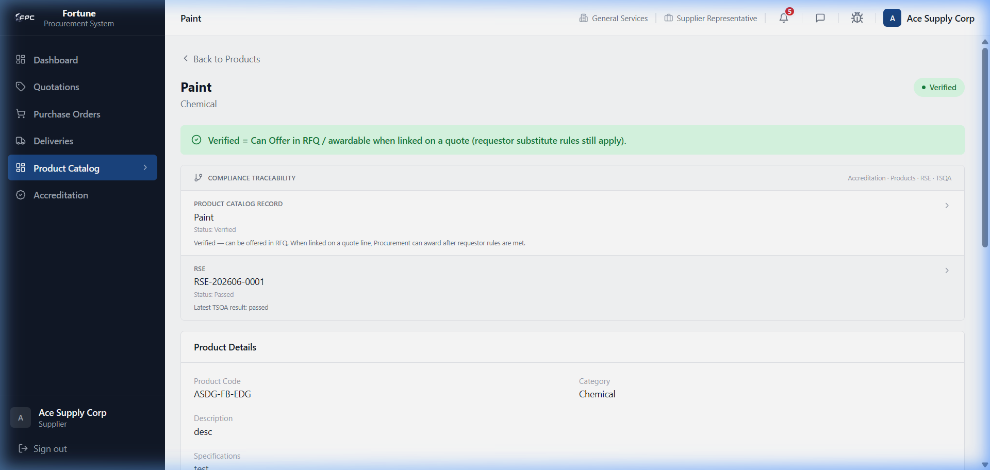
Caption: Supplier Product Details - Displays product specifications and historical verification decisions (Pending TSQA / Verified).

Status Glossary
Status Badge | Description
Verified | Green badge indicating the product is approved and can be selected for RFQ bids.
Pending TSQA | Yellow badge showing that the item sample is awaiting inspection by quality assurance.

Expected Outcome
Successful catalog management, insertion, and details review.

5.4 RFQ Quotations (/supplier/quotations)

Module Purpose
Lists invitations to bid on corporate requisitions and provides a workspace to submit pricing proposals.

Module UI Map
Component Type | Element Label / Value | Description / Action
Table | Quotations Queue Table | Columns: RFQ Number, Closing Date, Status, Action
Link | View Quote / Edit Quote | Directs to the RFQ bidding workspace
Select Field | Select Product | Drop-down selector to link bid line to catalog product
Number Input | Unit Price | Pricing per unit of measure
Number Input | Lead Time (Days) | Guaranteed shipping lead time in days
Text Input | Remarks | Optional remarks for proposed alternatives
Button | Submit Quotation | Finalizes the bid and routes to corporate procurement comparison matrix

Step-by-Step Workflows
Workflow 1: Viewing RFQ Queue
1. Select Quotations from the sidebar. Inspect active RFQ numbers and closing deadlines.
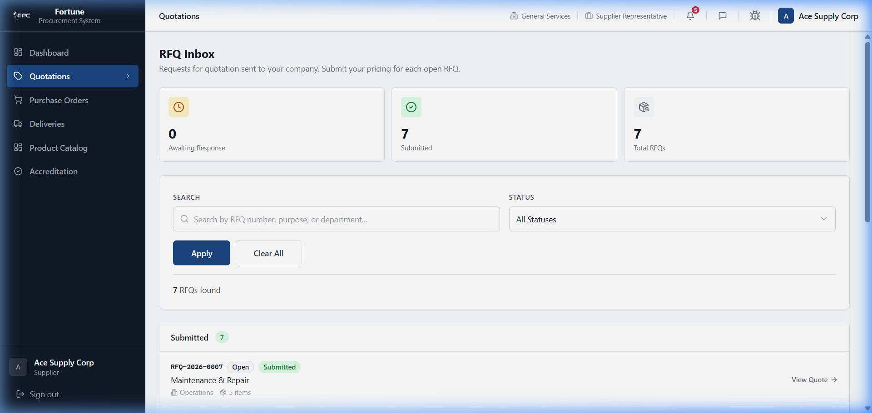
Caption: Quotations Queue - Lists active Request for Quotation (RFQ) invitations showing closing dates, reference numbers, and active bidding statuses.
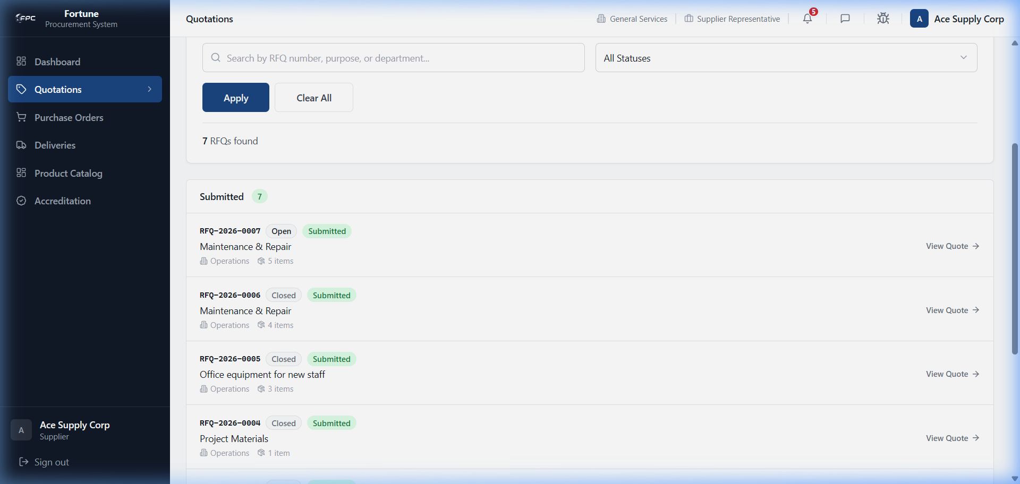
Caption: Quotations Queue (Scrolled) - Displays further quotation details and historical closed bids.
Workflow 2: Submitting a Bid
1. Click View Quote on an open RFQ. Review requested items and specifications. Link each requested item to one of your catalog products, input Unit Price and Lead Time, enter optional remarks, and click Submit Quotation.
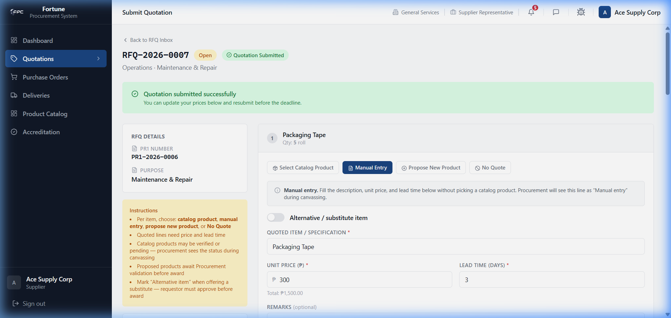
Caption: RFQ Specifications Header - Shows the RFQ ID, closing date, and company billing/shipping details for the quotation form.
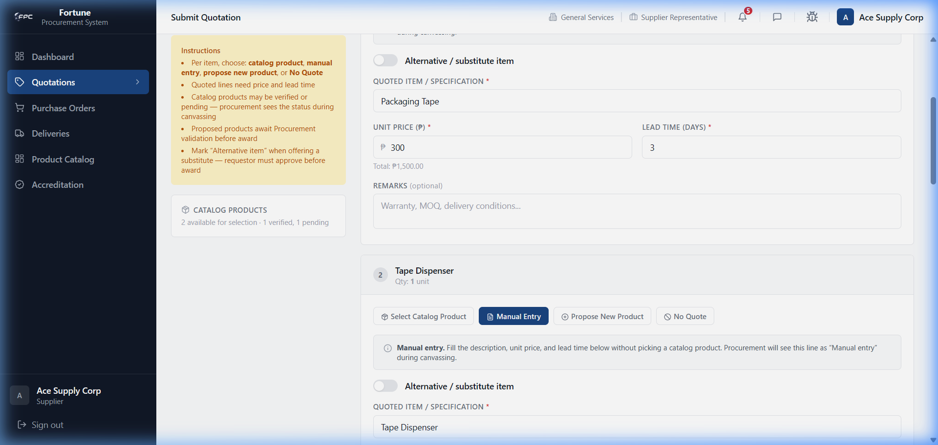
Caption: RFQ Bid Entry Form - Shows requested items. Suppliers link each line to a product from their catalog and input unit prices, lead times, and remarks.
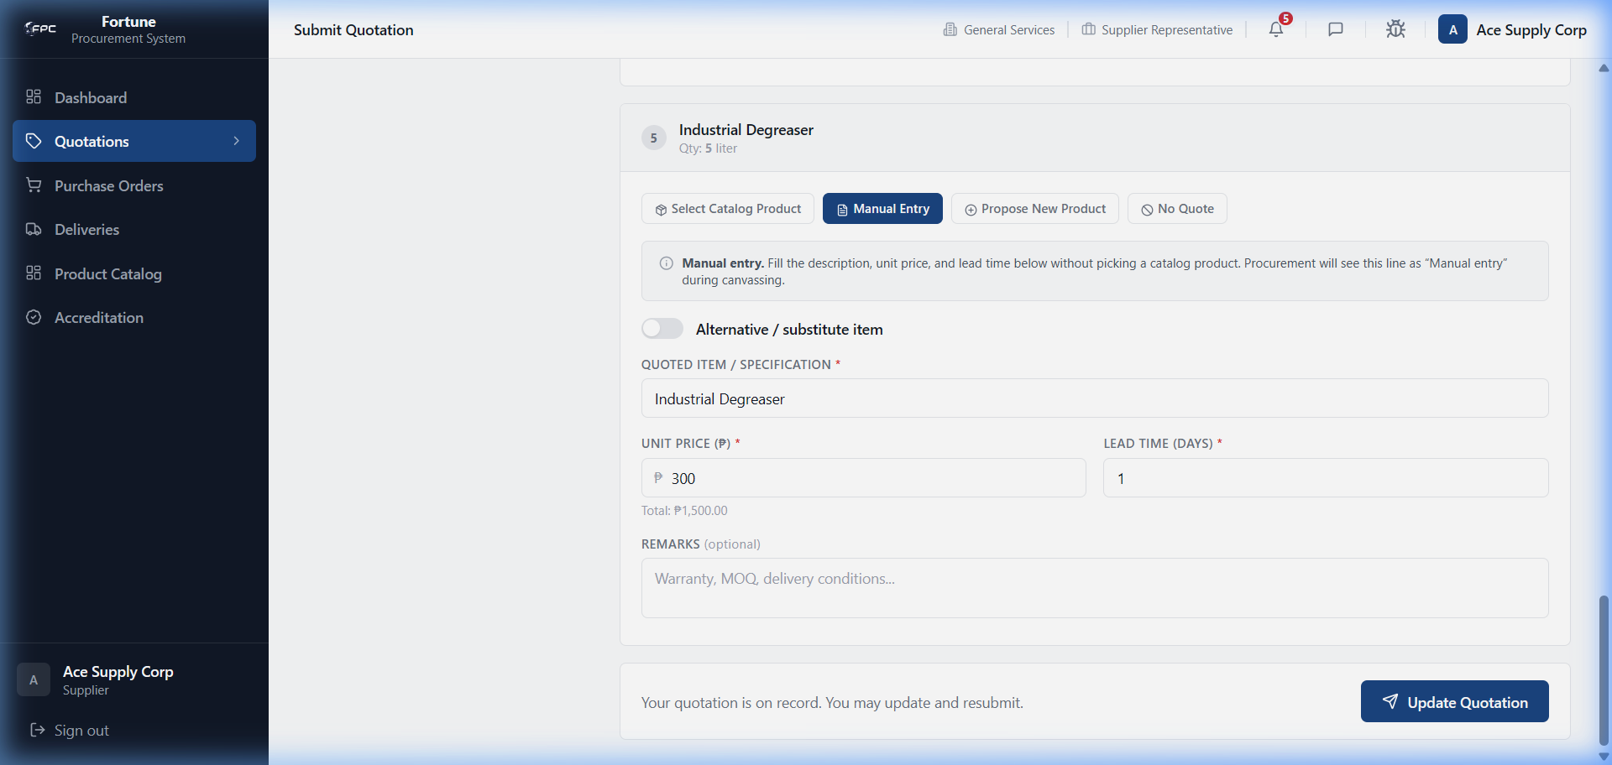
Caption: Quotation Submission Actions - The submission panel. Clicking 'Submit Quotation' registers the supplier's pricing bids in the database.

Status Glossary
Status Badge | Description
Active | Green status showing that the RFQ is currently open and accepting pricing quotes.
Submitted | Blue status showing that the supplier has successfully submitted a quotation.
Closed | Grey status showing that bidding has ended and no further bids can be accepted.

Expected Outcome
Bid submission updates the RFQ state, making quotes visible to procurement agents.

5.5 Purchase Order Acknowledgment (/supplier/po)

Module Purpose
Provides visibility over issued POs and enables committing to delivery dates.

Module UI Map
Component Type | Element Label / Value | Description / Action
Table | Purchase Orders Table | Columns: PO Number, Date, Total Amount, Status, Action
Link | View PO | Opens detail and acknowledgment panel
Date Picker | Commitment Date * | Required date selector to commit to delivery
Textarea | Remarks | Optional acknowledgment details
Button | Acknowledge PO | Submits signature commitment and issues PO

Step-by-Step Workflows
Workflow 1: Reviewing POs
1. Click Purchase Orders in the sidebar. Locate POs marked 'Pending Acknowledgment'.
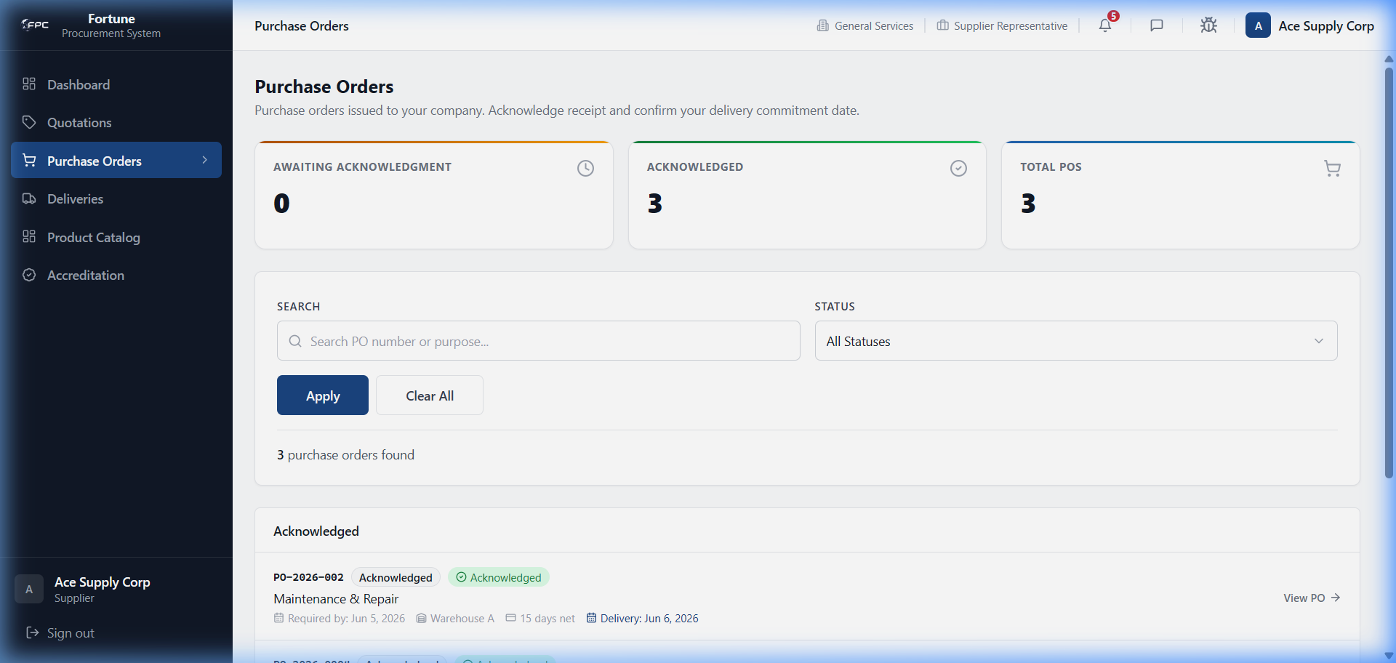
Caption: Supplier Purchase Orders - Lists POs issued to the supplier, showing PO numbers, total amounts, and statuses (Pending Acknowledgment / Acknowledged).
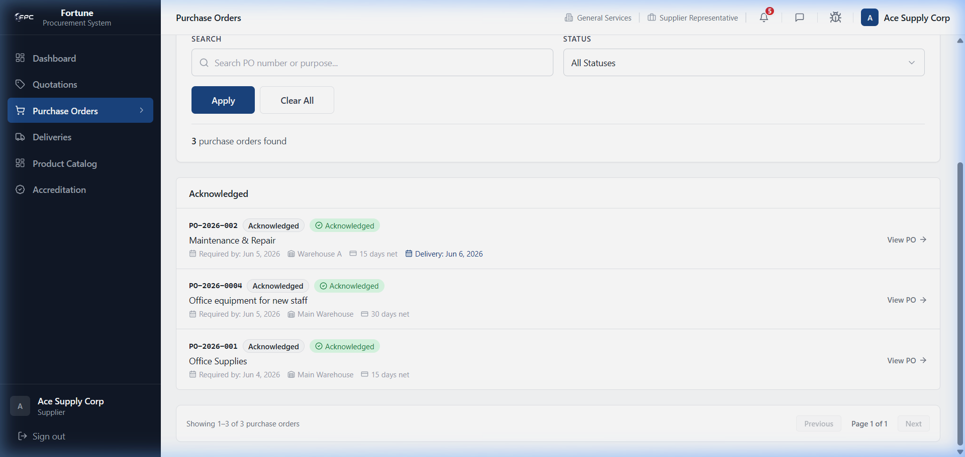
Caption: Supplier PO List (Scrolled) - Displays historical delivered POs and transaction totals.
Workflow 2: Acknowledging a PO
1. Click View PO on a pending order. Verify pricing, payment terms, and items requested. Select a Commitment Date, write optional remarks, and click Acknowledge PO.
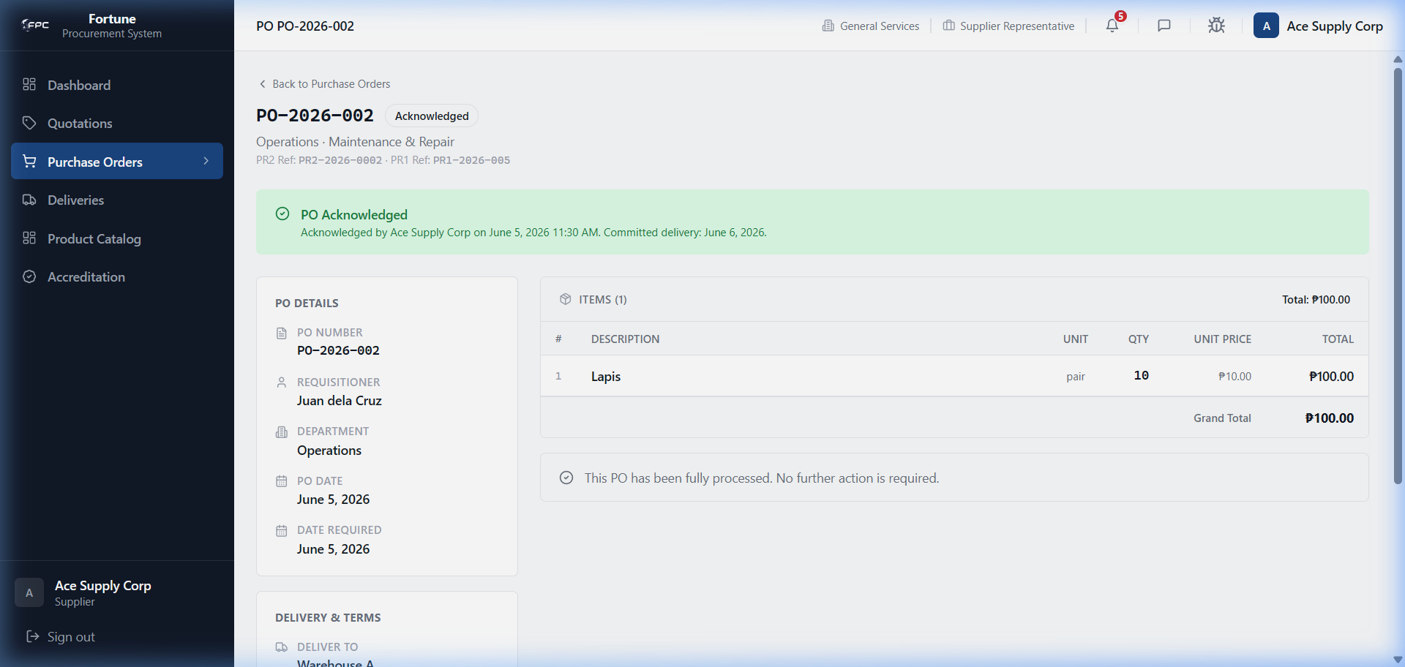
Caption: PO Detail View (Supplier) - Displays details of an issued PO, showing the items table, billing address, and commercial terms.
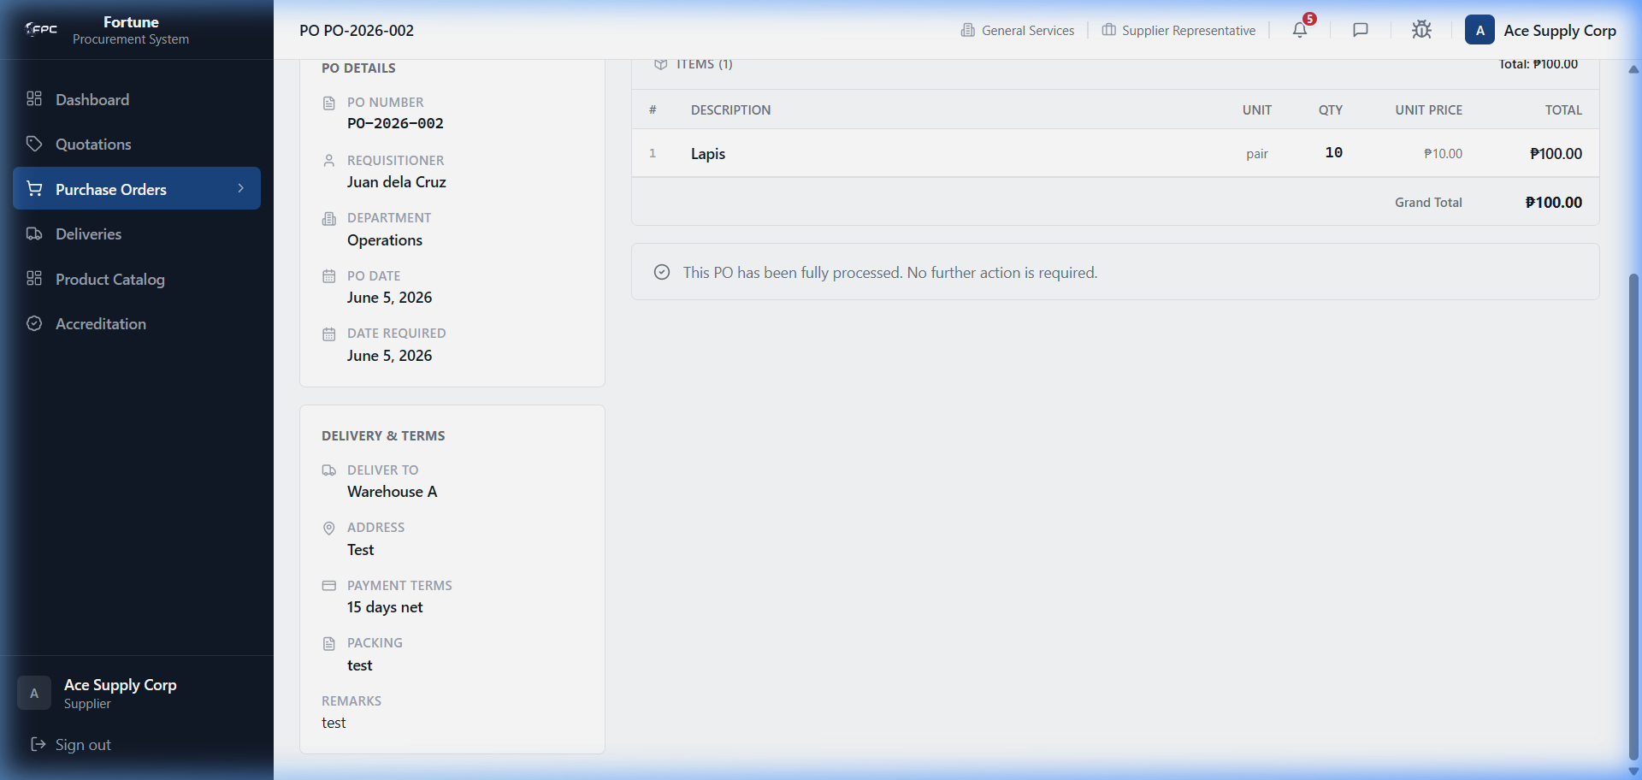
Caption: PO Acknowledgment Actions - The commitment panel. Suppliers select a committed delivery date, add remarks, and click 'Acknowledge PO'.

Status Glossary
Status Badge | Description
Pending Acknowledgment | Orange badge indicating the PO was sent to the supplier but has not been acknowledged.
Acknowledged | Green badge indicating the supplier accepted the PO and committed to a delivery date.
Delivered | Grey badge indicating warehouse receipt of items and closed PO.

Expected Outcome
PO acknowledgment generates an active shipping record in the deliveries module.

5.6 Delivery Management (/supplier/delivery)

Module Purpose
Allows suppliers to schedule dispatches, attach digital receipts, and write transit logs.

Module UI Map
Component Type | Element Label / Value | Description / Action
Table | Deliveries Table | Columns: Delivery Number, PO Reference, Estimated Delivery, Status, Action
Link | View / Update | Opens the shipping tracker detail page
Select Field | Status Dropdown | Update status (Scheduled, In Transit, Delayed, Delivered)
Date Picker | Actual Delivery Date | Date picker for scheduling
Upload Slot | Delivery Receipt / Invoice | Attachments slots for digital receipts
Button | Confirm Update | Submits status update and adds log entry

Step-by-Step Workflows
Workflow 1: Reviewing Shipments
1. Select Deliveries from the sidebar. Inspect statuses of current dispatches.
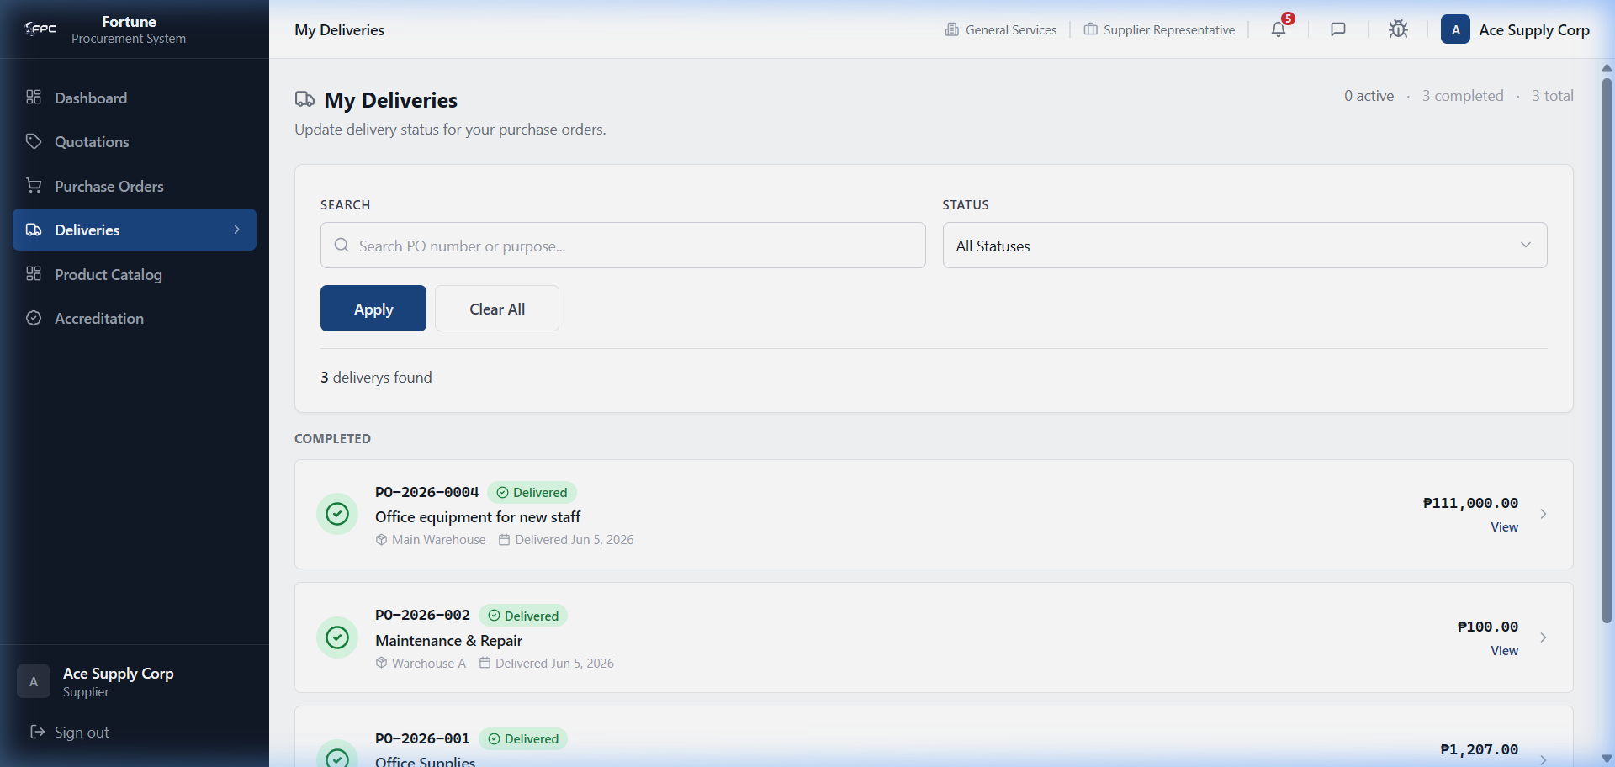
Caption: Supplier Deliveries - Lists dispatches showing estimated delivery dates, related PO references, and status badges (Scheduled, In Transit, Delivered).
Workflow 2: Dispatching a Shipment
1. Click View on a scheduled shipment. Under Update Status, select In Transit. Select delivery date. Upload digital PDF copies of the Delivery Receipt (DR) and Invoice. Click Confirm Update.
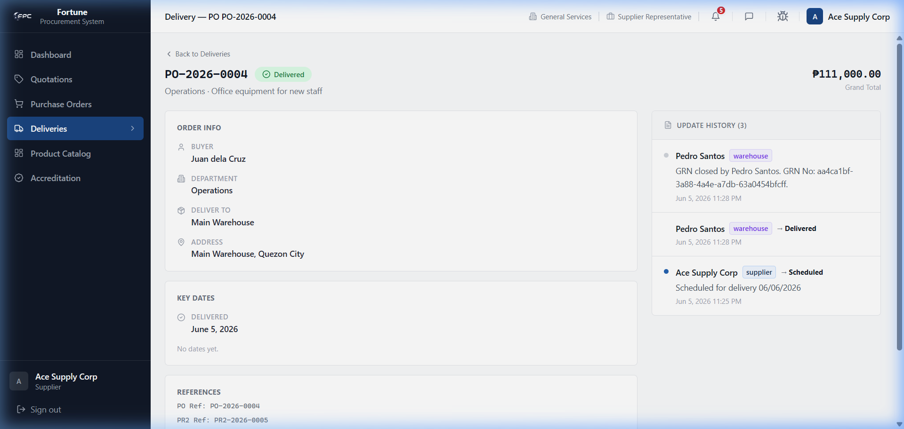
Caption: Delivery Detail (Supplier) - Displays transit details. Suppliers update status to 'In Transit' or 'Delivered' and upload Delivery Receipt (DR) / Invoice documents.
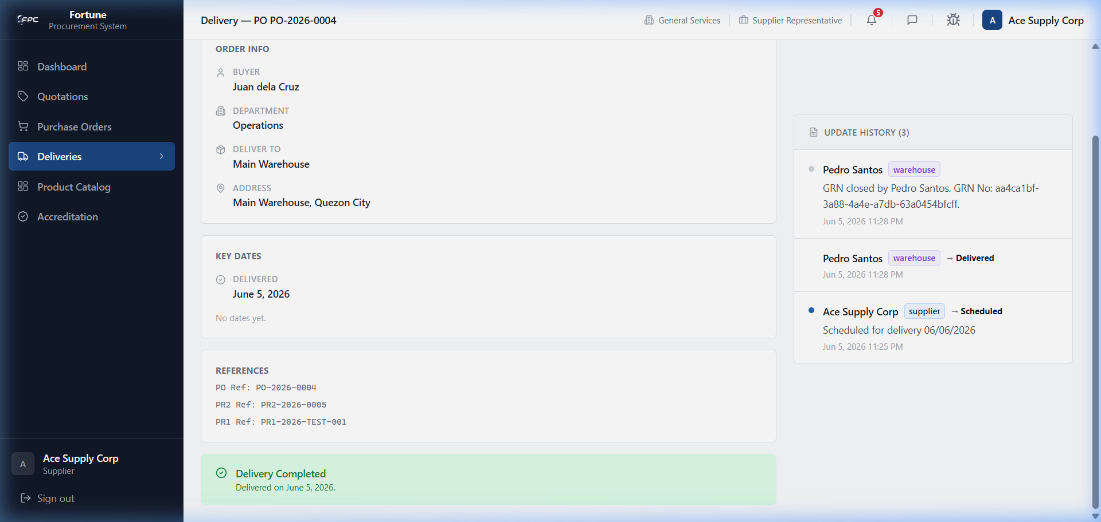
Caption: Delivery Dispatch Status Actions - Dropdown selectors to change shipment states and a chronological transit history log.

Status Glossary
Status Badge | Description
Scheduled | Yellow status indicating the shipment date is set but items have not left the facility.
In Transit | Blue status indicating the shipment is currently en route to the warehouse.
Delivered | Green status indicating items were successfully delivered to the warehouse.

Expected Outcome
Updating status logs updates the delivery timeline immediately for warehouse operators.

5.7 Message Center

Module Purpose
Enables direct communication with procurement staff and buyers.

Module UI Map
Component Type | Element Label / Value | Description / Action
Sidebar | Conversation List | Shows active chats with preview text
Search Input | User Search | Find procurement staff to message
Thread Panel | Message Thread | Type and send messages; view read status
Upload | Attachment | Attach files (max 10 MB, up to 5 per message)

Step-by-Step Workflows
1. Click the messages icon in the top header. 2. Use User Search to find a procurement contact. 3. Select or start a conversation. 4. Type your message and press Send.
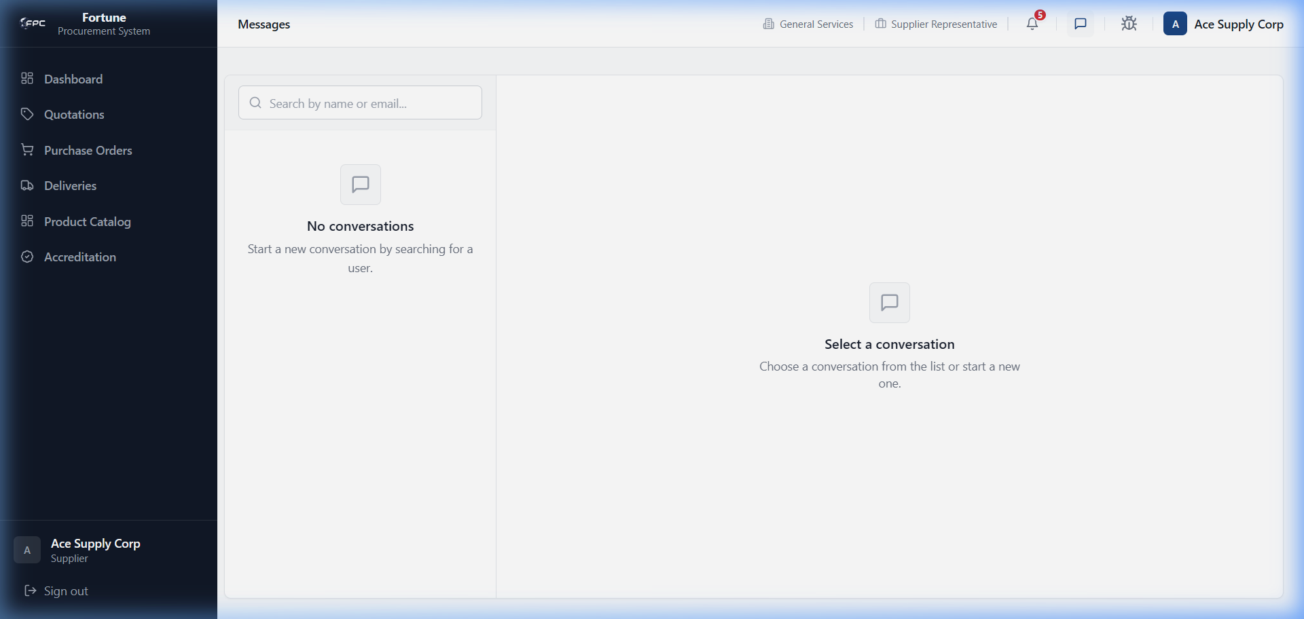
Caption: Supplier Messages - Communication interface showing a direct conversation with a procurement staff member.

Expected Outcome
Message is delivered to the recipient and appears in both users' conversation lists.

5.8 User Profile

Module Purpose
Enables the supplier representative to manage display credentials and update security passwords.

Module UI Map
Component Type | Element Label / Value | Description / Action
Input | Full Name | Editable display name
Read-only | Role / Company | Supplier account metadata
Input | Current Password | Required to change password
Input | New Password / Confirm | Set a new password
Button | Save Name / Change Password | Submit profile updates

Step-by-Step Workflows
1. Click your avatar in the top header. 2. Update your display name and click Save Name, or enter current and new passwords and click Change Password.
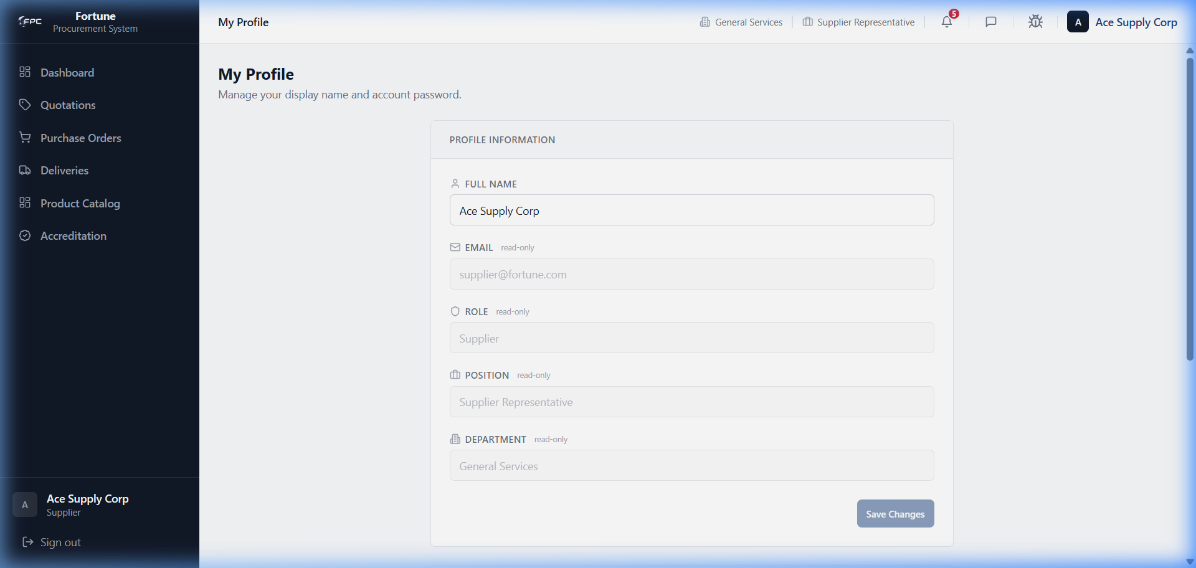
Caption: Supplier Profile - Displays display name credentials and password security settings.

Expected Outcome
Profile name or password updates are saved; you remain logged in with updated credentials.

5.9 Bug Reporting Tool

Module Purpose
Enables reporting portal interface bugs to application administrators.

Module UI Map
Component Type | Element Label / Value | Description / Action
Input | Title / URL / Severity | Required bug summary fields
Textarea | Description / Expected Behavior | Detailed issue explanation
Button | Submit Bug Report | Sends report to admin notification email

Step-by-Step Workflows
Workflow 1: Validation
1. Click Submit without filling fields. Browser highlights required inputs.
Workflow 2: Submit a Bug
1. Fill title, URL, severity, description, and expected behavior. Click Submit Bug Report.
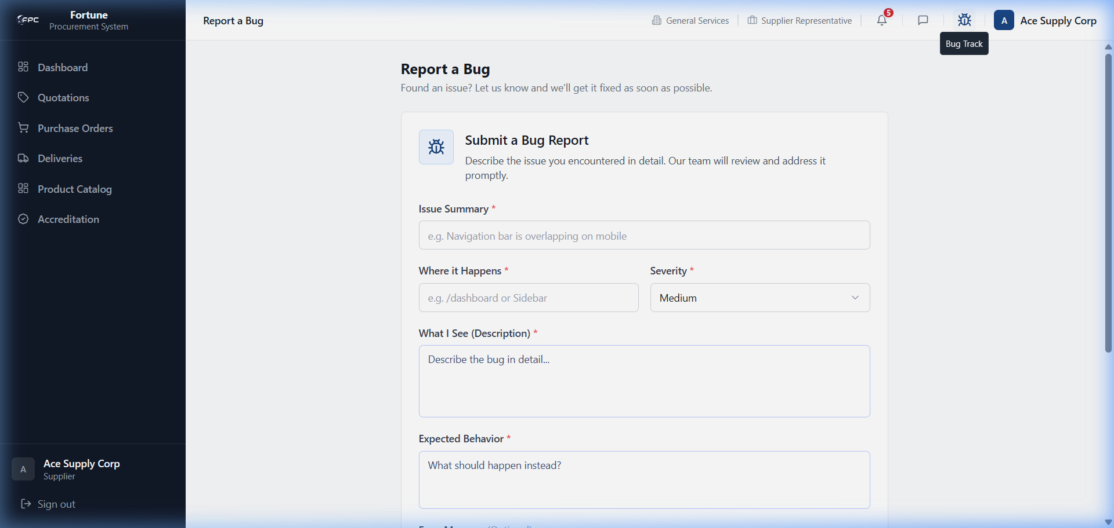
Caption: Supplier Bug Report - Form to report technical issues, showing severity, summary, and location inputs.
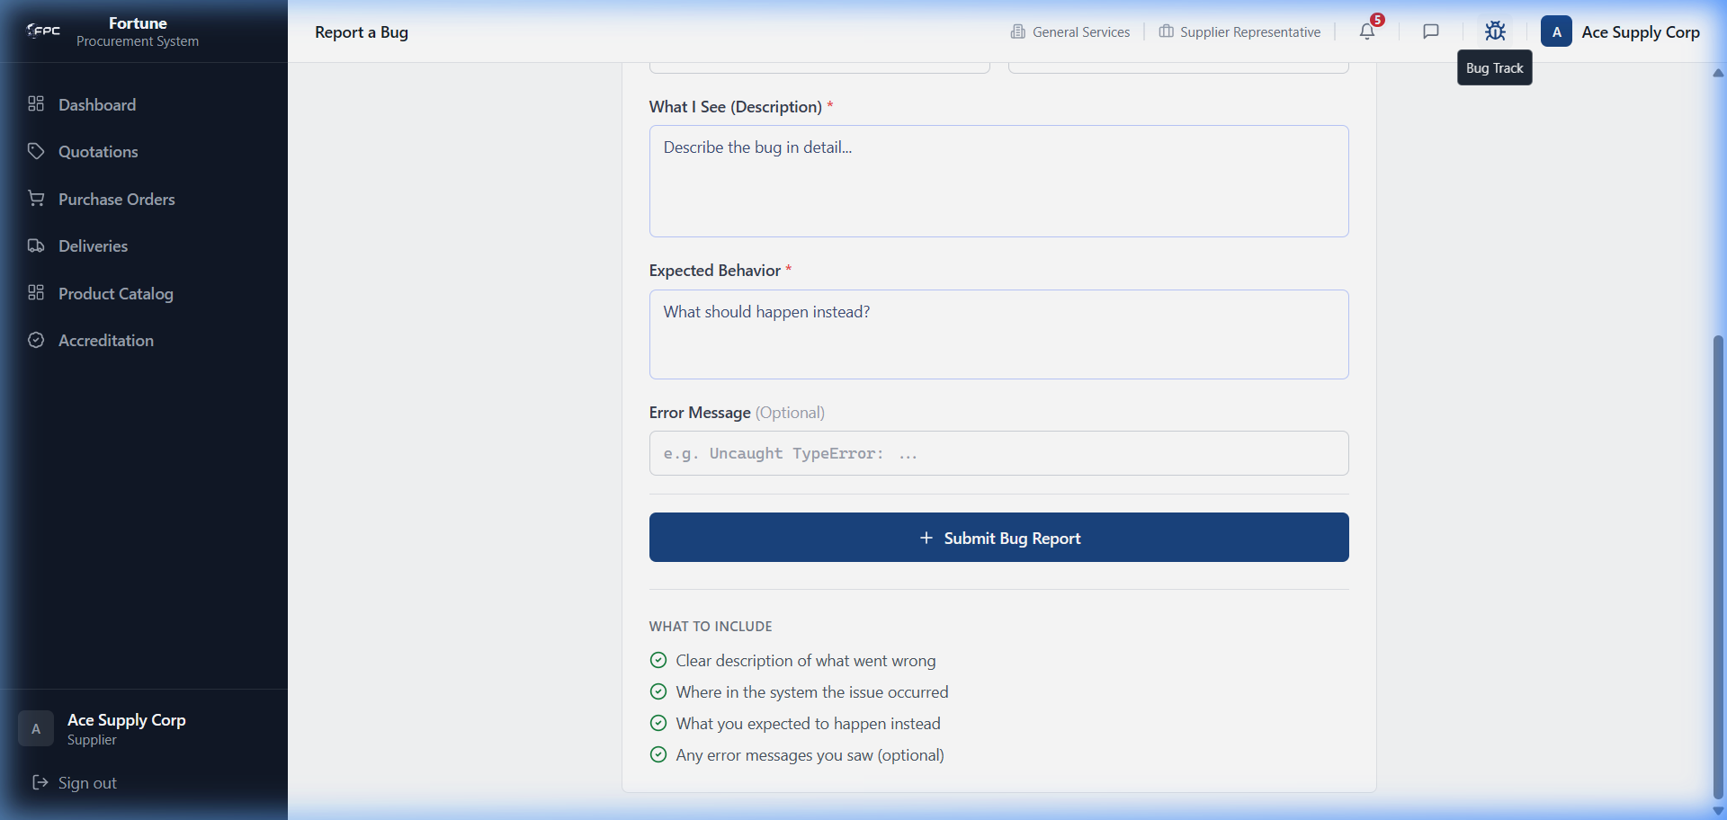
Caption: Supplier Bug Report (Scrolled) - Displays the submission buttons and error log inputs.

Expected Outcome
Bug report is saved and an email alert is sent to the configured admin address.

Role: TSQA
The TSQA (Technical Services & Quality Assurance) Staff performs Receiving & Storage Evaluations (RSE) on supplier sample products, records test findings, and determines if catalog submissions meet standards.

6.1 RSE Management

Module Purpose
Enables TSQA staff to view active evaluations and self-assign tasks.

Module UI Map
Component Type | Element Label / Value | Description / Action
Tabs | Created, Assigned, Under Review, Passed, Failed | Filters evaluation queue by active RSE status
Table | RSE Queue Table | Columns: RSE Number (RSE-YYYYMM-XXXX), Supplier, Product, Accreditation Doc, Action
Button | Self-Assign | Assigns active RSE to current TSQA logged-in user

Step-by-Step Workflows
1. Navigate to RSE Queue, click Created tab to see unassigned tasks. Click Self-Assign. Status changes to 'Assigned', transferring the record to your personal worklist.
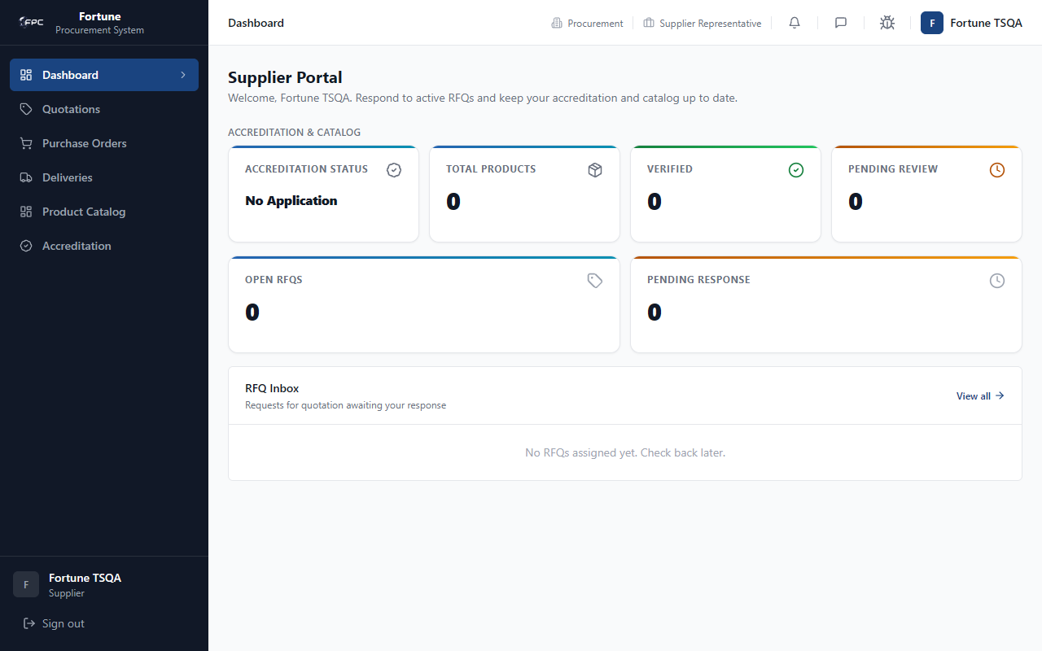
Caption: TSQA RSE Queue - Landing page for TSQA reviewers. It lists active RSE records, categorized by tabs (Created, Assigned, Under Review, Passed, Failed). Reviewers click 'Self-Assign' to assume responsibility.

Expected Outcome
RSE moves to Assigned status and appears in your personal worklist.

6.2 Sample Inspection

Module Purpose
Allows recording laboratory findings and uploading verification reports.

Module UI Map
Component Type | Element Label / Value | Description / Action
Button | Start Review | Changes status to 'Under Review'
Textarea | Test Findings | Enter lab measurements, test details, and results
Textarea | Inspection Remarks | Enter general inspection remarks
Upload Slot | Inspection Report File | Upload formal test report (PDF/JPG)
Button | Save Progress | Saves draft of current test values

Step-by-Step Workflows
1. Open assigned RSE. Click Start Review. Enter metrics in Test Findings and remarks in Inspection Remarks. Upload test report PDF. Click Save Progress.

Caption: TSQA Sample Inspection - The laboratory data entry page. Reviewers click 'Start Review', record test findings and remarks, and upload the formal test report file.

Expected Outcome
RSE status changes to Under Review; findings and report are saved.

6.3 Verdict & Product Approval

Module Purpose
Enables submitting final evaluation decisions on product accreditation.

Module UI Map
Component Type | Element Label / Value | Description / Action
Button | Submit Passed Verdict | Approves product; updates status to Passed and product to Verified
Button | Submit Failed Verdict | Rejects product; requires failure reason remarks

Step-by-Step Workflows
1. Open RSE under review. To approve, click Submit Passed Verdict. To reject, click Submit Failed Verdict, enter reasons in the remarks popup, and click Confirm.

Caption: TSQA RSE Verdict - The verdict panel. Reviewers select 'Submit Passed Verdict' (verifying the product) or 'Submit Failed Verdict' (requiring a failure reason).

Status Glossary
Status Badge | Description
Passed | Product verified; supplier product status set to Verified
Failed | Product rejected; supplier notified

Expected Outcome
Product status updates to Verified or Rejected; supplier and procurement are notified.

Role: Super Admin
The Super Admin has complete control over system configurations, user directory setups, master data structures, dynamic approval workflows, and module visibilities. The administrative accounts are managed through position-based permissions and all critical administrator operations are tracked in detail by the audit logs. The primary account used is admin@fortune.com.

7.1 Dashboard (/admin or /dashboard)

Module Purpose
Monitors system user totals and records recent administrative activity.

Module UI Map
Component Type | Element Label / Value | Description / Action
KPI Card | Total Users | Total count of active and inactive user accounts
KPI Card | Roles | Count of roles defined in the system
KPI Card | Positions | Count of organizational positions
KPI Card | Departments | Count of company departments
KPI Card | Audit Logs | Total number of captured activity logs
Table | Recent Activity Table | List of the 5 most recent audit log records
Link | View All | Redirects to the full Audit Logs search dashboard

Step-by-Step Workflows
1. Access the administrator workspace. The system displays dashboard metric cards showing total system volume. Scroll down to check the list of recent actions. Click on the View All link to load the complete historical audit log grid.
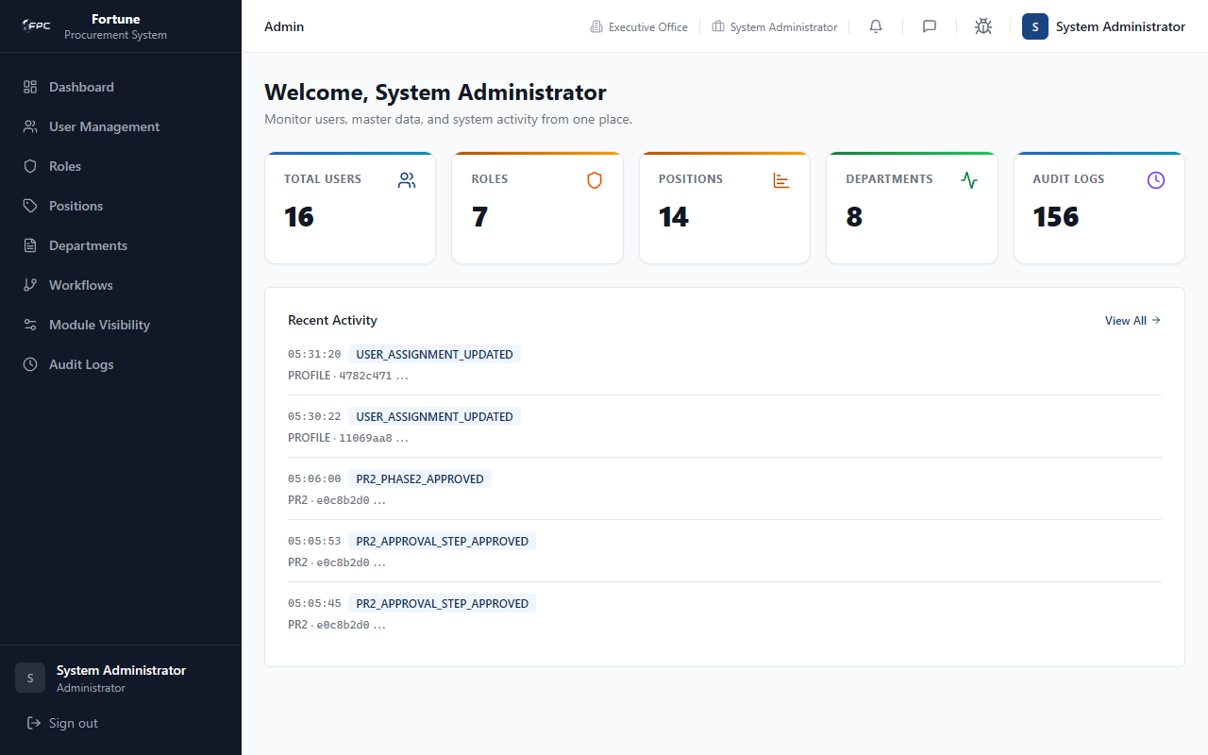
Caption: Admin Dashboard - Operational dashboard displaying KPI counters for total users, roles, positions, departments, and audit logs. The bottom half contains a real-time list of recent activity logs showing timestamps, actions, and references.

Expected Outcome
Dashboard metrics and recent activity load; View All navigates to the full audit log page.

7.2 User Management (/admin/users)

Module Purpose
Enables provisioning new user accounts, modifying user roles, positions, and departments, resetting account passwords, and deactivating or reactivating access.

Module UI Map
Component Type | Element Label / Value | Description / Action
Button | Create User | Opens user account creation form modal
Search Input | Search | Filters user records by name, email, or employee ID
Dropdown Select | Role | Filters user records by role
Dropdown Select | Department | Filters user records by department
Table | User Directory Table | Columns: Name/Email, Role, Department, Position, Status badge, Actions
Action Link | Edit | Opens user assignment edit modal
Action Link | Deactivate | Opens account deactivation dialog (displays warning status)
Action Link | Reactivate | Opens account reactivation dialog
Action Link | Reset Password | Opens password change modal
Form Fields | Full Name, Email, Role, Department, Position, Password | Create user form inputs

Step-by-Step Workflows
Workflow 1: Creating a User Account
1. Click Create User. Input the user's Full Name, Email, select their Role, Department, and Position from the dropdown lists. Type a strong Password and click Save.
Workflow 2: Modifying User Assignments
1. Search for the target user. Click the Edit link next to their name. In the Edit User Assignment modal, select the new Role, Department, or Position, and click Save.
Workflow 3: Resetting a User Password
1. Click the Reset Password action link for the user. Enter a new password in the input field, and click Confirm to overwrite their credentials.
Workflow 4: Deactivating/Reactivating an Account
1. To disable a user, click the Deactivate link. Review the deactivation warning dialog and click Confirm. To restore access, click Reactivate and confirm in the reactivate dialog.
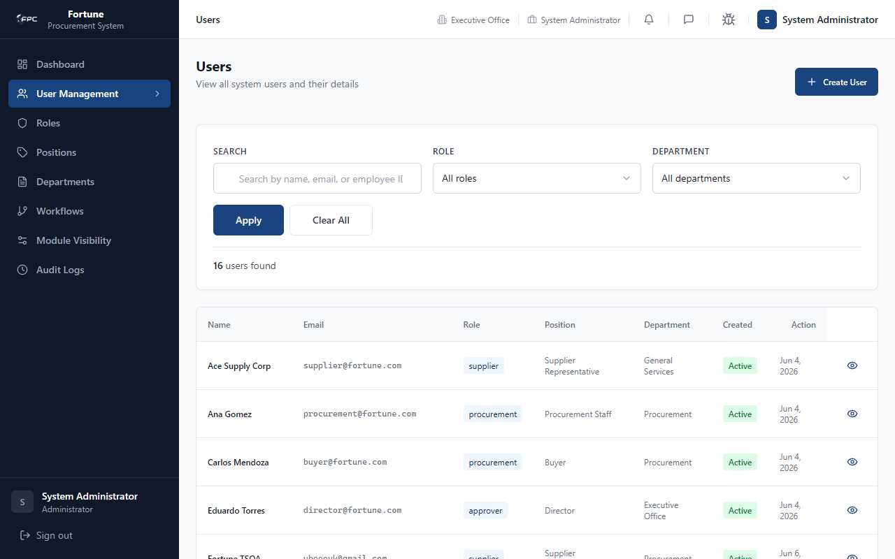
Caption: Admin User Management - User management list view. Features include text searching, role and department filtering, a directory list displaying active/inactive statuses, and actions to edit, deactivate, reactivate, or reset passwords.

Expected Outcome
User records are created, updated, deactivated, reactivated, or password-reset successfully; changes take effect on next login.

7.3 Roles Management (/admin/roles)

Module Purpose
Provides a read-only overview of system roles and shows user counts assigned to each role.

Module UI Map
Component Type | Element Label / Value | Description / Action
Table | Roles Table | Columns: Role Name, Users count badge, Created Date

Step-by-Step Workflows
1. Click Roles in the navigation sidebar. Inspect the roles list. Check the Users count badge to see how many accounts are assigned to each role (e.g., admin, employee, warehouse, procurement, approver, supplier, tsqa).
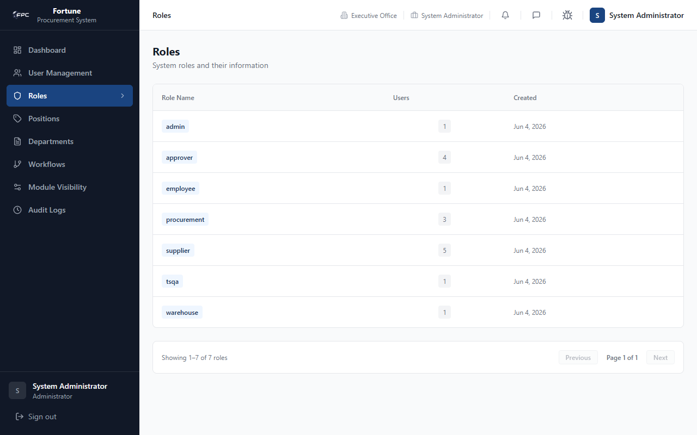
Caption: Roles Management - Displays system roles, showing the specific role names, the count of active users currently associated with each role, and the date each role was created.

Expected Outcome
Roles list displays with accurate user counts per role (read-only view).

7.4 Positions Management (/admin/positions)

Module Purpose
Manages job positions, maps them to system roles, and controls their active state while warning of workflow dependencies.

Module UI Map
Component Type | Element Label / Value | Description / Action
Button | Add Position | Launches the position creation dialog
Table | Positions Table | Columns: Position Title, Role, Status badge, Created Date, Actions
Action Link | Edit | Launches the edit position dialog
Action Link | Deactivate | Opens safety check deactivation dialog
Action Link | Reactivate | Opens reactivation dialog
Form Fields | Title, Role ID | Add/Edit position form inputs
Warning Banner | Workflow Usage Notice | Displays alerts if the position is currently referenced in active approval workflows

Step-by-Step Workflows
Workflow 1: Creating a Position
1. Click Add Position. Enter the Title and select the corresponding Role ID. Review warnings if applicable, and click Save.
Workflow 2: Editing a Position
1. Locate the position, click Edit. Modify the Title or change the assigned Role. Click Save. If the position is used in active approval workflows, a warning banner will appear.
Workflow 3: Deactivating a Position
1. Click Deactivate. The system checks active user counts and workflow step configurations. If the position is actively used in approval steps, a warning alert will block deactivation until the steps are updated. Click Confirm to finalize deactivation.
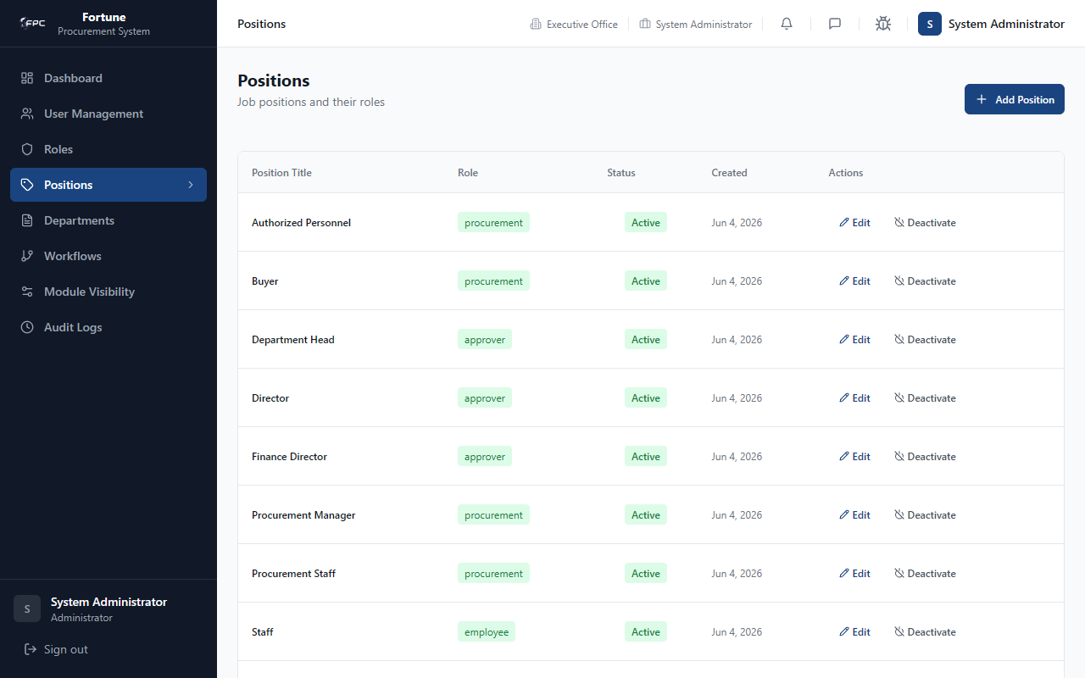
Caption: Positions Management - Lists job positions and their associated system roles, showing status badges (Active/Inactive) and options to edit, deactivate, or reactivate positions.

Expected Outcome
Positions are created, edited, or deactivated; workflow dependency warnings block unsafe deactivations.

7.5 Departments Management (/admin/departments)

Module Purpose
Configures organizational departments and their short codes, protecting departments that have active users assigned.

Module UI Map
Component Type | Element Label / Value | Description / Action
Button | Add Department | Opens the department creation dialog
Table | Departments Table | Columns: Department Name, Code badge, Status badge, Users count badge, Created Date, Actions
Action Link | Edit | Opens edit department dialog
Action Link | Deactivate | Opens safety check deactivation dialog
Action Link | Reactivate | Opens reactivation dialog
Form Fields | Name, Code | Add/Edit department inputs

Step-by-Step Workflows
Workflow 1: Creating a Department
1. Click Add Department. Enter the Name (e.g. operations) and a short Code (e.g. OPS). Click Save.
Workflow 2: Editing a Department
1. Click Edit on the department row. Update the Name or Code fields, and click Save.
Workflow 3: Deactivating a Department
1. Click Deactivate. Review the safety dialog which displays the count of active users currently in the department. Click Confirm to disable the department.
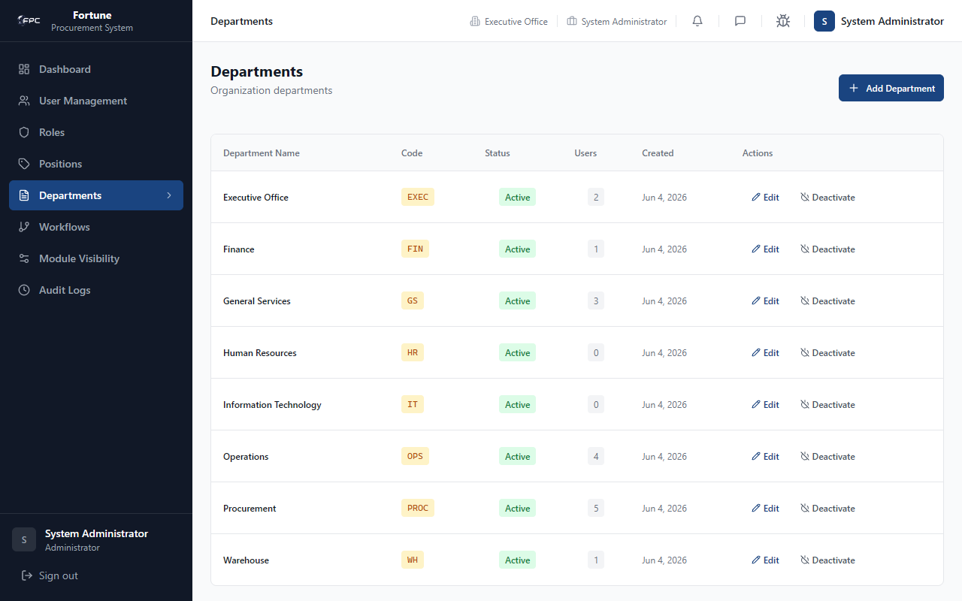
Caption: Departments Management - Directory of departments showing department codes, status badges, the number of users assigned to each department, and action buttons.

Expected Outcome
Departments are created, edited, or deactivated; active-user safety dialog prevents unsafe deactivation.

7.6 Workflow Configuration (/admin/workflows)

Module Purpose
Defines and configures dynamic, sequence-based approval pipelines for different document types, validating rules and protecting active steps.

Module UI Map
Component Type | Element Label / Value | Description / Action
Table | Workflows Table | List of workflows: Code, Name, Steps count, Active Instances, Status badge
Panel Panel | Workflow Step Editor | Displays active instances count, Add Step button, stepper visualization, and step list table
Button | Add Step | Launches the step creation dialog
Action Button | Edit | Launches the step edit dialog
Action Button | Delete | Opens delete step dialog (with active instance check)
Form Fields | Step Order, Step Label, Role, Position, Min Value, Max Value | Form fields inside the Add/Edit Step modal

Step-by-Step Workflows
Workflow 1: Navigating and Selecting a Workflow
1. Select a workflow from the list (e.g., PR1_APPROVAL). The Workflow Step Editor panel loads, showing the dynamic stepper diagram.
Workflow 2: Adding an Approval Step
1. Click Add Step. Select the Step Order number (determines approval sequence). Write a Step Label. Choose the required Role and Position. If the step is threshold-based, enter the Min Value and Max Value range. Click Save. The system validates that step orders are contiguous and do not skip sequences.
Workflow 3: Deleting an Approval Step
1. Click Delete on the target step. The system checks if there are any active document instances currently pending on this workflow. If active documents exist, the system blocks the deletion. If safe, click Confirm Delete.
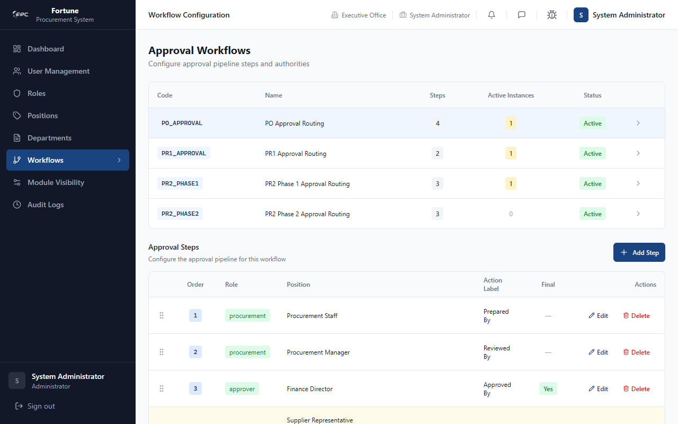
Caption: Workflows Configuration - Approval workflow editor. Clicking on a workflow loads its dynamic signatory steps. Stepper configurations include step order sequence, role and position requirements, and threshold values.

Expected Outcome
Workflow steps are added, edited, or deleted; active-instance guard prevents deleting steps with pending documents.

7.7 Module Visibility (/admin/module-visibility)

Module Purpose
Controls which sidebar links are visible to users. Admins can toggle default visibilities for roles or customize menu visibility per position, including borrowing modules from other roles.

Module UI Map
Component Type | Element Label / Value | Description / Action
Dropdown Select | Role | Select the target role for configuration
Dropdown Select | Position Scope | Select role default or a specific position
Table | Role Modules Table | Columns: Visible (Switch toggle), Label, href, module_key
Table | Added Modules from Other Roles | Columns: Label, Source Role, module_key, Remove action (Only visible in position scope)
Button | Add Module | Opens add borrowed module modal
Button | Save Changes | Saves visibility rules to the database
Form Fields | Source Role, Select Modules | Add modules modal inputs

Step-by-Step Workflows
Workflow 1: Toggling Default Role Visibility
1. Select a Role. Keep Position Scope as 'Role default'. Toggle the Switch icons in the table to show/hide specific links. Click Save Changes.
Workflow 2: Borrowing Modules for a Position
1. Select a Role. Select a specific Position from the scope dropdown. Under 'Added Modules from Other Roles', click Add Module. Select the Source Role, check the boxes for the modules you wish to add, and click Add. Review the list of added modules and click Save Changes.
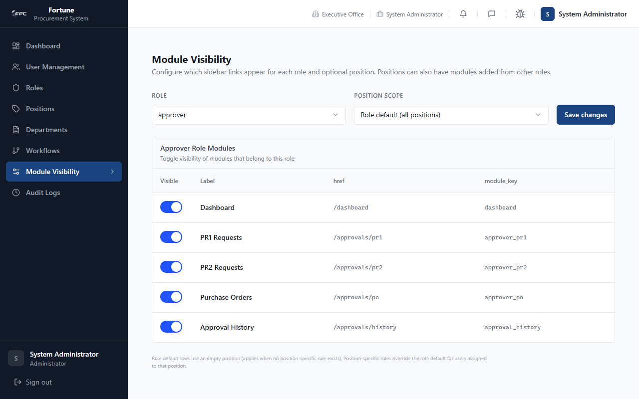
Caption: Admin Module Visibility - Visibility controls. Admins select a role and position scope, toggle switches to show/hide standard modules, and borrow pages from other roles using checkable selectors.

Expected Outcome
Saved visibility rules update the sidebar for the selected role/position on next page load.

7.8 Audit Logs (/admin/audit)

Module Purpose
Provides a searchable and filterable database of system operations, showing actor details, IP addresses, and payload before/after state changes.

Module UI Map
Component Type | Element Label / Value | Description / Action
Input search | Search | Filters logs by action, actor email/name, or document reference
Dropdown Select | Document Type | Filters logs by document type
Dropdown Select | Action | Filters logs by exact action name
Date Pickers | Date Range | Filters logs by start and end timestamps
Table | Audit Logs Table | Columns: Action, Actor, Document Type, Document Reference, IP Address, Timestamp
Drawer Panel | Audit Log Detail | Displays complete log details, including actor User Agent and database payload JSON tree

Step-by-Step Workflows
1. Access the Audit Logs workspace. Type a query in search or apply filters to update the logs table. Click on a log row to open the Audit Log Detail drawer. Expand the formatted JSON tree to review the exact payload fields changed before and after the action.
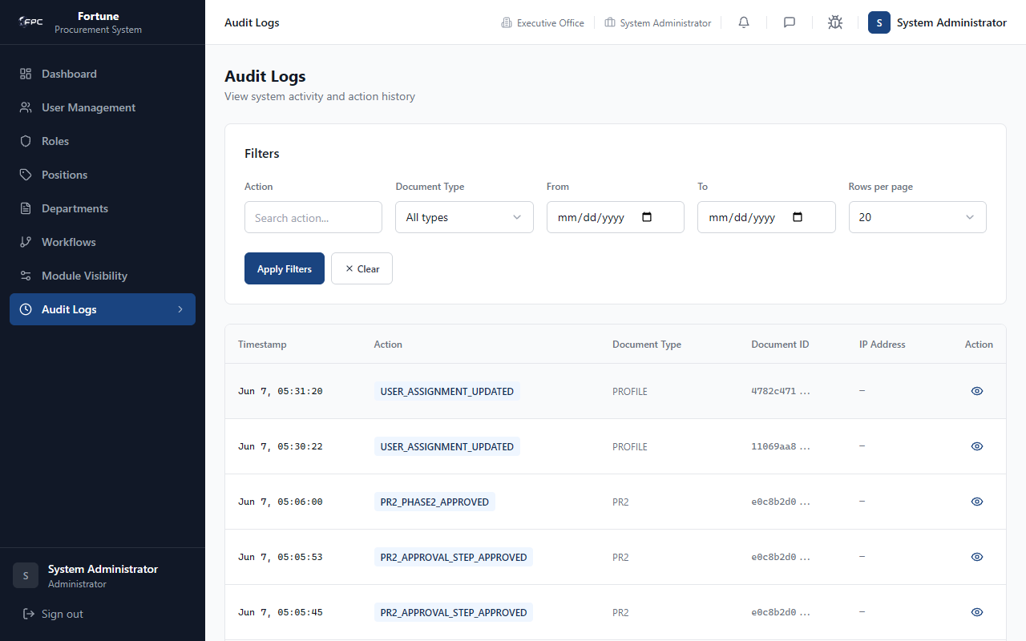
Caption: Admin Audit Logs - System audit list view. Displays action histories, IP addresses, and timestamps with searching and filtering. Row clicks open details to view exact payload state transitions.

Expected Outcome
Filtered audit log results display; row click opens detail drawer with full payload JSON.

Troubleshooting & FAQs
This section addresses the most commonly encountered issues within the Fortune Procurement System. Refer to the relevant sub-section for your problem category. If an issue persists after following the steps below, contact your system administrator.

8.1 Login & Authentication
Problem | Likely Cause | Resolution
Cannot log in — 'Invalid credentials' error | Wrong email or password entered | Re-enter credentials carefully. Use the correct company email. Passwords are case-sensitive.
Account is locked / deactivated message displayed | Administrator has deactivated the account | Contact your system administrator to reactivate the account.
Page shows 'Unauthorized' after login | Session token expired or role not properly assigned | Sign out, clear browser cache, and sign back in. If the problem persists, ask the admin to verify your role assignment.
Forgot password — no reset link received | System SMTP configuration issue or email in spam folder | Check the spam/junk folder. If not found, contact the administrator to manually reset your password.
Redirected to login page mid-session | Session timeout (default 8 hours) or browser cookie cleared | Sign in again. Keep the browser tab active to avoid session expiry.

8.2 Purchase Requisition (PR1)
Problem | Likely Cause | Resolution
Cannot submit PR1 — 'Purpose is required' validation | Purpose dropdown was not selected | Select a Purpose category from the dropdown before clicking Submit PR1.
Cannot submit PR1 — 'At least one item is required' | No line items were added to the Items Requested table | Click Add Item, fill in Description, Unit, and Qty, then resubmit.
PR1 status stuck at 'Pending Warehouse Validation' | Warehouse personnel has not yet reviewed the request | Follow up with the Warehouse team. Warehouse must validate each item's stock-on-hand before the PR1 progresses.
PR1 status shows 'Returned for Revision' | An approver or warehouse user has requested corrections | Open the PR1 details, review the notes left by the approver, correct items, and resubmit.
Item Code field is empty after selecting an item | Item does not exist in the product catalog | Ask the Admin or Procurement Officer to add the product to the catalog first.
SOH shows 0 but item exists in warehouse | Warehouse inventory record not yet updated | Contact the Warehouse team to update the stock-on-hand record.

8.3 Approval Workflow
Problem | Likely Cause | Resolution
Approve / Reject buttons not visible on a document | Logged-in user is not the designated approver for the current workflow step | Verify workflow step assignments in Admin > Workflows. Only the user assigned to the active step can act.
Document is stuck at a workflow step with no visible approver | No user is assigned to the required role/position for that step | Admin must assign a user to the correct role and position in User Management.
Approver receives no email notification | SMTP configuration issue or approver email address is incorrect | Verify the SMTP server settings with the administrator. Confirm the approver's email address in their profile.
Approval was completed but status did not advance | Workflow step requires multiple approvers (if configured) | Check if the workflow has a multi-step configuration. All required step signatories must approve before advancing.

8.4 RFQ & Supplier Quotation
Problem | Likely Cause | Resolution
Supplier cannot see the RFQ invitation link | Email delivery failed or link expired | Procurement Officer should re-send the RFQ invitation from the RFQ detail page.
Supplier submitted a quote but it does not appear in canvassing | Quote was submitted after the RFQ closing deadline | Only quotes submitted before the deadline are included. Re-open the RFQ if necessary.
Cannot award a bid — 'Pending TSQA Review' label shown | Items flagged as Raw Materials require TSQA inspection before award | Wait for the TSQA team to complete the Raw Sample Evaluation (RSE). The award button becomes active after TSQA approval.
RFQ shows 0 invited suppliers | No accredited suppliers are linked to the requested item category | Procurement must accredit at least one supplier and link the relevant products before opening an RFQ.

8.5 Purchase Order (PO)
Problem | Likely Cause | Resolution
PO cannot be generated — PR2 not fully approved | PR2 is still in Phase 1 or Phase 2 approval | Wait for all PR2 approvers to complete sign-off. PO generation is only available after full PR2 approval.
Supplier did not acknowledge the PO | Supplier portal access issue or missed email notification | Re-send the PO notification from the PO detail page. Confirm the supplier's portal login credentials.
PO total amount does not match expected value | Canvassed unit prices have changed or additional items were added | Review line-item prices in the PO details and compare to the awarded RFQ canvass sheet.

8.6 Warehouse & Goods Receipt Note (GRN)
Problem | Likely Cause | Resolution
GRN cannot be created — delivery not found | Supplier has not yet updated their delivery schedule in the portal | Ask the supplier to log in and confirm the delivery schedule. The GRN option appears once confirmed.
Item quantity received does not match PO quantity | Partial delivery or supplier short-shipped | Record the actual received quantity in the GRN. Mark over/under delivery accordingly.
GRN status stuck at 'Pending Warehouse Confirmation' | Warehouse has not yet reviewed and closed the GRN | The Warehouse Manager must open the GRN and click Confirm Receipt to finalize.

8.7 TSQA & Raw Sample Evaluation
Problem | Likely Cause | Resolution
RSE task does not appear in the TSQA queue | Product was not flagged as Raw Material in the PR1 | Ensure the 'Raw Mat.' checkbox is ticked when creating the PR1 line item. Only flagged items trigger the TSQA evaluation queue.
RSE result cannot be submitted — form validation error | Required evaluation fields are left empty | Complete all mandatory evaluation fields (Appearance, Odor, Texture, Moisture, etc.) before submitting.
Product status remains 'Pending TSQA Review' after evaluation | RSE was saved as draft, not submitted | Open the RSE record and click the Submit/Finalize button to publish the result.

8.8 Notifications & Messaging
Problem | Likely Cause | Resolution
Notification badge count does not decrease after reading | Page not refreshed after marking as read | Click 'Mark all as read' inside the notification bell dropdown. If count persists, refresh the page.
Message not received by intended recipient | Recipient has no active user account or inbox | Confirm the recipient's user account is active in Admin > Users.
Email notifications not arriving | SMTP server settings incorrect or email blocked | Contact the administrator to verify the outgoing mail server configuration.

8.9 General & Administration
Problem | Likely Cause | Resolution
Cannot deactivate a user — 'User is in active workflow' error | The user is a pending signatory on one or more open documents | Reassign the active workflow steps to another user before deactivating.
Cannot delete an approval workflow step — 'Active documents exist' error | One or more documents are currently pending on that step | Wait for those documents to complete or be withdrawn before modifying the step.
Sidebar module not visible to a user | Module visibility was toggled off for that role/position | Go to Admin > Module Visibility, select the relevant role/position, and toggle the module to visible.
User can access a page they should not | Module borrowed from another role without intent | Go to Admin > Module Visibility, select the position scope, and remove the borrowed module from the Added Modules table.
Audit log does not show expected action | Action was performed before audit logging was enabled, or filter is narrowing results | Clear all filters in Audit Logs and search by actor email or document reference.

Appendices

Appendix A – System Roles Summary
The following table summarizes each system role and the primary modules accessible to that role within the Fortune Procurement System.
Role | Primary Modules | Key Capabilities
Employee / Requestor | Dashboard, My Requests (PR1), Substitute Review, Delivery Status, Messages | Submit PR1, review substitute proposals, confirm deliveries
Warehouse Personnel | Warehouse Dashboard, PR1 Validation, GRN Management, Delivery Tracking | Validate stock-on-hand, create and close GRNs
Procurement Officer | Procurement Dashboard, RFQ Management, Canvassing, PR2 Management, Purchase Orders, Supplier Accreditation | Manage supplier sourcing, generate POs, accredit suppliers
Approver | Approvals Inbox (PR1, PR2, PO), Approval History, Messages | Sign-off on documents based on workflow step assignment
Supplier | Supplier Portal (Quotations, Deliveries, Products, Profile) | Submit quotations, manage product catalog, schedule deliveries
TSQA | TSQA Dashboard, Raw Sample Evaluations (RSE), Product Review Queue | Inspect raw material samples and publish evaluation verdicts
Administrator | User Management, Positions, Departments, Workflows, Module Visibility, Audit Logs | Full system configuration, user lifecycle, and audit access

Appendix B – Notification Triggers
The following events automatically generate in-app and email notifications to relevant stakeholders.
Trigger Event | Recipients Notified | Channel
PR1 submitted for warehouse validation | Warehouse Personnel | In-App + Email
PR1 validated by warehouse — routed for approval | Assigned PR1 Approvers | In-App + Email
PR1 approved / rejected / returned by approver | Requisitioner (Employee) | In-App + Email
Substitute item proposed by supplier | Requisitioner (Employee) | In-App + Email
Substitute item decision submitted | Procurement Officer | In-App
RFQ invitation sent | Invited Suppliers | Email (unique link)
Supplier submits quotation | Procurement Officer | In-App
RFQ canvassing completed / awarded | Awarded Supplier | In-App + Email
PR2 submitted for Phase 1 approval | Phase 1 Approvers | In-App + Email
PR2 Phase 1 approved — forwarded to Phase 2 | Phase 2 Approvers | In-App + Email
PR2 fully approved — PO ready | Procurement Officer | In-App
Purchase Order issued to supplier | Supplier | In-App + Email
Supplier acknowledges PO | Procurement Officer | In-App
Delivery scheduled by supplier | Warehouse Personnel, Employee | In-App
GRN created by warehouse | Procurement Officer, Employee | In-App
GRN closed / delivery confirmed | Requisitioner (Employee) | In-App
Raw Sample Evaluation (RSE) result published | Procurement Officer | In-App

Appendix C – Document Status Reference
This appendix provides a comprehensive reference of all document status values used across the procurement lifecycle.
Document Type | Status Value | Meaning
PR1 | Draft | Saved locally; not yet submitted
PR1 | Pending Warehouse Validation | Submitted; awaiting warehouse stock check
PR1 | Pending PR1 Approval | Warehouse validated; routing through approvers
PR1 | Approved | Fully approved; Procurement can proceed to RFQ
PR1 | Returned for Revision | Approver requested corrections from requester
PR1 | Rejected | Permanently rejected by an approver
PR1 | Canvassing | RFQ process is active for this requisition
PR1 | Canvassing Complete | Supplier bids are awarded; PR2 stage next
PR1 | Completed (GRN Closed) | All items received at warehouse; fully closed
PR2 | Draft | Generated by procurement; not yet submitted
PR2 | Pending Phase 1 Approval | Routed to first-tier approvers
PR2 | Pending Phase 2 Approval | Phase 1 done; forwarded to second-tier approvers
PR2 | Approved | Fully approved; PO generation enabled
PR2 | Rejected | Rejected during approval phase
PO | Draft | Created; not yet sent to supplier
PO | Sent | Issued to supplier portal
PO | Acknowledged | Supplier confirmed receipt of the PO
PO | Completed | Delivery fulfilled and GRN closed
RFQ | Open | Active; accepting supplier quotations
RFQ | Closed | Bidding period ended; canvassing in progress
RFQ | Awarded | Winning supplier(s) selected
GRN | Pending Confirmation | Created; awaiting warehouse receipt confirmation
GRN | Confirmed | Warehouse confirmed receipt of all items
RSE | Pending | Raw sample submitted; awaiting TSQA inspection
RSE | Passed | Sample passed evaluation; item can be awarded
RSE | Failed | Sample failed evaluation; item disqualified

Appendix D – Procurement Lifecycle Overview
The following table outlines the complete end-to-end procurement workflow in sequential order, mapping each phase to the responsible role.
Phase | Step | Responsible Role | Output Document
1. Requisition | Employee creates and submits PR1 | Employee / Requestor | PR1
2. Validation | Warehouse verifies stock-on-hand for each item | Warehouse Personnel | PR1 (Validated)
3. PR1 Approval | Approvers review and approve/reject the PR1 | Approver | PR1 (Approved)
4. RFQ | Procurement creates RFQ and invites suppliers | Procurement Officer | RFQ
4a. TSQA Review | TSQA inspects raw material samples (if applicable) | TSQA | RSE Result
5. Canvassing | Procurement evaluates bids and awards winners | Procurement Officer | Canvass Sheet
6. PR2 | Procurement generates and routes PR2 for approval | Procurement Officer | PR2
7. PR2 Approval | Phase 1 and Phase 2 approvers sign off on PR2 | Approver | PR2 (Approved)
8. Purchase Order | Procurement generates PO and sends to supplier | Procurement Officer | PO
9. PO Approval | PO is reviewed and signed off by approvers | Approver | PO (Approved)
10. Delivery | Supplier schedules delivery; Warehouse receives | Supplier + Warehouse | Delivery Record
11. GRN | Warehouse creates and confirms Goods Receipt Note | Warehouse Personnel | GRN (Confirmed)
12. Closure | PR1 status updates to Completed (GRN Closed) | System (Automatic) | Closed PR1

Appendix E – System Configuration Checklist
Before going live or onboarding new users, administrators should verify that all of the following system settings have been configured correctly.
Configuration Item | Where to Configure | Notes
User accounts created for all staff | Admin > Users | Assign correct role and position
All company positions created | Admin > Positions | Each position must have a Role ID
All departments created | Admin > Departments | Departments must have short Code
PR1 Approval workflow configured | Admin > Workflows | Minimum 1 step required
PR2 Phase 1 Approval workflow configured | Admin > Workflows | Must not have gaps in step order
PR2 Phase 2 Approval workflow configured | Admin > Workflows | Threshold values set if amount-based
PO Approval workflow configured | Admin > Workflows | Minimum 1 step required
Module visibility set per role/position | Admin > Module Visibility | Toggle off unused modules
Supplier accounts created in portal | Admin > Users | Role must be set to Supplier
Products added to catalog | Product Catalog | Item codes must be unique
SMTP outgoing mail configured | System Settings | Test with a sample email notification

Appendix F – Role Permission Examples
The following summarizes the default access scope for each system role. Actual permissions may vary based on Module Visibility customizations configured by the administrator.
Role | Can Do | Cannot Do
Employee / Requestor | Create PR1, track own requests, review substitutes, confirm deliveries | Approve documents, access canvassing, view POs, manage users
Warehouse Personnel | Validate PR1 stock levels, create GRNs, confirm delivery receipt | Create PR1, approve PR2/PO, manage suppliers
Procurement Officer | Create RFQ, manage canvassing, generate PR2 and PO, accredit suppliers | Approve documents (unless assigned), manage users, configure workflows
Approver | Approve or reject PR1, PR2, and PO based on workflow step assignment | Create requisitions, manage products, access admin settings
Supplier | Submit quotations, manage product catalog, schedule deliveries, view own POs | Access internal documents, modify canvassing results, view other suppliers
TSQA | View RSE queue, conduct raw sample evaluations, publish pass/fail verdicts | Create or approve procurement documents, manage users
Administrator | Manage all users, configure workflows, review audit logs, set module visibility | Submit operational documents (PR1, PO) by default role

Glossary
This glossary defines key terms and abbreviations used throughout the Fortune Procurement System and this user manual.
Term / Abbreviation | Definition
Accreditation | The compliance and eligibility review process that a supplier must complete before being allowed to participate in RFQs.
Administrator (Admin) | A system role with full access to user management, workflow configuration, module visibility, and audit logs.
Approver | A system role assigned to review and sign off on procurement documents (PR1, PR2, PO) at designated workflow steps.
Audit Log | A chronological database record of all system actions, including actor identity, IP address, document reference, and before/after payload changes.
Canvassing | The process of comparing supplier quotations and selecting the best bid(s) for each requested item in an RFQ.
Canvass Sheet | The output document of the canvassing process, summarizing bid comparisons and awarded suppliers.
Department | An organizational unit within the company (e.g., Operations, Finance) used to classify users and purchase requests.
Employee / Requestor | A system role representing general company staff who initiate purchase requests (PR1).
GRN (Goods Receipt Note) | A document issued by the warehouse confirming the receipt of delivered goods, including counted quantities and acceptance/rejection status.
In-App Notification | An alert displayed within the procurement system UI, used for time-sensitive updates (e.g., approval requests, delivery confirmations).
Module | A distinct functional section of the procurement system (e.g., My Requests, Canvassing, Audit Logs).
Module Visibility | An administrative feature that controls which sidebar modules are displayed to users, configurable by role and position.
Position | A job title within the company (e.g., Procurement Manager, Warehouse Supervisor) that maps to a system role for workflow routing.
PO (Purchase Order) | An official commercial document issued by the company to a supplier, authorizing the purchase of specified goods or services at agreed prices.
PR1 (Purchase Request Level 1) | The initial internal requisition document submitted by an employee to request goods or services.
PR2 (Purchase Memo / Purchase Request Level 2) | A level 2 procurement document generated by the Procurement Officer after canvassing, summarizing selected supplier quotes for managerial approval.
Procurement Officer | A system role responsible for managing RFQs, canvassing, supplier coordination, and generating PR2s and Purchase Orders.
Raw Material (Raw Mat.) | Items flagged in a PR1 as requiring TSQA quality inspection before procurement can proceed.
RFQ (Request for Quotation) | A document sent to accredited suppliers inviting them to submit pricing bids for requested items within a specified deadline.
Role | A system-level permission grouping that determines what modules and actions a user can access (e.g., Employee, Approver, Supplier).
RSE (Raw Sample Evaluation) | The technical inspection workflow conducted by TSQA staff to verify whether a raw material sample meets quality standards.
SMTP (Simple Mail Transfer Protocol) | The protocol used by the system to send outgoing email notifications to users and suppliers.
SOH (Stock on Hand) | The current physical inventory quantity of an item available in the warehouse at the time of PR1 validation.
Substitute Item | An alternative product proposed by a supplier when the originally requested item is unavailable, subject to employee approval.
Supplier | An external vendor registered in the system portal who submits quotations, manages product catalogs, and schedules deliveries.
Supplier Accreditation | See Accreditation.
TSQA (Technical Standards & Quality Assurance) | The department responsible for conducting raw material inspections and publishing pass/fail evaluation verdicts.
Workflow | A configured sequence of approval steps that a document must pass through, mapped to required roles and positions.
Workflow Step | A single approval stage within a workflow, specifying the required role, position, and optional amount threshold.

